UNITED STATES

SECURITIES AND EXCHANGE COMMISSION

Washington, DC 20549

SCHEDULE 14A

PROXY STATEMENT PURSUANT TO SECTION 14(a)

OF THE SECURITIES EXCHANGE ACT OF 1934
(Amendment No. )

Filed by the Registrant Filed by a Party other than the Registrant
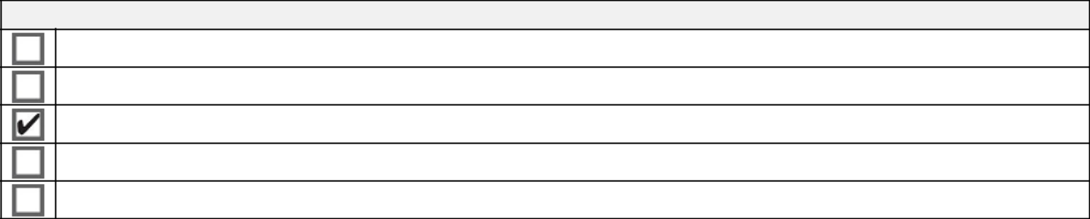

Check the appropriate box:

Preliminary Proxy Statement

Confidential, for Use of the Commission Only (as permitted by Rule 14A-6(E)(2))

Definitive Proxy Statement

Definitive Additional Materials

Soliciting Material under §240.14a-12

HALLIBURTON

(Name of Registrant as Specified in Its Charter)

(Name of Person(s) Filing Proxy Statement, if other than the Registrant)
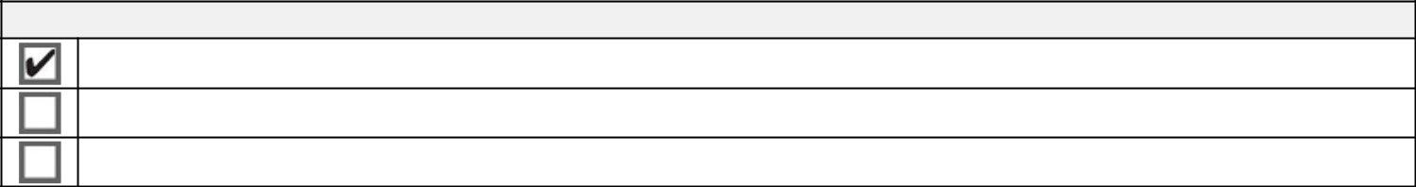

Payment of Filing Fee (Check all boxes that apply):

No fee required.

Fee paid previously with preliminary materials.

Fee computed on table in exhibit required by Item 25(b) per Exchange Act Rules 14a-6(i)(1) and 0-11.

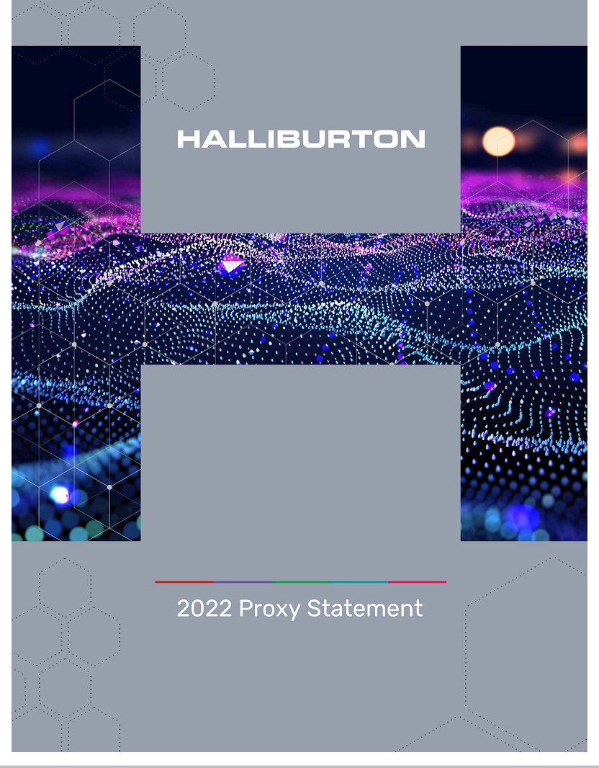

To Our Valued Shareholders:

April 5, 2022

Dear Fellow Shareholders:

On behalf of our Board of Directors, management team, and more than 40,000 employees, thank you for your investment in Halliburton.

Energy markets in 2021 demonstrated the importance of oil and gas to fueling economic recovery and to sustaining the quality of life for people everywhere. Halliburton’s value proposition, core competencies, and service delivery play a vital role in the reliability, affordability, and sustainability of oil and gas for a growing world population. Halliburton also delivered technology to help reduce emissions for ourselves and our customers while enabling future low carbon technology through our cleaner and more affordable energy accelerator, Halliburton Labs.

In 2021, oil and gas demand accelerated, marking the beginning of an energy upcycle. Halliburton’s solid strategy execution delivered outperformance in every part of our business – safety, service quality, and financial results. Our clear strategy to deliver profitable international growth, maximize cash flow in North America, deploy new digital and automation technology, increase capital efficiency, and advance a sustainable energy future drove our financial outperformance, and created value for our shareholders.

Our refreshed shareholder outreach efforts made sure we met with and heard from you about Halliburton and our performance. During 2021, we communicated with shareholders collectively representing approximately 60% of our outstanding shares and held face-to-face video calls with shareholders representing about 40% of our shares. Our Compensation Committee Chair, Murry Gerber or Lead Independent Director, Bob Malone attended these calls, along with members of senior management. That outreach also included engagement with the two largest proxy advisors, ISS and Glass Lewis. The information each of you shared with us is integral to the Board’s decision-making process and your views help inform our Company’s policies, practices, and disclosures.

Your vote is important regardless of how many shares you own. Whether or not you plan to attend our annual meeting on May 18, 2022, at our corporate offices in Houston, Texas, please review the proxy materials and vote as soon as possible. You may do so by phone, online, or if you received a paper proxy, through the mail. See the Notice of Annual Meeting for instructions on how to vote.

On behalf of the Board of Directors, thank you for the confidence you place in Halliburton.

Sincerely,
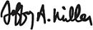
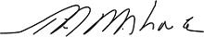

Jeffrey A. Miller | Robert A. Malone
Chairman, President and CEO | Lead Independent Director

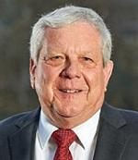

Table of Contents

Letter from the Chairman, President and CEO and Lead Independent Director
Notice of Annual Meeting of Shareholders | 1
Proxy Statement Summary | 2
2021 Strategic Priorities | 2
2021 Performance Overview | 2
Our 2022 Board Nominees | 3
Our 2021 Named Executive Officers | 3
Our Executive Compensation Program | 4
Our Year-round Shareholder Engagement | 5
Corporate Governance | 6
Corporate Governance Guidelines and Committee Charters | 6
Code of Business Conduct | 6
Related Persons Transactions Policy | 6
The Board of Directors and Standing Committees of Directors | 7
Board Leadership | 7
Board and Committee Oversight | 8
Members of the Committees of Our Board of Directors | 10
Board Attendance | 10
Evaluation of Board and Director Performance | 11
Shareholder Nominations of Directors | 12
Qualifications of Directors | 12
Board Refreshment | 13
Shareholder Engagement | 13
Communication to the Board | 14
Proposal No. 1 Election of Directors | 15
Information about Nominees for Director | 17
Directors’ Compensation | 21
Directors’ Fees | 21
Directors’ Equity Awards | 21
Directors’ Deferred Compensation Plan | 21
Directors’ Stock Ownership Requirements | 22
Director Clawback Policy | 22
Matching Programs | 22
2021 Director Compensation | 23
Stock Ownership Information | 25
Delinquent Section 16(a) Reports | 25
Stock Ownership of Certain Beneficial Owners and Management | 25
Proposal No. 2 Ratification of Selection of Principal Independent Public Accountants | 27
Audit Committee Report | 28
Fees Paid to KPMG LLP | 29
Proposal No. 3 Advisory Approval of Executive Compensation | 30
Compensation Committee Report | 30
Compensation Discussion and Analysis | 31
Compensation Committee Letter | 31
Enhancing Our Shareholder Outreach and Board Activity | 32
Straight from the Boardroom: Talking with Murry S. Gerber | 33
2021 CEO Compensation Overview | 35
2021 Performance Overview | 38
The Foundation of Our Executive Compensation Program | 40
Setting Executive Compensation | 42
2021 Executive Compensation Outcomes in Detail | 44
Other Executive Benefits and Policies | 49
Executive Compensation Tables | 53
Summary Compensation Table | 53
Supplemental Table: All Other Compensation | 54
Grants of Plan-Based Awards in Fiscal 2021 | 56
Outstanding Equity Awards at Fiscal Year End 2021 | 57
2021 Option Exercises and Stock Vested | 59
2021 Nonqualified Deferred Compensation | 59
Employment Contracts and Change-in-Control Arrangements | 60
Post-Termination or Change-in-Control Payments | 61

Equity Compensation Plan Information |  | 64
CEO Pay Ratio |  | 64
General Information |  | 65
Additional Information |  | 66
Involvement in Certain Legal Proceedings |  | 66
Advance Notice Procedures and Shareholder Proposals |  | 66
Proxy Solicitation Costs |  | 66
Other Matters |  | 67
Directions to the Halliburton Annual Meeting of Shareholders |  | 68
www.halliburton.com |  | HALLIBURTON | 2022 Proxy Statement ii

Back to Contents

Notice of Annual Meeting of Shareholders to be held May 18, 2022

April 5, 2022

Halliburton Company, a Delaware corporation, will hold its Annual Meeting of Shareholders on Wednesday, May 18, 2022, at 9:00 a.m. Central Daylight Time at its corporate office at 3000 N. Sam Houston Parkway East, Life Center - Auditorium, Houston, Texas 77032.

At the meeting, the shareholders will be asked to consider and act upon the matters discussed in the attached proxy statement as follows:

- To elect the eleven nominees named in the attached proxy statement as Directors to serve for the ensuing year and until their successors shall be elected and shall qualify.

- To consider and act upon a proposal to ratify the appointment of KPMG LLP as principal independent public accountants to examine the financial statements and books and records of Halliburton for the year ending December 31, 2022.

- To consider and act upon advisory approval of our executive compensation.

- To transact any other business that properly comes before the meeting or any adjournment or adjournments of the meeting.

These items are fully described in the following pages, which are made a part of this Notice. The Board of Directors has set the close of business on March 21, 2022, as the record date for the determination of shareholders entitled to notice of and to vote at the meeting and at any adjournment of the meeting.

Internet Availability of Proxy Materials

On or about April 5, 2022, we mailed our shareholders a Notice of Internet Availability of Proxy Materials containing instructions on how to access our 2022 proxy statement and 2021 Annual Report on Form 10-K and how to vote online. The notice also provides instruction on how you can request a paper copy of these documents if you desire. If you received your Annual Meeting materials via e-mail, the e-mail contains voting instructions and links to the proxy statement and Form 10-K on the Internet.

If You Plan to Attend

Attendance at the meeting is limited to shareholders and one guest each. Admission will be on a first-come, first-served basis. Registration will begin at 8:00 a.m., and the meeting will begin at 9:00 a.m. Each shareholder holding stock in a brokerage account will need to bring a copy of a brokerage statement reflecting stock ownership as of the record date. Please note that you will be asked to present valid picture identification, such as a driver’s license or passport.

By order of the Board of Directors
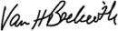

Van H. Beckwith

Executive Vice President, Secretary and Chief Legal Officer


You can vote by any of the following methods:

INTERNET | BY TELEPHONE | BY MAIL | IN PERSON
www.proxyvote.com | until 11:59 p.m. | Completing, signing, and returning your | at the annual meeting
until 11:59 p.m. | Eastern Daylight Time on | proxy or voting instruction card
Eastern Daylight Time on | May 17, 2022 | before May 18, 2022
May 17, 2022

The following voting matters are described in this proxy statement.
 | Board Vote
 | Recommendation | Page Reference
Election of Directors | FOR Each Nominee | 15
Ratification of Selection of Principal Independent Public Accountants | FOR | 27
Advisory Approval of Executive Compensation | FOR | 30

Back to Contents

Proxy Statement Summary

This summary highlights information contained elsewhere in this proxy statement or as otherwise noted. This summary does not contain all of the information that you should consider, and you should read the entire proxy statement carefully before voting. Page references are supplied to help you find further information in this proxy statement.

2021 Strategic Priorities

As we began 2021, we identified the following focus areas in our 2020 Form 10-K:

- International: We are stronger technically, geographically, and organizationally; we see an unfolding activity recovery and are well positioned to drive profitable growth internationally.

- North America: As operators increase their activity levels to achieve maintenance level production, the operating leverage we have created in North America should allow us to increase our operating profits and cash flows.

- Digital: We are positioned to accelerate the deployment and integration of digitally enabled technologies, both internally and for our customers.

- Capital efficiency: We plan to advance technologies and make strategic choices that lower our capital expenditure profile.

- Sustainable energy: We will play an active role in advancing cleaner, affordable energy solutions.

2021 Performance Overview (pages 38-39)

So how did we do? Our employees delivered solid execution across every part of our business in 2021 – safety, service quality, and financial results. Despite the challenges of working during a pandemic and global energy demand complexity, they again outperformed and delivered what the world requires – affordable and reliable energy provided by oil and gas – in a safe, efficient, and ethical manner – while minimizing our environmental impact. Here are the highlights for 2021:

- Financial: Internationally we delivered profitable growth with revenue and operating income increasing every quarter in 2021. In North America, strong operating leverage allowed us to maximize the value of our business as U.S. land activity rebounded. Overall, our Completion and Production and Drilling and Evaluation operating segments finished the year with 15% and 12% operating margins, respectively, and generated strong cash flows from operations.

- Digital: Our accelerated deployment and integration of digitally enabled technologies created technical differentiation in the market and contributed to our higher margins.

- Capital efficiency: We advanced technologies and made strategic choices that kept our capital expenditures to 5.2% of revenue, which is in the range of our 5-6% of revenue target.

- Sustainable energy: We announced our science-based emission reduction targets, added eleven new participating companies to Halliburton Labs, our clean energy accelerator, and were named to the Dow Jones Sustainability Index North America for Energy Equipment and Services, which highlights the top 10% most sustainable North America companies in identified industries as determined by S&P Global through their Corporate Sustainability Assessment.

www.halliburton.com HALLIBURTON | 2022 Proxy Statement 2

Back to Contents

Our 2022 Board Nominees (pages 17-20)

Name | Age | Occupation
Abdulaziz F. Al Khayyal | 68 | Retired director and Senior Vice President of Industrial Relations of Saudi Aramco
William E. Albrecht | 70 | President of Moncrief Energy, LLC
M. Katherine Banks | 62 | President, Texas A&M University
Alan M. Bennett | 71 | Retired President and Chief Executive Officer of H&R Block, Inc.
Milton Carroll | 71 | Retired Executive Chairman of the Board of CenterPoint Energy, Inc.
Earl M. Cummings | 57 | Managing Partner of MCM Houston Properties, LLC and Chief Executive Officer of BTS Team, Inc.
Murry S. Gerber | 69 | Retired Executive Chairman of the Board of EQT Corporation
Robert A. Malone | 70 | Executive Chairman, President and Chief Executive Officer of First Sonora Bancshares, Inc.
Jeffrey A. Miller | 58 | Chairman of the Board, President and Chief Executive Officer of Halliburton
Bhavesh V. (Bob) Patel | 55 | Chief Executive Officer of W. R. Grace
Tobi M. Edwards Young | 46 | Senior Vice President, Global Privacy, Government Affairs, and Chief Regulatory Attorney of Cognizant Technology
 |  | Solutions
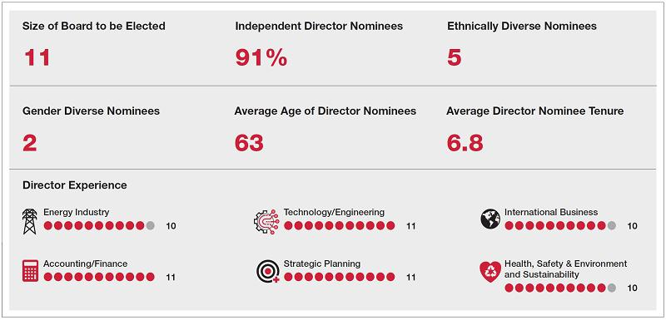

Our 2021 Named Executive Officers (page 40)

Name | Age | Occupation
Jeffrey A. Miller | 58 | Chairman, President and Chief Executive Officer
Lance Loeffler | 45 | Executive Vice President and Chief Financial Officer
Eric J. Carre | 56 | Executive Vice President – Global Business Lines
Joe D. Rainey | 65 | President – Eastern Hemisphere
Mark J. Richard | 60 | President – Western Hemisphere

HALLIBURTON | 2022 Proxy Statement 3

Back to Contents

Our Executive Compensation Program (pages 31-63)

Objectives (page 40)

Our executive compensation program is composed of base salary, a short-term incentive, and long-term incentives and is designed to achieve the following objectives:

- Provide a clear and direct relationship between executive pay and our performance on both a short-term and long-term basis;

- Target market competitive pay levels with a comparator peer group;

- Emphasize operating performance drivers;

- Link executive pay to measures that drive shareholder returns;

- Support our business strategies; and

- Maximize the return on our human resource investment.

How Our Executive Compensation Program Links to Performance (page 41)

Our executive compensation program emphasizes variable pay that aligns compensation with performance and shareholder value. The mix of compensation elements is heavily weighted toward variable, performance-based compensation to ensure our senior executives continue to deliver the reliable execution, strong cash flow, and industry-leading returns that our shareholders expect.

FIXED


AT

RISK

 | Reward |  |  |  | How Award Value
 | Element | Objective | Key Features |  | is Determined | 2021 Decisions
 | Base Salary | Compensates executives | Fixed element of |  | Benchmarked against a group | Effective January 1, 2021,
 |  | based on their | compensation paid in cash. |  | of comparably sized | base salaries were
 |  | responsibilities, experience, |  |  | corporations and industry | reinstated to pre-reduction
 |  | and skillset. |  |  | peers. | January 1, 2020 levels.
 | Short-Term | To motivate and incentivize | Award value and measures are |  | Performance measured | Award values were targeted
 | (Annual) | performance over a one- | reviewed annually. Targets are |  | against: | at the market median for
 | Incentive | year period. | set at the beginning of the |  | • 75% NOPAT | 2021.
 |  |  | period. |  | • 75% NOPAT
 |  |  |  |  | • 25% Asset Turns | Additionally, split year
 |  |  |  |  |  | performance goals
 |  |  |  |  |  | consisting of two six-month
 |  |  |  |  |  | performance periods were
 |  |  |  |  |  | established to address the
 |  |  |  |  |  | challenge with setting full
 |  |  |  |  |  | year performance goals in
 |  |  |  |  |  | an uncertain market
 |  |  |  |  |  | environment.
 | Long-Term | To motivate and incentivize | Value is delivered: |  | The 2021 performance units | Award values were targeted
 | Incentives | sustained performance over | • | 70% performance units | measured against ROCE | at the market median for
 |  | the long-term. Aligns | • | 70% performance units | performance relative to | 2021.
 |  | the long-term. Aligns |  | measured over three years | performance relative to | 2021.
 |  | interests of our NEOs with |  | measured over three years | performance peers and
 |  | interests of our NEOs with |  | (1/2 in stock; 1/2 in cash) | performance peers and
 |  | long-term shareholders. |  | (1/2 in stock; 1/2 in cash) | includes a relative TSR
 |  | long-term shareholders. |  | with relative TSR modifier | includes a relative TSR
 |  |  |  | with relative TSR modifier | modifier.
 |  |  | • | 30% restricted stock | modifier.
 |  |  | • | 30% restricted stock | Restricted stock grants have
 |  |  |  |  | time-based vesting and value
 |  |  |  |  | is driven by our share price.

www.halliburton.com HALLIBURTON | 2022 Proxy Statement 4

Back to Contents

Our Year-round Shareholder Engagement (page 13)

- In 2021, independent Board members offered off-season meetings to 34 of our top shareholders representing 60% of our shares.

- A refreshed shareholder presentation highlighted the latest information about our Board oversight and corporate governance; executive compensation program; health, safety, and environment (HSE) performance and strategies; diversity, equity, and inclusion (DE&I) performance and strategies; and our approach to energy transition.

- Board members and management conducted video conferences with 18 shareholders representing about 40% of our shares and with the two largest proxy advisors, Institutional Services Shareholder (ISS) and Glass Lewis.

- Participants included Murry Gerber, Chair of the Compensation Committee or Bob Malone, Lead Independent Director, and senior management.

- Also, our senior management and Investor Relations team participated in 13 sell-side conferences, three non-deal roadshows, and approximately 300 investor meetings that are all part of our ongoing shareholder outreach cadence.

- Our senior management and directors presented shareholder feedback to the full Board of Directors for discussion. As a result of these engagements and Board consideration of investor feedback, we enhanced Board governance and included ESG-related metrics in our annual incentive plan effective January 1, 2022.

HALLIBURTON | 2022 Proxy Statement 5

Back to Contents

Corporate Governance

Corporate Governance Guidelines and Committee Charters

Our Board has long maintained a formal statement of its responsibilities and guidelines to ensure effective governance in all areas of its responsibilities. Our Corporate Governance Guidelines are available on our website at www.halliburton.com by clicking on the tabs “Investors”, “Company Information”, and then the “Corporate Governance” link. The guidelines are reviewed periodically and revised as appropriate to reflect the dynamic and evolving processes relating to corporate governance, including the operation of the Board.

Our current Board structure and governance practices, as specified in those Guidelines and our By-laws, Code of Business Conduct, and policies and business practices, include the following:

Annual Election of Directors | Yes | Shareholder Called Special Meetings | Yes
Mandatory Retirement Age | 75 | Poison Pill | No
Majority Voting in Director Elections | Yes | Code of Conduct for Directors, Officers, and Employees | Yes
Lead Independent Director | Yes | Stock Ownership Guidelines for Directors/Officers | Yes
Related Persons Transactions Policy | Yes | Anti-Hedging and Pledging Policy | Yes
Supermajority Voting Threshold for Mergers | No | Compensation Recoupment Policy | Yes
Proxy Access | Yes | Corporate Political Contributions | No
Shareholder Action by Written Consent | Yes

In order for our shareholders to understand how the Board conducts its affairs in all areas of its responsibility, the full text of the charters of our Audit; Compensation; Health, Safety and Environment; and Nominating and Corporate Governance Committees and for our Lead Independent Director are also available on our website.

Except to the extent expressly stated otherwise, information contained on or accessible from our website or any other website is not incorporated by reference into and should not be considered part of this proxy statement.

Code of Business Conduct

Our Code of Business Conduct, which applies to all of our Directors and employees and serves as the code of ethics for our principal executive officer, principal financial officer, principal accounting officer or controller, and other persons performing similar functions, is available on our website. Any waivers to our Code of Business Conduct for our Directors or executive officers can only be made by our Audit Committee. There were no waivers of the Code of Business Conduct in 2021.

Related Persons Transactions Policy

Our Board has adopted a written policy governing related persons transactions as part of the Board’s commitment to good governance and independent oversight. The policy covers transactions involving any of our Directors, executive officers, nominees for Director, greater than 5% shareholders, or any of their immediate family members, among others.

The types of transactions covered by this policy are transactions, arrangements, or relationships, or any series of similar transactions, arrangements, or relationships, including any indebtedness or guarantee of indebtedness, in which (i) we or any of our subsidiaries were or will be a participant, (ii) the aggregate amount involved exceeds $120,000 in any calendar year, and (iii) any related person had, has, or will have a direct or indirect material interest.

Under the policy, we generally only enter into or ratify related persons transactions when the Audit Committee determines such transactions are in our best interests and the best interests of our shareholders. In determining whether to approve or ratify a related persons transaction, the Audit Committee will consider the following factors and other factors it deems appropriate:

- whether the related persons transaction is on terms comparable to terms generally available with an unaffiliated third party under the same or similar circumstances;

- the benefits of the transaction to us;

- the extent of the related person’s interest in the transaction; and

- whether there are alternative sources for the subject matter of the transaction.

www.halliburton.com HALLIBURTON | 2022 Proxy Statement 6

Back to Contents

The Board of Directors and Standing Committees

of Directors

The Board has standing Audit; Compensation; Health, Safety and Environment; and Nominating and Corporate Governance Committees. Each standing Committee is comprised of Directors who, in the business judgment of the Board, are independent, after considering all relevant facts and circumstances, including the independence standards set forth in our Corporate Governance Guidelines.

Our independence standards meet New York Stock Exchange, or NYSE, independence requirements. Our independence standards and compliance with those standards are periodically reviewed by the Nominating and Corporate Governance Committee. There were no relevant transactions, arrangements, or relationships not disclosed in this proxy statement that were considered by the Board in making its determination as to the independence of the Directors.

Board Leadership

Our Board believes that it is important to maintain flexibility to determine the appropriate leadership of the Board and whether the roles of Chairman and Chief Executive Officer should be combined or separate. Our Corporate Governance Guidelines provide that the Board consider annually whether it is appropriate for the same individual to fill both of those roles. When making that determination, the Board considers issues such as industry and financial expertise, in-depth knowledge of Halliburton and its business, and succession planning. In 2021, the Board decided that a combined leadership role would currently best serve the Company and its shareholders. The Board believes that Jeffrey A. Miller, our Chairman, President and Chief Executive Officer, with his industry expertise, financial expertise, and in-depth knowledge of Halliburton and its business, is the correct person to fill both roles. The Board also believes that Mr. Miller is best suited to lead the Board’s discussion and evaluation of the Company’s business, financial, and health, safety, environment, and sustainability strategy and performance. With the exception of Mr. Miller, the Board is composed of independent Directors.

Robert A. Malone is our Lead Independent Director. The Lead Independent Director’s role and responsibilities are set forth in the Lead Independent Director Charter adopted by the Board. These include the following:

liaises between the independent Directors and the Chairman | participates in shareholder engagement
approves agendas for Board meetings and ensures the agendas | advises management on and approves information sent to the Board
provide opportunities for the Board to provide input on the Company’s | and approves schedules for meetings of the Board
business strategy and management’s execution of that strategy
presides over meetings and executive sessions of the independent | authorizes the retention of outside advisors and consultants who report
Directors | directly to the Board
leads the Board’s annual evaluation of the Chief Executive Officer | schedules meetings of the independent Directors as appropriate

Our Lead Independent Director Charter is available on our website at www.halliburton.com.

HALLIBURTON | 2022 Proxy Statement 7

Back to Contents

Board and Committee Oversight

Enhancements to ESG Oversight

Based on our commitment to provide thorough oversight of ESG risks, opportunities, and strategy, the Halliburton Board of Directors conducted a detailed analysis of our Board structure in 2021. We performed an extensive review of other Board structures and consulted with our shareholders and leading experts. The analysis found that our Board structure and oversight provide a leading model for good governance. Through the review, we also identified an opportunity for Halliburton to dedicate a committee to oversee ESG and elevated the Nominating and Corporate Governance Committee for oversight of these issues. Although the Nominating and Corporate Governance Committee oversees ESG, each committee is responsible for different aspects of ESG, as outlined in each respective charter. The Board sharpened its overall ESG oversight of the Company by focusing more time on these matters in both committee and full Board meetings, as well as in our engagements with Halliburton’s shareholders. By engaging regularly with shareholders and other outside experts to discuss sustainability topics, the Board can more effectively prioritize relevant ESG issues within our overall corporate strategy. During outreach, our shareholders endorsed this oversight structure and other governance enhancements.

Below are the primary oversight responsibilities of our Board’s committees, with newly expanded or clarified responsibilities bolded:
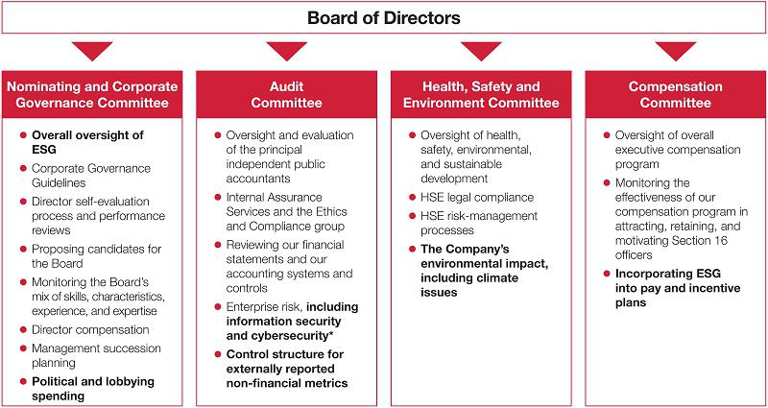

* The Board also enhanced its oversight of cybersecurity to include a quarterly update to the full Board of Directors.

The Board believes that it has a strong governance structure in place to ensure independent oversight on behalf of all shareholders. All standing Committees of the Board are comprised solely of independent Directors. Below is a discussion of some of these areas of oversight.

Political and Lobbying Spending

The Nominating and Corporate Governance Committee is responsible for oversight of political expenditures, payments to trade associations, and lobbying activity. In 2021, we published a comprehensive report (Halliburton Policies for Political Engagement) on our annual political activity. The report is available on our website at www.halliburton.com.

www.halliburton.com HALLIBURTON | 2022 Proxy Statement 8

Back to Contents

Notable highlights from this report include:

- Zero corporate contributions made directly to political parties or candidates

- Zero corporate contributions used to support ballot measures

- Prohibitions against using corporate funds to contribute to 527 and 501(c)(4) organizations

- Board oversight of the Company’s strategy for political engagement

For our efforts, in 2021 we scored an 80% on the CPA-Zicklin index. Developed by the Wharton School of Business, Zicklin Center for Business Ethics Research, this index scores corporations on the transparency and accountability demonstrated within their political engagement policies. The index uses 24 scoring elements focused on political contributions, trade associations, and political action committee (PAC) activities to calculate a raw score. Halliburton’s raw score of 56 points places us within the top 20% of all companies.

Enterprise Risk Management

We have implemented an Enterprise Risk Management (ERM) program to identify and analyze enterprise-level risks and their potential impact on our business. The objectives of our ERM program are to:

- increase the probability of achieving higher returns on capital and reducing cash flow volatility by identifying:

  - current and developing risks; and

  - significant controls and potential gaps related to identified risks;

- ensure that our key risks are being effectively managed; and

- assess whether our compensation policies are reasonably likely to have a materially adverse effect on us.

Our internal processes to identify and manage risks include our Code of Business Conduct; extensive policies and business practices; financial controls; Internal Assurance Services audits of our internal controls and health, safety, environment, and sustainability; the activities of the Ethics and Compliance group of the Law Department; and our ERM program.

The Audit Committee receives an annual ERM report on risk assessment and risk management in which risks are identified and assigned a significance rating based on potential consequences of the risk and the likelihood of occurrence.

Our Chief Executive Officer, who is primarily responsible for managing our day-to-day business, is ultimately responsible to the Board for all risk categories. Our executive officers are assigned responsibility for the various risk categories. The Board has delegated to its Committees the responsibility to monitor certain risks and receive regular updates on those risks.

Cybersecurity

The frequency and sophistication of global attacks on corporate IT systems containing sensitive information have increased. Halliburton takes each threat seriously and dedicates significant resources to protect our IT systems and data, in alignment with industry security standards, such as the International Organization for Standardization (ISO) 27001 and the National Institute of Standards and Technology (NIST) 800-53. In response, our Board of Directors now receives quarterly updates on cybersecurity matters, and our Audit Committee receives an annual, in-depth review.

Climate Initiatives

The Health, Safety and Environment Committee is responsible for oversight of our environmental impact, including climate matters. In 2021, under its guidance, we continued our steady march forward in meeting the goals of our science-based targets to reduce Scope 1 and Scope 2 emissions by 40% by 2035 from our baseline year of 2018. We quantified and executed on opportunities to reduce emissions, and we are on track to meet our reduction targets. We also completed our climate scenario analysis, aligned with the Task Force on Climate-Related Financial Disclosure (TCFD). For more information on our approach to climate change and our emissions reduction targets, please visit our Climate Change Statement on our website at www.halliburton.com.

ESG Elements of Pay and Incentive Plans

As a result of our Listen and Respond shareholder outreach effort, and with the endorsement of our shareholders, the Compensation Committee decided, effective January 1, 2022, to include ESG-related metrics focused on greenhouse gas (GHG) emissions and DE&I — two of our main areas of focus — in our annual incentive plan. ESG-related metrics will comprise 20% of the total award, with achievement of specific financial goals comprising 80% of the total award.

HALLIBURTON | 2022 Proxy Statement 9

Back to Contents

Members of the Committees of Our Board of Directors

 | Audit | Compensation | Health, Safety and | Nominating and Corporate
Name | Committee | Committee | Environment Committee | Governance Committee
Abdulaziz F. Al Khayyal
William E. Albrecht
M. Katherine Banks
Alan M. Bennett
Milton Carroll

Earl M. Cummings#

Murry S. Gerber

Patricia Hemingway Hall*

Robert A. Malone

Jeffrey A. Miller

Bhavesh V. Patel

Tobi M. Edwards Young#
Chair Member

- Ms. Hemingway Hall has decided not to stand for re-election to the Board, due solely to a personal decision related to health and travel issues associated with the continuing COVID-19 pandemic and endemic, and will continue as a Director until her term ends on May 18, 2022.

- Ms. Young and Mr. Cummings both joined the Board in February 2022 and will be appointed to Committees of the Board in May 2022.

The Board has determined that all members of the Audit Committee are independent under our Corporate Governance Guidelines. The Board has determined that Alan M. Bennett, Murry S. Gerber, and Bhavesh V. Patel are “audit committee financial experts” as defined by the Securities and Exchange Commission, or SEC.

Board Attendance

During 2021, the Board held 7 meetings and met in executive session of the independent Directors, without management present, on 4 occasions.

Committee meetings were held as follows:

Audit Committee | 8
Compensation Committee | 5
Health, Safety and Environment Committee | 4
Nominating and Corporate Governance Committee | 4

All members of the Board attended at least 93% of the total number of meetings of the Board and the Committees on which he or she served during the last fiscal year.

All of our Directors attended the 2021 Annual Meeting, as required by our Corporate Governance Guidelines.

www.halliburton.com HALLIBURTON | 2022 Proxy Statement 10

Back to Contents

Evaluation of Board and Director Performance

The Board believes that a rigorous evaluation process is an essential component of strong corporate governance practices. The Nominating and Corporate Governance Committee annually conducts a four-part evaluation process to evaluate Board effectiveness and aid in succession planning.
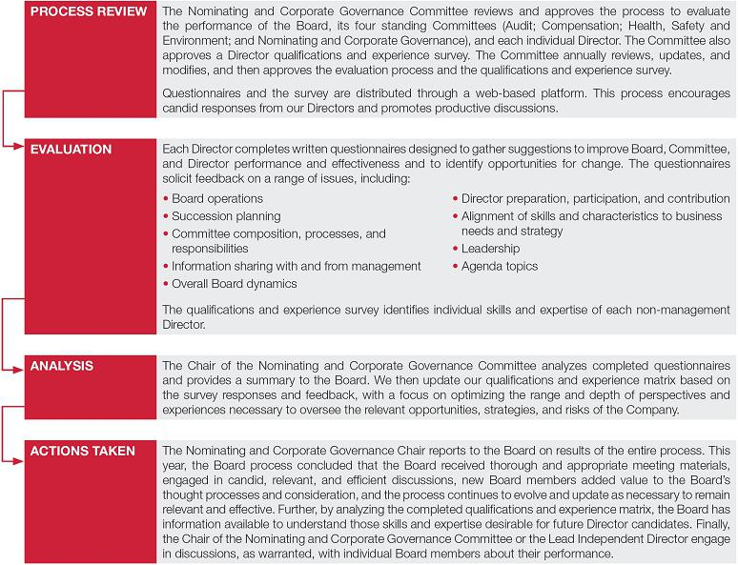

HALLIBURTON | 2022 Proxy Statement 11

Back to Contents

Shareholder Nominations of Directors

Our By-laws provide that shareholders may nominate persons for election to the Board at a meeting of shareholders.

Shareholder nominations require written notice to the Corporate Secretary at the address of our principal executive offices set forth on page 65 of this proxy statement, and for the Annual Meeting of Shareholders in 2023, must be received not less than 90 days nor more than 120 days prior to the anniversary date of the 2022 Annual Meeting of Shareholders, or no later than February 17, 2023, and no earlier than January 18, 2023. The shareholder notice must contain, among other things, certain information relating to the shareholder and the proposed nominee as described in our By-laws. In addition, the proposed nominee may be required to furnish other information as we may reasonably require to determine the eligibility of the proposed nominee to serve as a Director.

Our By-laws also provide for proxy access for shareholder nominations of Directors. The provision permits up to 20 shareholders owning 3% or more of our outstanding common stock continuously for at least three years to nominate and include in our proxy materials for a meeting of shareholders up to two directors or 20% of the Board, whichever is greater, provided that the shareholder(s) and the nominee(s) satisfy the requirements specified in the By-laws.

Our By-laws further provide that if a shareholder owning at least 1% of our issued and outstanding common stock continuously for at least one year as of the date the written notice of the nomination is submitted to us proposes a nominee not submitted under the proxy access provision, our Corporate Secretary will

- obtain from such nominee any additional relevant information the nominee wishes to provide in consideration of his or her nomination, (ii) report on each such nominee to the Nominating and Corporate Governance Committee, and (iii) facilitate having each such nominee meet with the Nominating and Corporate Governance Committee as the Committee deems appropriate.

Qualifications of Directors

Candidates nominated for election or re-election to the Board should possess the following qualifications:

- Personal characteristics:

  - high personal and professional ethics, integrity, and values;

  - an inquiring and independent mind; and

  - practical wisdom and mature judgment;

- Broad training and experience at the policy-making level in business, government, education, or technology;

- Expertise that is useful to us and complementary to the background and experience of other Board members, so that an optimum balance of experience and expertise of members of the Board can be achieved and maintained;

- Willingness to devote the required amount of time to carry out the duties and responsibilities of Board membership;

- Commitment to serve on the Board for several years to develop knowledge about our business;

- Willingness to represent the best interests of all of our shareholders and objectively evaluate management performance; and

- Involvement only in activities or interests that do not create a conflict with the Director’s responsibilities to us and our shareholders.

The Nominating and Corporate Governance Committee is responsible for assessing the appropriate mix of skills and characteristics required of Board members and periodically reviews and updates the criteria. In selecting Director nominees, the Board considers the personal characteristics, experience, and other criteria as set forth in our Corporate Governance Guidelines, as well as our specific needs and the needs of our Board at the time.

www.halliburton.com HALLIBURTON | 2022 Proxy Statement 12

Back to Contents

Board Refreshment

The Board is responsible for filling vacancies on the Board and ensuring regular refreshment of the Board. Our Corporate Governance Guidelines provide that each non-management Director shall retire from the Board immediately prior to the annual meeting of shareholders following his or her seventy-fifth
(75 ^{th}) birthday. The Board has delegated to the Nominating and Corporate Governance Committee the duty of selecting and recommending candidates to the Board for approval.
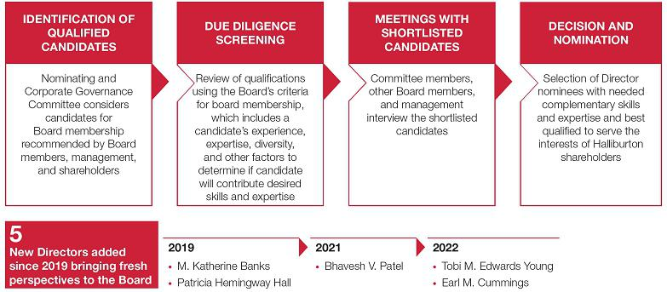

The Nominating and Corporate Governance Committee will consider candidates for Board membership recommended by Board members, our management, and shareholders. The Committee may also retain an independent executive search firm to identify candidates for consideration and to gather additional information about the candidate’s background, experience, and reputation. Ms. Young was identified as a potential Director candidate by an executive officer. Mr. Cummings was identified as a potential Director candidate by a non-management Director. A shareholder who wishes to recommend a candidate should notify our Corporate Secretary.

This process resulted in enhancement of our Board over the last several years with the addition of three female Directors, one of which is ethnically diverse, and two ethnically diverse male Directors. Ms. Young and Mr. Cummings joined the Board in 2022. Ms. Young contributes technology, governance, policy making, and regulatory experience. Mr. Cummings contributes leadership in technology solutions and entrepreneurship. Mr. Patel joined the Board in 2021. His chemical industry experience benefits us greatly as we expand our chemicals business. Dr. Banks and Ms. Hemingway Hall joined the Board in 2019. Dr. Banks contributes extensive experience in engineering and technology to the Board as well as her perspective as the President of a major research university. While she decided not to stand for re-election to the Board, due solely to a personal decision related to health and travel issues associated with the continuing COVID-19 pandemic and endemic, Ms. Hemingway Hall contributed substantial public company and corporate governance experience.

Shareholder Engagement

Halliburton values ongoing, open shareholder dialogue to ensure that the Board and management have a regular pulse on investors’ views. This dialogue also provides valuable feedback on how we can continue to improve.

Following our 2021 Annual Meeting, the Board recommitted to more active shareholder engagement. We enhanced shareholder communications, refreshed our shareholder presentation, opened additional availability for director video calls, and listened and responded to shareholders about possible changes to governance and executive compensation.

In 2021, independent Board members offered and held off-season meetings with representatives from our top shareholders to gain a better understanding of their priorities and concerns prior to the proxy voting season. We offered these meetings to 34 shareholders representing approximately 60% of our shares. Each received the opportunity to meet with Board members by video conference. For those unable to attend,

HALLIBURTON | 2022 Proxy Statement 13

Back to Contents

we sent our refreshed shareholder presentation to each and offered follow-up. The updated materials highlighted the latest information about our Board oversight and corporate governance; executive compensation program; health, safety, and environment (HSE) performance and strategies; diversity, equity, and inclusion (DE&I) performance and strategies; and our approach to energy transition. After receiving these new materials, additional shareholders accepted the offer to meet.

During off-season engagement, Board members and management conducted video conferences with 18 shareholders representing about 40% of our shares and with the two largest proxy advisors, Institutional Shareholder Services (ISS) and Glass Lewis. These included video conferences with Murry Gerber, Chair of the Compensation Committee or Robert Malone, Lead Independent Director, and senior management.

This off-season investor engagement program was in addition to routine solicitation of shareholder feedback coincident with annual and quarterly reporting, earnings conference calls, and investor meetings. Also, our senior management and Investor Relations team regularly hold meetings and conference calls with analysts, institutional investors, and ESG rating firms, among others. In 2021, Halliburton participated in 13 sell-side conferences, three non-deal roadshows, and approximately 300 investor meetings that are all part of our ongoing shareholder outreach cadence.

Our senior management and directors presented shareholder feedback to the full Board of Directors for discussion. As a result of these engagements and Board consideration of investor feedback, we refreshed Board governance and made changes to our 2022 annual executive incentive plan.

Communication to the Board

To foster better communication from our shareholders and other interested persons, we maintain a process for shareholders and others to communicate with the Audit Committee and the Board. The process has been approved by both the Audit Committee and the Board and meets the requirements of the NYSE and SEC. The methods of communication with the Board include telephone, mail, and e-mail.

888.312.2692 | Board of Directors | BoardofDirectors@halliburton.com
or | c/o Code of Business Conduct
770.613.6348 | Halliburton Company
 | P.O. Box 2625
 | Houston, TX 77252-2625
 | USA

Our Director of Business Conduct, an employee, reviews all communications directed to the Audit Committee and the Board. The Audit Committee is promptly notified of any substantive communication involving accounting, internal accounting controls, or auditing matters. The Lead Independent Director is promptly notified of any other significant communication, and any Board-related matters which are addressed to a named Director are promptly sent to that Director. Copies of all communications are available for review by any Director. Communications may be made anonymously or confidentially. Confidentiality shall be maintained unless disclosure is:

- required or advisable in connection with any governmental investigation or report;

- in the interests of Halliburton, consistent with the goals of our Code of Business Conduct; or

- required or advisable in our legal defense of a matter.

Information regarding these methods of communication is also on our website at www.halliburton.com.

www.halliburton.com HALLIBURTON | 2022 Proxy Statement 14

Back to Contents

Proposal No. 1 Election of Directors

In considering whether a current Director should be nominated for election as a Director, the Nominating and Corporate Governance Committee and the Board considered, among other matters, the expertise and experience of the Director, the annual performance evaluation of the Director, the Director’s attendance at, preparation for, and engagement in Board and Committee meetings, the diversity of the Board, the tenure of the Director, and the overall distribution of tenure among Directors to ensure sufficient experience with the Company’s operations, performance, and technology, and the cycles of the industry. A summary of the qualifications and experience of our non-management Directors is provided under Information about Nominees for Director.

AFTER CONSULTATION WITH THE NOMINATING AND CORPORATE GOVERNANCE COMMITTEE, THE BOARD OF DIRECTORS RECOMMENDS A VOTE FOR THE ELECTION OF EACH OF THE DIRECTOR NOMINEES LISTED UNDER INFORMATION ABOUT NOMINEES FOR DIRECTOR.

The eleven nominees are all current Directors. If any nominee is unwilling or unable to serve, favorable and uninstructed proxies will be voted for a substitute nominee designated by the Board. If a suitable substitute is not available, the Board will reduce the number of Directors to be elected. Each nominee has indicated approval of his or her nomination and his or her willingness to serve if elected. The Directors elected will serve for the ensuing year and until their successors are elected and qualify.

HALLIBURTON | 2022 Proxy Statement 15

Back to Contents

NON-MANAGEMENT DIRECTOR QUALIFICATIONS AND EXPERIENCE
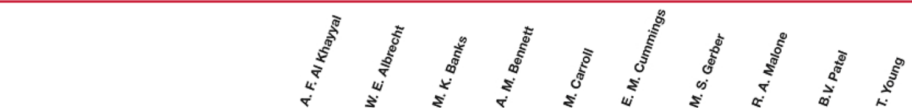

TENURE
Year Elected |  | 2014 | 2016 | 2019 | 2006 | 2006 | 2022 | 2012 | 2009 | 2021 | 2022
INDEPENDENCE AND EXPERIENCE
Independence
Board or Board Committee Leadership
Public Company Experience
Private Company Experience
Not-for-Profit Experience
Government Experience
Academia
Community Leadership/Philanthropic
DECISION-MAKING OR OTHER
SUBSTANTIAL EXPERIENCE
Energy Industry |  | A | A | A | B | B | B | A | A | A
Accounting/Finance |  | B | A | B | A | B | A | A | A | A |  | A
Technology/Engineering |  | A | B | A | A | B | A | A | A | A |  | A
Legal/Compliance |  | B | B | B | A |  | B | A | A | A |  | A
Mergers & Acquisitions |  | B | A | B | A | A | B | A | A | A |  | A
Human Resources/Compensation |  | A | A | A | A | B | A | A | A | A |  | A
Strategic Planning |  | A | A | A | A | B | A | A | A | A |  | A
International Business |  | A | A | B | A | B |  | B | A | A |  | A
Health, Safety & Environment and |  | A | A | A | A |  | A | A | A | A |  | A
Sustainability
Public Policy |  | B | A | A | A | A | B | A | A | A |  | A
Corporate Governance |  | A | A | A | A | A | A | A | A | A |  | A
LEGEND
A Policy-making experience in business, government, education, or technology
B Other substantial experience
DEMOGRAPHICS
Race/Ethnicity
Black/African American
Indian/South Asian
White/Caucasian
Middle Eastern
Native American
Gender
Male
Female
www.halliburton.com |  |  |  |  |  |  | HALLIBURTON | 2022 Proxy Statement |  |  |  |  | 16

Back to Contents

Information about Nominees for Director

ABDULAZIZ F. AL KHAYYAL
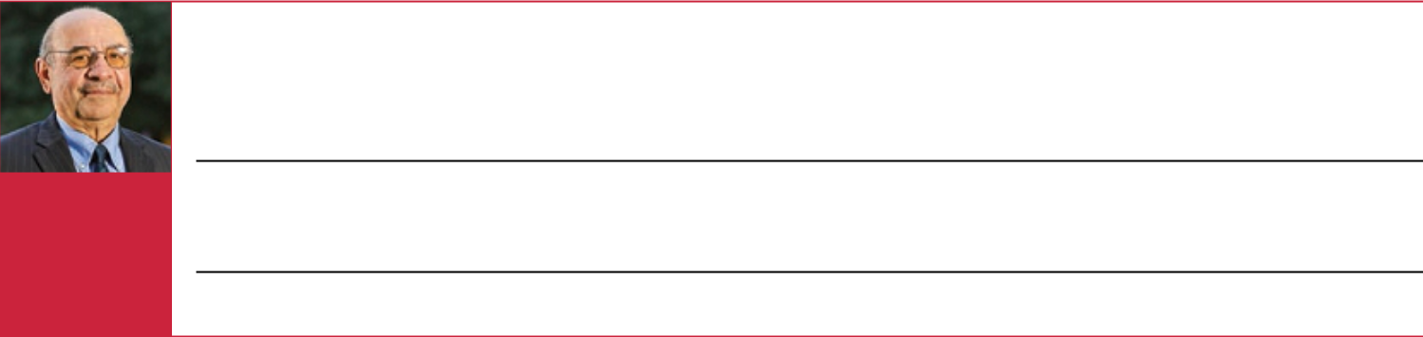

Professional Experience:

Age 68

Director since: 2014

INDEPENDENT

- Retired director and Senior Vice President of Industrial Relations of Saudi Aramco (the world’s largest producer of crude oil), where he held multiple senior roles over a career spanning from 1981 to 2014
- Saudi Aramco roles included: member of general management, Vice President of Sales and Marketing, Vice President of Employee Relations and Training, Vice President of Corporate Planning, Senior Vice President of International Operations, and Senior Vice President of Refining, Marketing and International

Skills and Expertise:

The Board determined that Mr. Al Khayyal should be nominated for election as a Director because of his exceptional knowledge of the energy industry, including significant international industry experience, a thorough understanding of the geopolitics of the oil and gas business, and executive experience with the world’s largest producer of crude oil.

Other Company Directorships: Former Directorships in the Past 5 Years:

• Marathon Petroleum Corporation (since 2016) • None

WILLIAM E. ALBRECHT
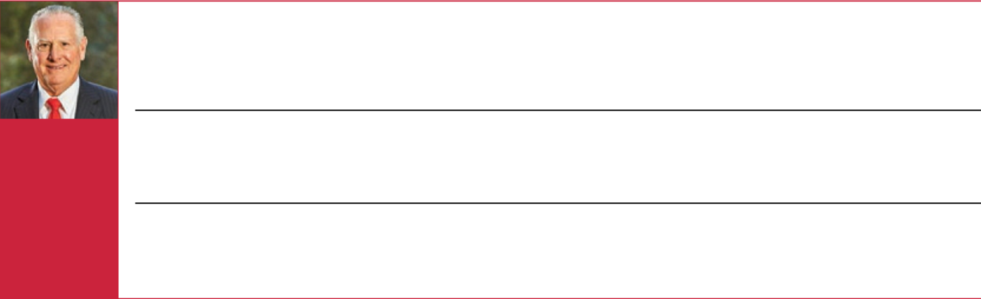

Age 70

Director since: 2016

INDEPENDENT

Professional Experience:

- President of Moncrief Energy, LLC (a private oil and gas operator) since 2021

- Non-Executive Chairman of the Board of California Resources Corporation from 2016 to 2020

- Executive Chairman of the Board of California Resources Corporation from 2014 to 2016

- Vice President of Occidental Petroleum Corporation from 2008 to 2014

- President of Oxy Oil & Gas, Americas from 2012 to 2014

Skills and Expertise:

The Board determined that Mr. Albrecht should be nominated for election as a Director because of his extensive experience in the domestic oil and natural gas industry and executive experience with a public oil and gas exploration and production company and an international offshore drilling company. Additionally, Mr. Albrecht’s expertise in the field of engineering gives him technical understanding of Halliburton’s business and customers.

Other Company Directorships:

- Chairman of the Board and director of Laredo Petroleum, Inc. (since 2020)

Former Directorships in the Past 5 Years:

- Chairman of the Board and director of Rowan Companies plc (2015-2019)

- California Resources Corporation (2014-2020)

- Lead Independent Director of Valaris Inc. (2019-2021)

M. KATHERINE BANKS


Age 62

Director since: 2019

INDEPENDENT

Professional Experience:

- President, Texas A&M University (a public research university) since 2021

- Vice Chancellor of National Laboratories and National Security Strategic Initiatives for the Texas A&M University System since 2012

- Vice Chancellor of Engineering and Dean of the College of Engineering at Texas A&M University from 2012 to 2021

- The Bowen Engineering Head for the School of Civil Engineering at Purdue University from 2007 to 2012

Skills and Expertise:

The Board determined that Dr. Banks should be nominated for election as a Director because of her extensive experience in engineering and technology, as an academic and mentor, and also her current role leading a large, public research university, and previous experience as an executive leading one of the largest engineering schools in the country while overseeing the engineering, academic, and research programs at seven universities. Dr. Banks also brings unique expertise in scientific lab management, safety, and nuclear security, as both a director of Triad National Security (which provides lab management, nuclear operations, national security, and scientific research to the National Nuclear Security Administration) and as Vice Chancellor of the Los Alamos National Laboratory. Given Halliburton’s focus on developing talent, Dr. Banks’ knowledge of the American academic system is also highly valuable to the Board’s discussions of talent recruitment, retention, and development. Dr. Banks’ oversight of Texas A&M’s Sustainability Master Plan also provides unique perspectives and knowledge to the Board’s work of overseeing ESG strategy at Halliburton.

 | Other Company Directorships: | Former Directorships in the Past 5 Years:
 | • None | • None
 |  |  | HALLIBURTON | 2022 Proxy Statement 17

Back to Contents

ALAN M. BENNETT
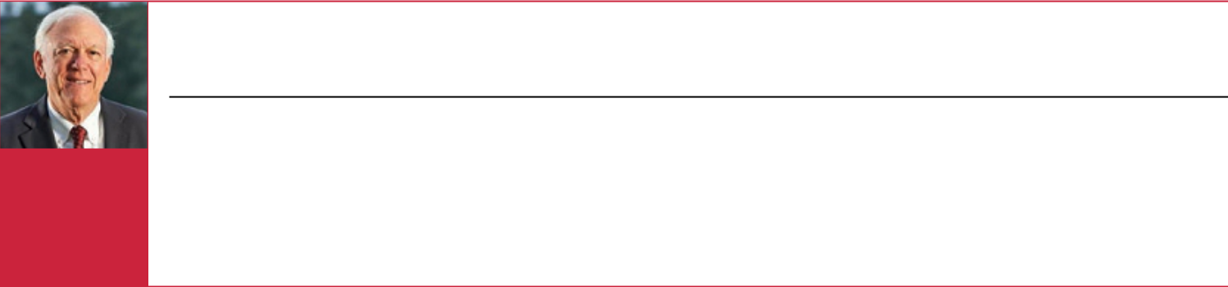

Professional Experience:

- President and Chief Executive Officer of H&R Block, Inc. (a tax and financial service provider) from 2010 until his retirement in 2011

- Interim Chief Executive Officer of H&R Block, Inc. from 2007 to 2008

- Senior Vice President and Chief Financial Officer of Aetna, Inc. from 2001 to 2007

 | Skills and Expertise:
 | The Board determined that Mr. Bennett should be nominated for election as a Director because of his business and financial
Age 71 | expertise, ranging from internal audit to corporate controller to chief financial officer of a large, public company. He is a certified public
Age 71 | accountant and also has chief executive officer experience. Mr. Bennett has deep experience in overseeing strategic decisions
Director
Director | related to mergers and acquisitions, giving him valuable perspectives in Board discussions of strategy and capital allocation.
since: 2006
since: 2006 | Other Company Directorships: | Former Directorships in the Past 5 Years:
INDEPENDENT | Other Company Directorships: | Former Directorships in the Past 5 Years:
INDEPENDENT | • Fluor Corporation (since 2011) | • None
• TJX Companies, Inc. (since 2007)

MILTON CARROLL
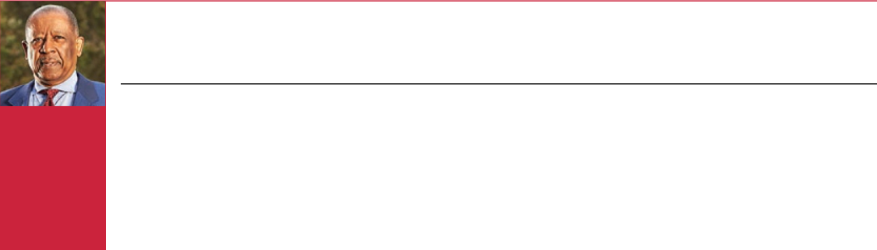

Professional Experience:

- Executive Chairman of the Board of CenterPoint Energy, Inc. (a public utility holding company) from 2013 until his retirement in 2021
- Non-Executive Chairman of the Board of CenterPoint Energy, Inc. from 2002 to 2013

- Founder of Instrument Products, Inc, a Houston-based company specializing in manufacturing oil field equipment

 |  | Skills and Expertise:
Age 71 |  | The Board determined that Mr. Carroll should be nominated for election as a Director because of his public company board
 |  | experience, corporate governance expertise, and deep knowledge of the oil and gas services industry. Mr. Carroll brings widely-
Director
 |  | regarded public company board expertise across a variety of industries with a particular focus in the power and energy industries.
since: 2006
 |  | Other Company Directorships: | Former Directorships in the Past 5 Years:
INDEPENDENT |  | Other Company Directorships:
 |  | • Chairman of the Board of Health Care Service Corporation | • | LyondellBasell Industries (2010-2016)
 |  | (since 2002) | • | Western Gas Holdings, LLC, the general partner of Western Gas
 |  |  |  | Partners, L.P. (2008-2019)
 |  |  | • | Western Midstream Partners, LP (February 2019-August 2019)
 |  |  | • | CenterPoint Energy, Inc. (1992-2021)

EARL M. CUMMINGS
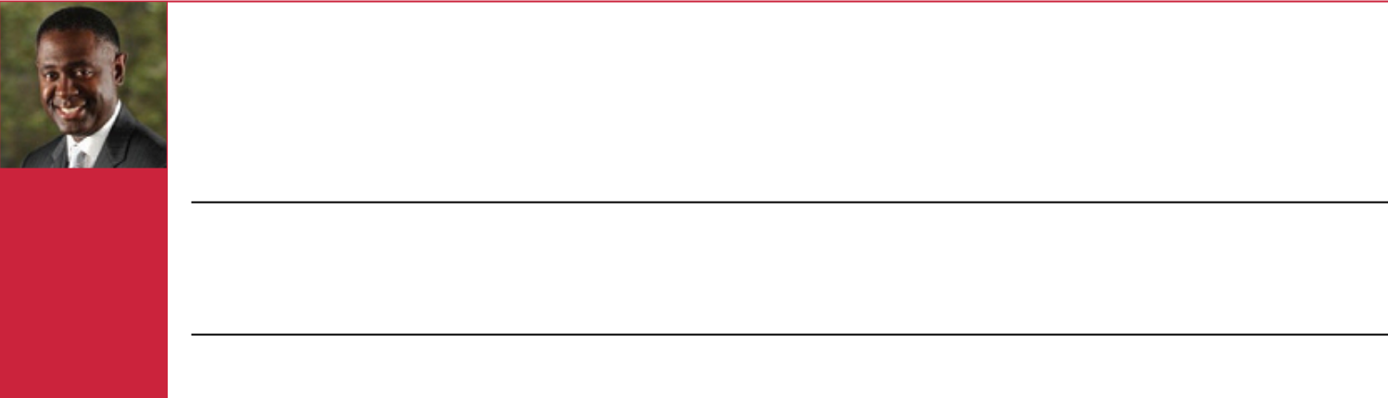

Age 57

Director since: 2022

INDEPENDENT

Professional Experience:

- Managing Partner of MCM Houston Properties, LLC (a real estate fund that invests in single family residential properties) since 2012
- Chief Executive Officer of BTS Team, Inc. (an information technology and consulting firm, specializing in network, programming, database, and desktop support services) since 1997
- Chief Executive Officer of BestAssets, Inc. (a private company providing real estate portfolio management and related services) from 2000 to 2010
- Founding Chairman of the Executive Board for C-STEM Robotics from 2002 to 2018; currently Chairman Emeritus

Skills and Expertise:

The Board determined that Mr. Cummings should be nominated for election as a Director because of his technical expertise, extensive leadership in information technology solutions, presence in the government sector, and deep entrepreneurship credentials needed for innovation in an evolving energy economy. In addition, Mr. Cummings brings valuable expertise in business strategy, capital markets, and mergers and acquisitions.

 | Other Company Directorships: |  | Former Directorships in the Past 5 Years:
 | • CenterPoint Energy, Inc. (since 2020) |  | • None
www.halliburton.com |  |  |  | HALLIBURTON | 2022 Proxy Statement 18

Back to Contents

MURRY S. GERBER
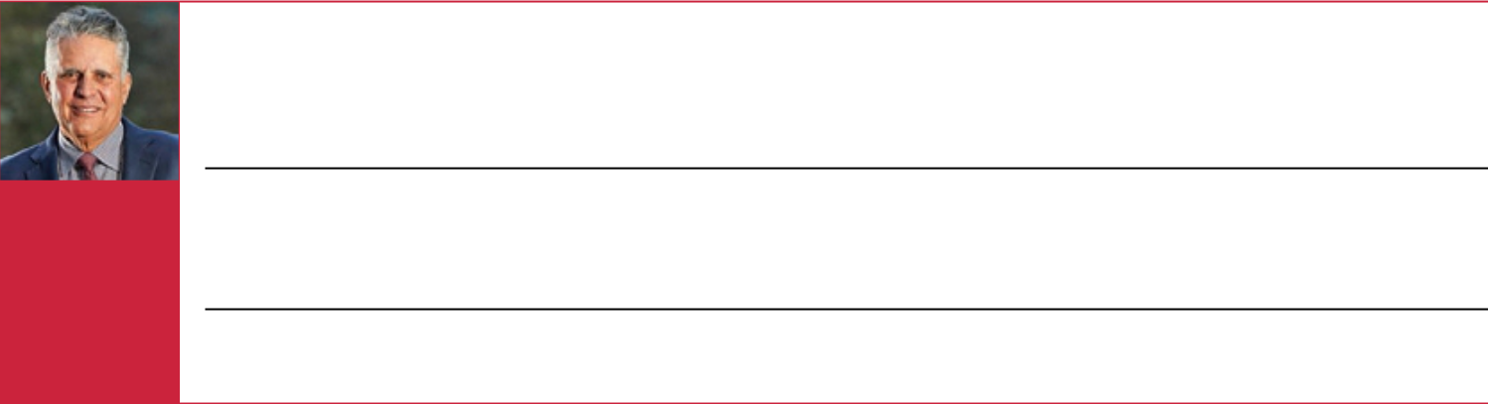

Age 69

Director since: 2012

INDEPENDENT

Professional Experience:

- Executive Chairman of the Board of EQT Corporation (a leading producer of unconventional natural gas) from 2010 until his retirement in 2011
- Chairman and Chief Executive Officer of EQT Corporation from 2000 to 2010

- Chief Executive Officer and President of EQT Corporation from 1998 to 2007

- CEO of Coral Energy (now Shell Trading North America) from 1995 to 1998

Skills and Expertise:

The Board determined that Mr. Gerber should be nominated for election as a Director because of his executive leadership skills and extensive business experience in the energy industry and domestic unconventional oil and natural gas basins. Mr. Gerber’s public company board experience spans two decades and multiple sectors, giving him important insights and perspectives on commodity markets and financial markets.

Other Company Directorships: Former Directorships in the Past 5 Years:

• BlackRock, Inc. (since 2000) • None

- United States Steel Corporation (since 2012)

ROBERT A. MALONE
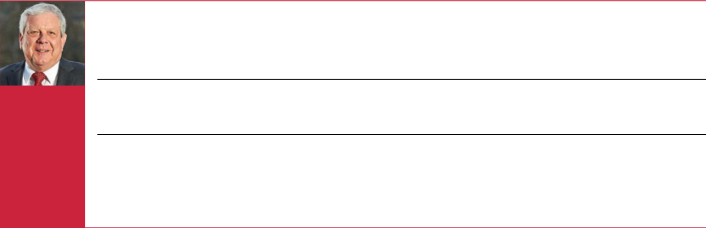

Professional Experience:

Age 70

Director since: 2009

INDEPENDENT

- Executive Chairman, President and Chief Executive Officer of First Sonora Bancshares, Inc. (a private bank holding company) and The First National Bank of Sonora, Texas (a community bank owned by First Sonora Bancshares, Inc.) since 2014
- Executive Vice President of BP p.l.c., and Chairman of the Board and President, BP America Inc. (one of the nation’s largest producers of oil and natural gas) from 2006 to 2009
- Chief Executive, BP Shipping Ltd from 2002 to 2006

Skills and Expertise:

The Board determined that Mr. Malone should be nominated for election as a Director because of his energy and natural resources industry expertise and executive leadership experience, including crisis management, safety, and performance. Additionally, Mr. Malone’s capital markets expertise is an important input into the Board’s discussions of finance and capital allocation decisions.

Other Company Directorships: Former Directorships in the Past 5 Years:

• Non-Executive Chairman of the Board of Peabody Energy • None

Corporation (since 2016) following the Company’s emergence

from bankruptcy and Director (since 2009)

• Teledyne Technologies Incorporated (since 2015)

• BP Midstream Partners GP LLC, the general partner of BP

Midstream (since 2017)⁽¹⁾

- On December 20, 2021, BP p.l.c. and it affiliates announced an agreement with BP Midstream Partners LP (BPMP) to acquire all outstanding common units of BPMP, which transaction is anticipated to close in the second quarter of 2022, at which time Mr. Malone will resign his position as a director of BP Midstream Partners GP LLC.

HALLIBURTON | 2022 Proxy Statement 19

Back to Contents

JEFFREY A. MILLER
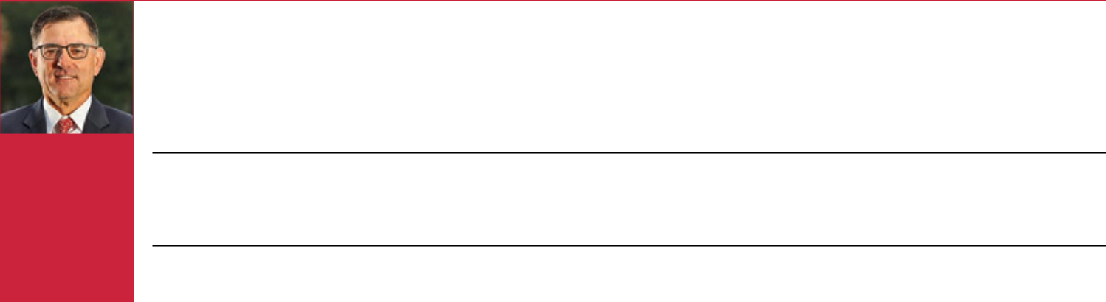

Professional Experience:

- Chairman of the Board, President and Chief Executive Officer of Halliburton since 2019

- Member of the Board of Directors, President and Chief Executive Officer of Halliburton from 2017 to 2018

- Member of the Board of Directors and President of Halliburton from 2014 to 2017

- President and Chief Health, Safety and Environment Officer from 2014 to 2017

- Various regional global leadership positions with Halliburton including in the United Arab Emirates, Indonesia, Venezuela, Angola, and the Gulf of Mexico

Age 58

Director since: 2014

CHAIRMAN, PRESIDENT AND CHIEF EXECUTIVE OFFICER

Skills and Expertise:

The Board determined that Mr. Miller should be nominated for election as a Director because of his energy industry expertise, executive and business development experience, and in-depth knowledge of Halliburton’s strategy, risks, health, safety and environment protocols, human capital management programs, and global operations.

Other Company Directorships: | Former Directorships in the Past 5 Years:
• None | • Atwood Oceanics, Inc. (2013-2017)

BHAVESH V. (BOB) PATEL
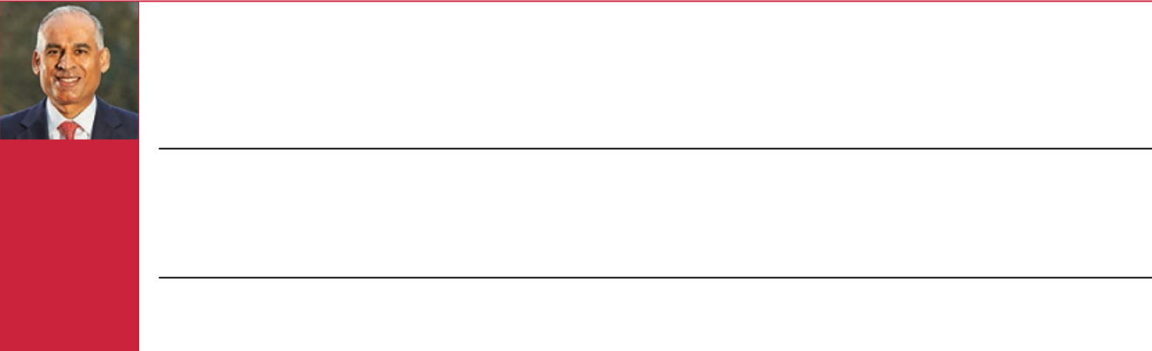

Age 55

Director since: 2021

INDEPENDENT

Professional Experience:

- Chief Executive Officer of W. R. Grace (a global leader in specialty chemicals and materials) since 2022

- Chief Executive Officer of LyondellBasell Industries from 2015 to 2021

- Senior Vice President, Olefins and Polyolefins-Americas and Executive Vice President Olefins and Polyolefins Europe, Asia, International & Technology of LyondellBasell from 2010 to 2015
- General Manager and other roles including process engineering, product development, and corporate planning at Chevron Phillips Chemical Company from 1990 to 2010

Skills and Expertise:

The Board determined that Mr. Patel should be nominated for election as a Director because of his chemical industry experience, global executive leadership skills, public company board experience, and emissions reduction and safety expertise. Mr. Patel’s experience in global commodity markets adds insight into the Board’s discussions of international operations, strategy, and risk. Additionally, Mr. Patel’s experience overseeing LyondellBasell’s emissions reduction strategy provides important context for our Board’s oversight of Halliburton’s ESG strategy.

Other Company Directorships: | Former Directorships in the Past 5 Years:
• None | • | Union Pacific Corporation (2017-2021)
 | • | LyondellBasell Industries (2018-2021)

TOBI M. EDWARDS YOUNG
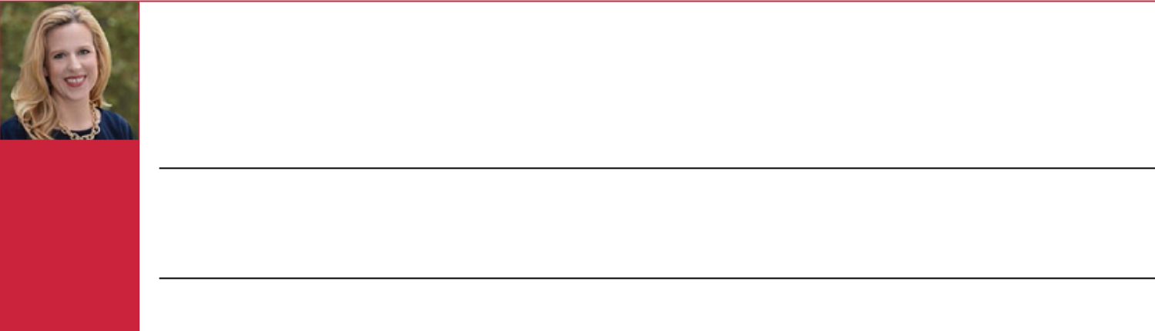

Age 46

Director since: 2022

INDEPENDENT

Professional Experience:

- Senior Vice President, Global Privacy, Government Affairs, and Chief Regulatory Attorney of Cognizant Technology Solutions (one of the world’s leading professional services companies) since 2021 and member of the Board of Directors of Cognizant Foundation, which leads Cognizant’s corporate social responsibility efforts

- Vice President, Government Affairs and Legal of Cognizant from 2020 to 2021

- Law Clerk to U.S. Supreme Court Associate Justice Neil M. Gorsuch from 2018 to 2019

- General Counsel and Board Secretary of the George W. Bush Foundation/Office of the Former President from 2009 to 2018

- Associate White House Counsel and Special Assistant to President George W. Bush from 2007 to 2008

Skills and Expertise:

The Board determined that Ms. Young should be nominated for election as a Director because of her extensive experience in policy making, compliance, governance, ESG, legal, and regulatory issues through service in the private and public sectors. Ms. Young also brings valuable knowledge in technology and digital including cybersecurity, data management, data privacy, and artificial intelligence, as well as in corporate social responsibility.

Other Company Directorships: | Former Directorships in the Past 5 Years:
• None | • None

www.halliburton.com HALLIBURTON | 2022 Proxy Statement 20

Back to Contents

Directors’ Compensation

Directors’ Fees

All non-management Directors receive an annual retainer of $115,000, which remains unchanged since 2014. The Lead Independent Director receives an additional annual retainer of $30,000, and the chair of each Committee receives an additional annual retainer for serving as chair as follows: Audit - $25,000; Compensation - $20,000; Health, Safety and Environment - $15,000; and Nominating and Corporate Governance - $15,000. Non-management Directors are permitted to defer all or part of their fees under the Directors’ Deferred Compensation Plan.

Directors’ Equity Awards

All non-management Directors receive an annual equity award with a value of approximately $185,000, which remains unchanged since 2014, consisting of restricted stock units (RSUs), each of which represents the right to receive a share of common stock at a future date. These annual awards are made in December. The actual number of RSUs is determined by dividing $185,000 by the average of the closing price of our common stock on the NYSE on each business day during the month of November. The value of the award may be more or less than $185,000 based on the methodology described above for determining the number of RSUs to be awarded and the closing price of our common stock on the NYSE on the date of the award. Non-management Directors are permitted to defer all of their RSUs under the Directors’ Deferred Compensation Plan.

Additionally, when a non-management Director first joins the Board, he or she receives an equity award shortly thereafter of RSUs equal to a prorated value of the annual equity award of $185,000. The factor used to determine the prorated award is the number of whole months of service from the beginning of the month in which Board service begins to the following first of December divided by 12. The number of RSUs awarded is determined by dividing the prorated award amount by the average of the closing price of our common stock on the NYSE on each business day during the month immediately preceding the Director joining the Board.

Directors may not sell, assign, otherwise transfer, or encumber restricted shares (which were previously granted to non-management Directors) or RSUs until the restrictions are removed. Beginning in 2020 and to align our practices with peer companies, restrictions on RSUs lapse entirely on the first anniversary of the grant date with the applicable underlying shares of common stock distributed to the non-management Director unless the Director elected to defer receipt of the shares under the Directors’ Deferred Compensation Plan. Restrictions on RSUs granted prior to 2020 lapse 25% a year over four years. If a non-management Director has a separation of service from the Board before completing the specified number of service years from the applicable award date, any unvested RSUs would be forfeited, unless the Board determines to accelerate vesting. Restrictions on restricted shares and RSUs lapse following termination of Board service only under specified circumstances, which include death or disability, retirement under the Director mandatory retirement policy, or early retirement after at least four years of service.

During the restriction period, Directors have the right to (i) vote restricted shares, but not shares underlying RSUs, and (ii) receive dividends or dividend equivalents in cash on restricted shares and RSUs that have not been deferred. RSUs that have been deferred receive dividend equivalents under the Directors’ Deferred Compensation Plan.

Directors’ Deferred Compensation Plan

The Directors’ Deferred Compensation Plan is a nonqualified deferred compensation plan and participation is completely voluntary. Under the plan, non-management Directors are permitted to defer all or part of their retainer fees and all of the shares of common stock underlying their RSUs when they vest. If a non-management Director elects to defer retainer fees under the plan, then the Director may elect to have his or her deferred fees accumulate under an interest-bearing account or translate on a quarterly basis into Halliburton common stock equivalent units (SEUs) under a stock equivalents account. If a non-management Director elects to defer receipt of the shares of common stock underlying his or her RSUs when they vest, then those shares are retained as deferred RSUs under the plan. The interest-bearing account is credited daily with interest at the prime rate of Citibank, N.A. The SEUs and deferred RSUs are credited quarterly with dividend equivalents based on the same dividend rate as Halliburton common stock and those amounts are translated into additional SEUs or RSUs, respectively.

HALLIBURTON | 2022 Proxy Statement 21

Back to Contents

After a Director’s retirement, distributions under the plan are made to the Director in a single distribution or in annual installments over a 5- or 10-year period as elected by the Director. Distributions under the interest-bearing account are made in cash, while distributions of SEUs under the stock equivalents account and deferred RSUs are made in shares of Halliburton common stock. Ms. Dicciani and Messrs. Al Khayyal, Bennett, Carroll, and Patel have deferred retainer fees under the plan. Dr. Banks, Mses. Dicciani and Hemingway Hall, and Messrs. Al Khayyal, Albrecht, Bennett, Carroll, and Patel have deferred RSUs under the plan.

Directors’ Stock Ownership Requirements

We have stock ownership requirements for all non-management Directors to further align their interests with our shareholders. As a result, all non-management Directors are required to own Halliburton common stock in an amount equal to or in excess of the greater of (i) the annual base retainer in effect on the date the non-management Director is first elected to the Board multiplied by five or (ii) $500,000. The Nominating and Corporate Governance Committee reviews the holdings of all non-management Directors, which include restricted shares, other Halliburton common stock, and RSUs owned by the Director, at each May meeting. Each non-management Director has five years to meet the requirements, measured from the date he or she is first elected to the Board. Each non-management Director currently meets the stock ownership requirements or is on track to do so within the requisite five-year period.

Director Clawback Policy

We have a clawback policy under which we will seek, in all appropriate cases, to recoup incentive compensation paid to, awarded to, or credited for the benefit of a Director, if and to the extent that:

- it is determined that, in connection with the performance of that Director’s duties, he or she breached his or her fiduciary duty by knowingly or recklessly engaging in a material violation of a U.S. federal or state law, or recklessly disregarded his or her duty to exercise reasonable oversight; or

- the Director is named as a defendant in a law enforcement proceeding for having breached his or her fiduciary duty by knowingly or recklessly engaging in a material violation of a U.S. federal or state law, the Director disagrees with the allegations relating to the proceeding, and either (i) we initiate a review and determine that the alleged action is not indemnifiable or (ii) the Director does not prevail at trial, enters into a plea arrangement, agrees to the entry of a final administrative or judicial order imposing sanctions, or otherwise admits to the violation in a legal proceeding.

The disinterested members of the Board and the disinterested members of the Compensation Committee and the Nominating and Corporate Governance Committee may be involved in reviewing, considering, and making determinations regarding the Director’s alleged conduct, whether recoupment is appropriate or required, and the type and amount of incentive compensation to be recouped from the Director.

The policy also provides that, to the extent permitted by applicable law and not previously disclosed in a filing with the SEC, we will disclose in our proxy statement the circumstances of any recoupment arising under the policy or that there has not been any recoupment pursuant to the policy for the prior calendar year. There was no recoupment under the policy in 2021.

Matching Programs

To further our support for charities, Directors may participate in the Halliburton Foundation’s matching gift programs for educational institutions, not-for-profit hospitals, and medical foundations. For each eligible contribution, the Halliburton Foundation makes a contribution of 2.25 times the amount contributed by the Director, subject to approval by its Trustees. The maximum aggregate of all contributions each calendar year by a Director eligible for matching is $50,000, resulting in a maximum aggregate amount contributed annually by the Halliburton Foundation in the form of matching gifts of $112,500 for any Director who participates in the programs. Neither the Halliburton Foundation nor we have made a charitable contribution, within the preceding three years, to any charitable organization in which a Director serves as an executive officer that exceeds in any single year the greater of $1 million or 2% of such charitable organization’s consolidated gross revenues.

The Halliburton Political Action Committee, or HALPAC, allows Directors to donate to political candidates and participate in the political process. We match the Directors’ donations to HALPAC dollar-for-dollar to a 501(c)(3) status nonprofit organization of the contributor’s choice.

www.halliburton.com HALLIBURTON | 2022 Proxy Statement 22

Back to Contents

2021 Director Compensation

 |  |  | Change in Pension Value
 | Fees Earned | Stock | and Nonqualified Deferred | All Other
 | or Paid in Cash | Awards | Compensation Earnings | Compensation | Total
Name | ($) | ($) | ($) | ($) | ($)
Abdulaziz F. Al Khayyal | 115,000 | 186,728 | 0 | 10,414 | 312,142
William E. Albrecht | 124,231 | 186,728 | 0 | 6,492 | 317,451
M. Katherine Banks | 115,000 | 186,728 | 0 | 45,341 | 347,069
Alan M. Bennett | 140,000 | 186,728 | 0 | 88,756 | 415,484
Milton Carroll | 130,000 | 186,728 | 0 | 22,899 | 339,627
Nance K. Dicciani⁽¹⁾ | 50,000 | 0 | 0 | 121,174 | 171,174
Murry S. Gerber | 135,000 | 186,728 | 0 | 116,316 | 438,044
Patricia Hemingway Hall | 115,000 | 186,728 | 0 | 116,062 | 417,790
Robert A. Malone | 145,000 | 186,728 | 0 | 118,627 | 450,355
Bhavesh V. Patel⁽²⁾ | 99,986 | 367,187 | 0 | 114,318 | 581,491

- Ms. Dicciani retired from the Board on May 19, 2021.

- Mr. Patel joined the Board on February 17, 2021. The Stock Awards for Mr. Patel involve a prorated award when he joined the Board and the grant in December received by all of the non-management Directors.

Fees Earned or Paid In Cash. The amounts in this column represent retainer fees earned in fiscal year 2021, but not necessarily paid in 2021. Refer to the section Directors’ Fees for information on annual retainer fees.

Stock Awards. The amounts in the Stock Awards column reflect the grant date fair value of RSUs awarded in 2021. We calculate the fair value of equity awards by multiplying the number of RSUs granted by the closing stock price as of the award’s grant date.

The number of restricted shares, RSUs, and SEUs held at December 31, 2021, by non-management Directors are:

Name | Restricted Shares | RSUs | SEUs
Abdulaziz F. Al Khayyal | 0 | 50,758 | 2,701
William E. Albrecht | 0 | 43,238 | 0
M. Katherine Banks | 0 | 13,387 | 0
Alan M. Bennett | 25,236 | 61,471 | 320
Milton Carroll | 20,271 | 61,471 | 6,277
Nance K. Dicciani | 0 | 23,319 | 125
Murry S. Gerber | 2,000 | 12,919 | 0
Patricia Hemingway Hall | 0 | 25,837 | 0
Robert A. Malone | 14,843 | 12,919 | 0
Bhavesh V. Patel | 0 | 15,692 | 4,480

Change in Pension Value and Nonqualified Deferred Compensation Earnings. None of the Directors had a change in pension value or nonqualified deferred compensation earnings that represented above market earnings in 2021.

All Other Compensation. This column includes compensation related to the matching gift programs under the Halliburton Foundation and for HALPAC, the Accidental Death and Dismemberment program, dividends or dividend equivalents on restricted shares or RSUs, and dividend equivalents associated with the Directors’ Deferred Compensation Plan.

HALLIBURTON | 2022 Proxy Statement 23

Back to Contents

Directors who participated in the matching gift program and the corresponding match provided by the Halliburton Foundation in 2021 are: Dr. Banks - $42,345; Mr. Bennett - $67,500; Ms. Dicciani - $112,500; Mr. Gerber - $112,500; Ms. Hemingway Hall - $112,500; Mr. Malone - $112,500; and Mr. Patel - $112,500.

Halliburton Political Action Committee matching contributions are: Mr. Albrecht - $5,000; Mr. Bennett - $5,000; and Mr. Malone - $5,000.

Non-management Directors are provided an Accidental Death and Dismemberment benefit, the annual premium for which is $155.

Directors who received dividends or dividend equivalents on restricted shares or RSUs held on Halliburton record dates are: Dr. Banks - $2,841; Mr. Bennett - $4,542; Mr. Carroll - $3,649; Ms. Dicciani - $1,636; Mr. Gerber - $3,661; Ms. Hemingway Hall - $1,177; and Mr. Malone - $5,972.

Directors who received dividend equivalents attributable to their stock equivalents account under the Directors’ Deferred Compensation Plan are: Mr. Al Khayyal - $2,575; Mr. Bennett - $6,956; Mr. Carroll - $9,493; Ms. Dicciani - $2,707; and Mr. Patel - $259.

Directors who received dividend equivalents attributable to their deferred RSUs under the Directors’ Deferred Compensation Plan are: Mr. Al Khayyal - $7,684; Mr. Albrecht - $6,337; Mr. Bennett - $9,602; Mr. Carroll - $9,602; Ms. Dicciani - $4,176; Ms. Hemingway Hall - $2,229; and Mr. Patel - $1,404.

www.halliburton.com HALLIBURTON | 2022 Proxy Statement 24

Back to Contents

Stock Ownership Information

Delinquent Section 16(a) Reports

The Company believes, based on our records and review of filings with the SEC, that during the fiscal year ended December 31, 2021, our Directors and executive officers complied with the filing requirements of Section 16(a) of the Securities Exchange Act of 1934.

Stock Ownership of Certain Beneficial Owners and Management

The following table sets forth beneficial ownership information about persons or groups that own or have the right to acquire more than 5% of our common stock, based on information contained in Schedules 13G filed with the SEC.

Name and Address | Amount and Nature of | Percent
of Beneficial Owner | Beneficial Ownership | of Class
BlackRock, Inc. | 67,462,484⁽¹⁾ | 7.5%
55 East 52nd Street, New York, NY 10055
Capital World Investors | 60,696,925⁽²⁾ | 6.8%
333 South Hope Street, 55th Fl, Los Angeles, CA 90071
State Street Corporation | 57,670,159⁽³⁾ | 6.4%
1 Lincoln Street, Boston, MA 02111
The Vanguard Group | 100,669,815⁽⁴⁾ | 11.3%
100 Vanguard Blvd, Malvern, PA 19355

- BlackRock, Inc. is deemed to be the beneficial owner of 67,462,484 shares. BlackRock has sole power to vote or to direct the vote of 58,035,658 shares and has sole power to dispose or to direct the disposition of 67,462,484 shares.

- Capital World Investors is deemed to be the beneficial owner of 60,696,925 shares. Capital World Investors has sole power to vote or to direct the vote of 60,696,925 shares and has sole power to dispose or to direct the disposition of 60,696,925 shares.

- State Street Corporation is deemed to be the beneficial owner of 57,670,159 shares. State Street Corporation has shared power to vote or to direct the vote of 52,257,277 shares and has shared power to dispose or to direct the disposition of 57,475,992 shares.

- The Vanguard Group is deemed to be the beneficial owner of 100,669,815 shares. The Vanguard Group has sole power to dispose or to direct the disposition of 97,163,522 shares. The Vanguard Group has shared power to vote or to direct the vote of 1,379,149 shares and has shared power to dispose or to direct the disposition of 3,506,293 shares.

HALLIBURTON | 2022 Proxy Statement 25

Back to Contents

The following table sets forth information, as of March 16, 2022, regarding the beneficial ownership of our common stock by each Director, each Named Executive Officer, and by all Directors and executive officers as a group.

Amount and Nature of Beneficial Ownership

Name of Beneficial Owner or

Number of Persons in Group

Sole Voting | Shared
and | Voting or
Investment | Investment | Percent of
Power⁽¹⁾ | Power | Class

Abdulaziz F. Al Khayyal | 0 | *
William E. Albrecht | 16,000 | *
M. Katherine Banks | 18,618 | *
Alan M. Bennett | 27,236 | *
Eric J. Carre | 292,199 | *
Milton Carroll | 20,271 | *
Earl M. Cummings | 5,600 | *
Murry S. Gerber | 551,911 | *
Patricia Hemingway Hall | 6,299 | *
Lance Loeffler | 216,281 | *
Robert A. Malone | 58,718 | *
Jeffrey A. Miller | 1,547,128 | *
Bhavesh V. Patel | 10,000 | *
Joe D. Rainey | 687,799 | *
Mark J. Richard | 410,085 | *
Tobi M. Edwards Young | 0 | *
Shares owned by all current Directors and executive officers as a group (22 persons) | 5,166,173 | *

- Less than 1% of shares outstanding.

- The table includes shares of common stock eligible for purchase pursuant to outstanding stock options within 60 days of March 16, 2022, for the following: Mr. Carre – 157,209; Mr. Loeffler – 80,600; Mr. Miller – 639,200; Mr. Rainey – 316,500; Mr. Richard – 150,273; and six unnamed executive officers – 500,405. Until the options are exercised, these individuals will not have voting or investment power over the underlying shares of common stock, but will only have the right to acquire beneficial ownership of the shares through exercise of their respective options. The table also includes restricted shares of common stock over which the individuals have voting power but no investment power.

www.halliburton.com HALLIBURTON | 2022 Proxy Statement 26

Back to Contents

Proposal No. 2 Ratification of Selection of Principal Independent Public Accountants

The Audit Committee is responsible for the appointment, compensation, retention, oversight of the work, and evaluation of the principal independent public accountants retained to audit our financial statements. The Audit Committee and Board have approved the selection of KPMG LLP as our principal independent public accountants to examine our financial statements and books and records for the year ended December 31, 2022, and a resolution will be presented at the Annual Meeting to ratify this selection. The Audit Committee and Board believe that the continued retention of KPMG to serve as our principal independent public accountants for the year ended December 31, 2022, is in the best interests of Halliburton and our shareholders. Representatives of KPMG are expected to be present at the Annual Meeting and be available to respond to appropriate questions from shareholders.

KPMG began serving as our principal independent public accountants for the year ended December 31, 2002. The Audit Committee routinely reviews the performance and retention of our independent public accountants, including an evaluation of service quality, the nature and extent of non-audit services, and other factors required to be considered when assessing independence from Halliburton and its management. The Audit Committee also periodically considers whether there should be a rotation of the principal independent public accountants and is involved in the selection of the Principal Independent Public Accountants’ lead engagement partner and the mandated rotation process of such partner.

The affirmative vote of the holders of a majority of the shares of our common stock represented at the Annual Meeting and entitled to vote on the matter is needed to approve the proposal.

If the shareholders do not ratify the selection of KPMG, the Board will reconsider the selection of independent public accountants.

THE BOARD OF DIRECTORS RECOMMENDS A VOTE FOR RATIFICATION OF THE APPOINTMENT OF KPMG LLP AS PRINCIPAL INDEPENDENT PUBLIC ACCOUNTANTS TO EXAMINE OUR FINANCIAL STATEMENTS AND BOOKS AND RECORDS FOR THE YEAR ENDING DECEMBER 31, 2022.

HALLIBURTON | 2022 Proxy Statement 27

Back to Contents

Audit Committee Report

We operate under a written charter, a copy of which is available on Halliburton’s website at www.halliburton.com. As required by the charter, we review and reassess the charter annually and recommend any changes to the Board for approval. We are also mindful of the observations provided in the Securities and Exchange Commission’s Statement on Role of Audit Committees in Financial Reporting and Key Reminders Regarding Oversight Responsibilities.

Halliburton’s management is responsible for preparing Halliburton’s financial statements and the principal independent public accountants are responsible for auditing those financial statements. The Audit Committee’s role is to provide oversight of management in carrying out management’s responsibility and to appoint, compensate, retain, oversee the work of, and evaluate the principal independent public accountants. The Audit Committee is not providing any expert or special assurance as to Halliburton’s financial statements or any professional certification as to the principal independent public accountants’ work.

In fulfilling our oversight role for the year ended December 31, 2021, we:

- reviewed and discussed Halliburton’s audited financial statements with management;

- discussed with KPMG LLP, Halliburton’s principal independent public accountants, the matters required by Auditing Standard 1301 relating to the conduct of the audit;

- received from KPMG the written disclosures and the letter required by the Public Company Accounting Oversight Board regarding KPMG’s independence;

- evaluated KPMG’s service quality; and

- discussed with KPMG its independence and reviewed other matters required to be considered under Securities and Exchange Commission rules regarding KPMG’s independence.

Based on the foregoing, we recommended to the Board that the audited financial statements be included in Halliburton’s Annual Report on Form 10-K for the fiscal year ended December 31, 2021, for filing with the Securities and Exchange Commission.

THE AUDIT COMMITTEE

M. Katherine Banks

Alan M. Bennett

Murry S. Gerber

Bhavesh V. Patel

www.halliburton.com HALLIBURTON | 2022 Proxy Statement 28

Back to Contents

Fees Paid to KPMG LLP

During 2020 and 2021, we incurred the following fees for services performed by KPMG LLP.
 |  | 2020 |  | 2021
 | (In millions) |  | (In millions)
Audit fees | $ | 10.7 | $ | 9.3
Audit-related fees |  | 0.2 |  | 0.5
Tax fees |  | 0.6 |  | 0.6
All other fees |  | — |  | 0.4
TOTAL | $ | 11.5 | $ | 10.8

Audit Fees

Audit fees represent the aggregate fees for professional services rendered by KPMG for the integrated audit of our annual financial statements for the fiscal years ended December 31, 2020, and December 31, 2021. Audit fees also include the audits of many of our subsidiaries in regards to compliance with statutory requirements in foreign countries and reviews of our financial statements included in the Forms 10-Q we filed during fiscal years 2020 and 2021.

Audit-Related Fees

Audit-related fees were incurred for assurance and related services that are traditionally performed by the independent public accountants. These services primarily include attestation engagements required by contractual or regulatory provisions.

Tax Fees

The aggregate fees for tax services primarily consisted of international tax compliance and tax return services related to our expatriate employees. In 2020, tax compliance and preparation fees total $0.2 million and tax advisory fees total $0.4 million, and in 2021, tax compliance and preparation fees total $0.2 million and tax advisory fees total $0.4 million.

All Other Fees

All other fees are comprised of professional services rendered by KPMG related to nonrecurring miscellaneous services.

Fee Approval Policies and Procedures

The Audit Committee has established a written policy that requires the approval by the Audit Committee of all services provided by KPMG as the principal independent public accountants that examine our financial statements and books and records and of all audit services provided by other independent public accountants. Prior to engaging KPMG for the annual audit, the Audit Committee reviews a Principal Independent Public Accountants Auditor Services Plan. KPMG then performs services throughout the year as approved by the Committee. KPMG reviews with the Committee, at least quarterly, a projection of KPMG’s fees for the year. Periodically, the Audit Committee approves revisions to the plan if the Committee determines changes are warranted. Our Audit Committee also considered whether KPMG’s provision of tax services as reported above were compatible with maintaining KPMG’s independence as our principal independent public accountants. All of the fees described above for services provided by KPMG were approved in accordance with the policy.

HALLIBURTON | 2022 Proxy Statement 29

Back to Contents

Proposal No. 3 Advisory Approval of Executive

Compensation

Pursuant to Section 14A of the Securities Exchange Act of 1934, our shareholders are being presented with the opportunity to vote to approve, on an advisory basis, the compensation of our Named Executive Officers (NEOs) as disclosed in this proxy statement. As reaffirmed by our shareholders at the 2017 Annual Meeting of Shareholders, consistent with our Board’s recommendation, we are submitting this proposal for a non-binding vote on an annual basis.

As described in detail under Compensation Discussion and Analysis, our executive compensation program is designed to attract, motivate, and retain our NEOs, who are critical to our success. Under the program, our NEOs are rewarded for the achievement of specific annual, long-term, and strategic goals, corporate goals, and the realization of increased shareholder returns. Please read Compensation Discussion and Analysis for additional details about our executive compensation program, including information about the fiscal year 2021 compensation of our NEOs and our Board’s ongoing commitment to ensure that our program aligns with our long-term strategy and shareholder value creation.

The Compensation Committee continually reviews the compensation program for our NEOs to ensure the program achieves the desired goals of aligning our executive compensation structure with our shareholders’ interests and current market practices. We believe our executive compensation program achieves the following objectives identified under Compensation Discussion and Analysis:


- Provide a clear and direct relationship between executive pay and our performance on both a short-term and long-term basis;

- Target market competitive pay levels with a comparator peer group;

- Emphasize operating performance drivers;

- Link executive pay to measures that drive shareholder returns;

- Support our business strategies; and

- Maximize the return on our human resource investment.

We are asking our shareholders to indicate their support for our NEOs’ compensation as described in this proxy statement and vote “FOR” the following resolution at the Annual Meeting: “RESOLVED, that the compensation paid to Halliburton’s Named Executive Officers, as disclosed in this proxy statement pursuant to Item 402 of Regulation S-K, including the Compensation Discussion and Analysis, compensation tables, and narrative discussion, is hereby approved.”

Our Board and our Compensation Committee value the opinions of our shareholders. The say-on-pay vote is advisory and, therefore, not binding on us, our Board, or our Compensation Committee. However, the Compensation Committee considers shareholder feedback in its ongoing review of our executive compensation program.

THE BOARD OF DIRECTORS RECOMMENDS A VOTE FOR THE APPROVAL, ON AN ADVISORY BASIS, OF THE COMPENSATION OF OUR NAMED EXECUTIVE OFFICERS.

Compensation Committee Report

We have reviewed and discussed the Compensation Discussion and Analysis with Company management and, based on such review and discussion, we recommended to the Board that the Compensation Discussion and Analysis be included in this proxy statement.

THE COMPENSATION COMMITTEE

William E. Albrecht

Milton Carroll

Murry S. Gerber

Patricia Hemingway Hall

Robert A. Malone

www.halliburton.com HALLIBURTON | 2022 Proxy Statement 30

Back to Contents

Compensation Discussion and Analysis

To Our Valued Shareholders:

April 5, 2022

“Our executive compensation program has evolved dramatically over the last few years. With your feedback, we have built a solid and responsible compensation platform to support a stable, high-performing executive leadership team committed to creating long-term shareholder value and driving sustainable, safe, and reliable energy solutions through any market conditions.”

Murry S. Gerber

Chair of the Compensation Committee

At Halliburton, we listen and respond. It is the Board’s priority to ensure that we hear your concerns, answer your questions, and respond to your feedback on all aspects of our business. This includes our executive compensation program, which has been a key area of focus for the last several years.

Our primary goal as a Compensation Committee is simple: to put forth a strongly supported executive compensation program that aligns the interests of our shareholders and executives and that’s well understood. In recent years, the valuable feedback we’ve received from you, as well as from the proxy advisory firms and independent consultants, has resulted in substantial changes and meaningful progress toward this goal. But after last year’s say-on-pay advisory vote result, and what we learned from a year of intense shareholder outreach and engagement efforts (described in detail on page 32), we know we can do better.

In 2021, we initiated a heightened, Board-driven shareholder outreach and engagement campaign. Through this intensified effort, we learned that most of our largest shareholders understand the methodology behind our program and strongly support the changes implemented in 2019 and 2020. We welcomed suggestions for increased emphasis on ESG-related metrics and additional progress on our communications. But this two-year transition period still left some with questions and confusion around the shift in our performance award structure and the presentation in the Summary Compensation Table. To help clarify this complicated issue, we spent significant time on this topic in our investor presentation materials and during our face-to-face video conferences, especially since we are faced with this issue for one more year as described in this proxy statement.

This proxy statement has been updated with the aim to clearly and accurately describe our program so that all our investors can cast their say-on-pay advisory votes based on an informed analysis. We also want you to have a complete view of how your feedback has influenced — and driven — the design of our program over the years, including two key changes we’ve approved for 2022: implementing ESG metrics in our Annual Performance Pay Plan and aligning the timing of restricted stock and performance unit grants for long-term incentives. On pages 33-34, Murry S. Gerber, the Chair of our Compensation Committee, addresses recent questions we’ve received from our shareholders to provide additional clarity around the rationale for our approach to executive pay. And, on pages 35-36, we offer a closer look at CEO pay and share key content from the investor presentation materials we used during our 2021 engagement campaign to address the complexities in our Summary Compensation Table.

We appreciate the care you will take in reading this year’s Compensation Discussion and Analysis (CD&A). We are confident it will demonstrate that our program is designed to align the interests of our executives with our long-term shareholders, is dutifully governed, and well-positioned to continue to attract, engage, and retain the high-caliber leadership talent needed to lead Halliburton through today’s demands for energy and well into the future.

Sincerely,

The Compensation Committee of the Board of Directors

William E. Albrecht
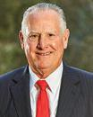

Milton Carroll
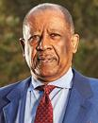

Murry S. Gerber


Patricia

Hemingway Hall


Robert A. Malone
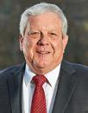

HALLIBURTON | 2022 Proxy Statement 31

Back to Contents

Enhancing Our Shareholder Outreach and Board Activity

Halliburton prioritizes open communications with its shareholders. Our ongoing, open dialogue helps ensure that the Board and management have a regular pulse on investors’ views and also provides valuable feedback on how we can continue to improve.

After the 2021 Annual Meeting, the Board recognized the need to take its shareholder engagement activity to a new level. We actively engaged with the majority of Halliburton’s shareholders, including many that hadn’t been reached in the past. They were invited to join the Chair of the Compensation Committee or our Lead Independent Director, and members of senior management, in face-to-face video conferences. Prior to each conference, we provided materials highlighting the latest information on our executive compensation program; Board oversight and governance; health, safety and the environment; diversity, equity and inclusion; and our approach to energy transition with Halliburton Labs. We also shared these materials with the shareholders that declined our invitation to meet with us. By the end of 2021, we communicated with shareholders collectively representing approximately 60% of our outstanding shares and had video call engagements with shareholders representing about 40% of our shares. These efforts were in addition to the 13 sell-side investor conferences, 3 roadshows, and about 300 investor meetings that are all part of our regular shareholder outreach cadence.

At the same time, the Board initiated an extensive internal review of the executive compensation program, with support from its independent compensation consultant, to determine if further program adjustments were needed. With the significant changes made in 2019 and 2020, along with validation of these changes from wide-ranging shareholder dialogues, the Compensation Committee determined that the overall structure of the redesigned program is sound, responsible, and fairly aligns the interests of both our shareholders and executives. However, there was opportunity for improvements, including aligning the timing of restricted stock and performance unit grants for long-term incentives and adding ESG-related metrics in measuring annual performance, both of which have been implemented for 2022. Moreover, we recognized the need to better describe the key components of our program, the changes we have made, and how these changes are reflected in the Summary Compensation Table.

Below is a summary of what we’ve heard from shareholders as part of our engagement activities over the last few years, and the actions we’ve taken regarding NEO compensation, as we considered and addressed the feedback.

Shareholders were seeking:

- Increased emphasis on free cash flow and capital discipline

- Additional long-term performance component directly linked to stock price

- More emphasis on performance-based long-term incentives

- A balance between cash and equity for PUP awards

- Increased emphasis on ESG-related metrics

- Clarity on timing of long-term incentive award grants

- Rationale for long-term incentive awards based on 100% relative performance and allowing for maximum payouts when returns are negative

 |  |  | Plan Design Changes & Other Actions
 | 2019 |  | 2020 | 2022
Eliminated stock grants for internal |  |  | Eliminated stock options that were | Introduced sustainability and Diversity,
promotions |  |  | previously 15% of long-term incentives | Equity & Inclusion (DE&I) metrics under
Implemented double-trigger vesting |  |  | and reduced weight of time-based | the Annual Performance Pay Plan
 |  |  | restricted stock from 35% to 30%. | • 20% of total award (weighted equally)
provision upon change-of-control |  |  | restricted stock from 35% to 30%. | • 20% of total award (weighted equally)
 |  |  | Increased weight of performance units | Moved grants of restricted stock from
Eliminated executive perquisites |  |  | Increased weight of performance units | Moved grants of restricted stock from
 |  |  | from 50% to 70% | Moved grants of restricted stock from
 |  |  | from 50% to 70% | December to January to align with grants
including: |  |  | from 50% to 70% | December to January to align with grants
 |  |  | Changed performance unit mix from 100% | of performance units
• Country club membership dues |  |  | Changed performance unit mix from 100% | of performance units
 |  |  | cash to 50% cash and 50% performance
• | Financial planning |  | cash to 50% cash and 50% performance | Added to this CD&A answers to
• |  |  | shares | Added to this CD&A answers to
• | Executive physicals |  | shares | representative shareholder questions from
• Tax gross ups for personal use of |  |  | Added relative TSR modifier metric for | Murry S. Gerber, the Chair of our
 | corporate aircraft |  | determining long-term performance-based | Compensation Committee, to provide
 |  |  | awards | additional clarity around the rationale for
 |  |  | Modified short-term incentive metrics to | our approach to executive pay (see pages
 |  |  | Modified short-term incentive metrics to | 33-34)
 |  |  | increase emphasis on free cash flow and | 33-34)
 |  |  | capital discipline | Added disclosure to explain increase in
 |  |  |  | CEO Summary Compensation Table
 |  |  |  | compensation resulting from the 2020
 |  |  |  | changes to our long-term incentive
 |  |  |  | program (see page 36)
www.halliburton.com |  |  |  | HALLIBURTON | 2022 Proxy Statement 32

Back to Contents

Straight from the Boardroom: Talking with Murry S. Gerber


Over the last few years, robust discussions with investors have led to meaningful and well-received changes to our executive compensation program. After the May 2021 say-on-pay advisory vote results, we reinvested in and refreshed our investor outreach efforts. Through direct shareholder engagement, we received excellent questions and feedback about aspects of our program. Below are the answers to representative shareholder questions from Murry S. Gerber, Chair of our Compensation Committee:

- What steps did you take to enhance your shareholder outreach and engagement efforts?

- During 2021, our Board directed a complete review and renewal of our approach to shareholder outreach and engagement. Our goal was to have substantive discussions with as many of our shareholders as possible, both active and passive, about all aspects of our program, and bring that feedback to our full Board. With a fresh approach and new outside input, we thoroughly reworked our presentation materials to focus on the most pressing shareholder concerns, primarily related to executive compensation and ESG. We also expanded the scope of our one-on-one engagements by adding Bob Malone, our Lead Director, to our outreach team that previously included myself and senior management. To enhance transparency and outreach, we provided our presentation and a commitment to follow up with those shareholders who could not engage directly with us. Several asked for a meeting after reviewing the presentation.

All this effort and these changes resulted in the most expansive shareholder outreach effort in Halliburton’s history and gave us a new perspective on important issues for the Board to consider. We will continue this refreshed approach in 2022 and beyond.

- How is measuring long-term performance using 100% relative Return on Capital Employed (ROCE) — and not a mix of absolute and relative metrics — in the best interests of shareholders?

- At Halliburton, we compete to win. Any company can perform well when markets are favorable, but only the best companies can outperform when market conditions are difficult. Our Board has directed Jeff Miller and his team to execute on strategies that drive superior returns (ROCE) — regardless of market conditions. Simply stated, we expect outperformance from Halliburton in all market scenarios and this expectation drives our thoughtful and disciplined deployment of capital.

Shareholders have historically agreed with this philosophy and supported us in 2015 when we changed long-term incentives from a mix of absolute and relative ROCE metrics to an exclusively relative ROCE metric.

HALLIBURTON | 2022 Proxy Statement 33

Back to Contents

- Why does your Performance Unit Plan (PUP) allow for maximum pay-outs when returns are negative? Why don’t you “cap” pay-outs?

- The Board believes a cap on long-term incentive awards in a highly volatile business like ours is a significant disincentive. Extreme stock price volatility driven by factors beyond management’s control is a consistent theme in our industry. We must balance this reality with our goal to keep senior management focused on driving superior performance against our Performance Peer Group, especially through business down cycles, so we remain strongly positioned when the markets rebound.

- Is it appropriate that the PUP has paid out at maximum?

- Our incentive plans work together to help ensure that our executives’ target incentive opportunities are reasonable across economic cycles and that the actual incentive pay-outs deliver appropriate levels of value based on a mix of absolute and relative performance results. That’s why when the Board assesses pay, we reflect on the sum of annual and long-term incentives.

Our PUP plan is designed to ensure long-term superior relative ROCE versus a specific energy peer group and the Board expects senior management to maintain those strong relative returns. Recently, our relative ROCE has consistently been in the top quartile of our Performance Peer Group, resulting in strong pay-outs in those PUP cycles. But our Annual Performance Plan is affected by difficult-to-predict market price and demand variations, which can lead to less consistent award pay-outs. Taken together, the sum of pay-outs to management from the incentive plans has provided competitive pay.

- Why is Mr. Miller’s 2020 and 2021 reported pay so much higher than his 2019 reported pay?

- This question has provoked more confusion than we thought it would. I am sorry about that. I assure you the Board’s intentions are in alignment with shareholder feedback and the strong support we received for the new design of our program. The confusion comes in two parts:

First, Jeff Miller’s pay increased from 2019 due to his promotion to CEO.

Second, in 2020, the Board decided (supported by shareholder feedback) to restructure the PUP to significantly reduce the cash part of any award. The new plan pays awards, if any, using a mix of stock (50%) and cash (50%). The prior plan paid entirely in cash.

This change, which shareholders overwhelmingly supported, created a reporting challenge. Specifically, the proxy statement rules require cash awards to be booked on receipt, while stock awards are booked on grant date. In simple terms, the proxy statement rules require two cycles of PUP compensation to be reported in one year. Starting on page 36 of the Compensation Discussion and Analysis, we present more information about this issue with illustrations of the transition.

The transition ends with this 2022 proxy statement and will not reappear in the 2023 proxy statement.

- What was your approach to setting performance targets for the 2021 Annual Performance Pay Plan?

- Given the continuing business challenges driven by the COVID-19 pandemic, the Board decided at the outset of 2021 that it would replace the traditional 12-month performance period with two six-month performance periods: January 1, 2021, through June 30, 2021 (1st performance period); and July 1, 2021, through December 31, 2021 (2nd performance period). Given the economic uncertainty, this half-year plan approach provided the Board the agility mid-year to ensure that the performance goals for the 2nd performance period were appropriately rigorous. Specifically, the Board set the 2nd half performance goals higher than both the maximum performance goals and actual results for the 1st performance period. The approach worked because during these uncertain times had the Board set a 12-month performance goal, it would have been lower than what we set for each of the two six-month periods, which were higher goals.

- How does ESG influence executive compensation decisions?

- The Board expects our senior executives to lead by example and drive results on both our principal financial and strategic objectives. Effective January 1, 2022, the Annual Performance Pay Plan includes ESG-related metrics focused on sustainability and DE&I, two of our main strategic priorities. ESG-related metrics will comprise 20% of the total award (weighted equally), while 80% of the total award will continue to focus on the achievement of NOPAT and Asset Turns performance goals. As part of adding ESG-related metrics, we also listened to shareholder feedback and set objective metrics that are clearly measurable and directly linked to our overall strategy.

www.halliburton.com HALLIBURTON | 2022 Proxy Statement 34

Back to Contents

2021 CEO Compensation Overview

Target vs. Realized Pay

The Compensation Committee looks at CEO compensation through various lenses to ensure that it is setting appropriate and competitive total target compensation opportunities and approving actual compensation outcomes that are aligned with actual performance results and shareholder expectations. This type of analysis is important to study, especially when plan designs are transitioning from one approach to a new approach — like shifting from all cash awards to a mix of cash and equity.

Total target compensation is structured to target market competitive pay levels in base salary and short- and long-term incentive opportunities. An

emphasis is placed on variable pay at risk, which enables the compensation structure to position actual pay above or below the 50th percentile of our Comparator Peer Group depending on performance. Total target compensation opportunities are set by the Compensation Committee at the beginning of each performance period and are intended to be forward looking. Since 2018, Mr. Miller’s first full year as CEO, his target compensation has increased commensurate with the market and is appropriately aligned with his role and responsibilities as CEO, as well as his individual performance.

Realized pay represents the amount of compensation actually paid during the year, as opposed to amounts that may or may not be paid in the future. Realized pay incorporates the amounts actually received during the year upon the vesting of restricted stock and the exercise of stock options. Evaluating realized pay provides the Compensation Committee with an additional measure to assess the robustness of our pay for performance. Realized pay demonstrates the positive correlation between high cash and equity payouts in years of strong performance and low cash and equity payouts in years of weak performance. In the illustration below, total realized pay consisted of the following:

- base salary paid;

- cash incentive payouts under the Halliburton Annual Performance Pay Plan;

- value realized upon exercise of stock options;

- value of restricted stock vested during the year; and

- incentive payouts under the Performance Unit Program.

From 2019 to 2021, Mr. Miller’s realized pay was consistently lower than total target compensation, demonstrating the “at-risk” nature of a substantial portion of his compensation and our program’s pay-for-performance design. Our compensation programs are designed to closely align our executives’ interests to those of our shareholders and to the long-term performance of the Company. A significant portion of executive pay is delivered in the form of long-term incentives with strong alignment to the stock price returns our shareholders’ experience. As shown in the below chart, our CEO’s average three-year realized pay has declined by a greater extent than the Company’s TSR, demonstrating this alignment and the Compensation Committee’s commitment to pay-for-performance.
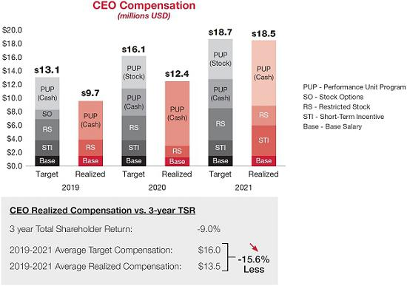

HALLIBURTON | 2022 Proxy Statement 35

Back to Contents

A Closer Look at the Summary Compensation Table

To understand the increase in CEO Summary Compensation Table compensation for 2021, there were two key factors to consider:

- Mr. Miller’s promotion to CEO, which increased his target market competitive pay levels, primarily impacting the amount earned under the Performance Unit Program (PUP) in 2020 and 2021 as compared to 2019; and

- Based on shareholder feedback, we fundamentally changed the structure of our long-term incentives. As a result, we are required to report two cycles of the performance awards for 2020 and 2021 in the 2021 and 2022 proxy statements, respectively. Because we are required to show for each year the cash awards actually earned and the performance-based equity awards granted, though not yet earned, the total compensation presented in our Summary Compensation Table appears “inflated” or “double counted” for 2020 and 2021 – when cash awards under our old performance structure were earned and equity awards under our revised structure were granted even though the equity cannot be earned until future years, if at all. Had we maintained our old performance award structure and the PUP continued to be awarded 100% in cash, the awards would be reflected in the Summary Compensation Table only at the time they are earned and this issue would not occur.

As an example, in the 2021 proxy statement the Summary Compensation Table included both the cash earned in 2020 for the 2018 PUP cycle and target level equity granted for the 2020 PUP cycle, resulting in an additional $5M reported in the Stock Awards column of the Summary Compensation Table that remained subject to performance vesting. And in the 2022 proxy statement the Summary Compensation Table includes both the cash earned for the 2019 PUP cycle and target level equity granted for the 2021 PUP cycle, resulting in an additional $6.3M reported in the Stock Awards column of the Summary Compensation Table that remained subject to performance vesting. Following the 2021 plan year and the 2022 proxy statement, this “double counting” issue of the compensation reported in the Summary Compensation Table will no longer occur.

The $17.3M reflected in both tables is aligned with the total compensation for Mr. Miller as determined by the Compensation Committee when setting his compensation.
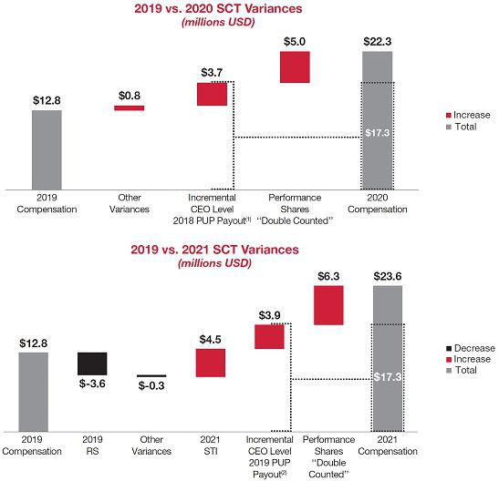

- Amount reflects the change in the 2018 cycle PUP award payout as compared to the 2017 cycle of the PUP. This increase in target compensation for the 2018 PUP was commensurate with Mr. Miller’s promotion from COO to CEO.

- Amount reflects the change in the 2019 cycle PUP award payout as compared to the 2017 cycle of the PUP. This increase in target compensation for the 2019 PUP was commensurate with Mr. Miller’s promotion from COO to CEO.

www.halliburton.com HALLIBURTON | 2022 Proxy Statement 36

Back to Contents

Individual Performance Highlights

The following summarizes Mr. Miller’s individual performance highlights for 2021:

LEADERSHIP AND VISION

- Led the organization through a transitional year as the industry began an uneven recovery from the global COVID-19 pandemic

- Prioritized stakeholder communication and maintained high visibility with employees, shareholders, and customers

- Facilitated the addition of one new Board member

INTEGRITY

- Stressed and upheld Halliburton’s Code of Business Conduct (COBC) as non-negotiable at all levels throughout the organization

- Continued to prioritize and advocate for the Local Ethics Officer (LEO) program, which continues to be at the cutting edge of compliance initiatives

- Led efforts and underscored the importance of making significant progress on increasing gender and ethnic/racial diversity, inclusion, and respect, all core elements of our COBC and imperative to the culture within Halliburton

KEEPING THE BOARD INFORMED

- Communicated regularly with the Board, providing updates on business issues and providing unfettered access to management and subject matter experts

- Led the Board in sharpening its focus on ESG oversight

PERFORMANCE OF THE BUSINESS

- Consistently strengthened our balance sheet, reducing gross debt by $1.2 billion during the pandemic

- Generated over $1.3 billion of free cash flow in 2021, demonstrating our ability to generate strong free cash flow in different business environments

- Outperformed primary competitors on ROCE

- Maintained unwavering commitment to our Health, Safety and Environment program

DEVELOP AND IMPLEMENT INITIATIVES THAT PROVIDE LONG-TERM ECONOMIC BENEFITS

- Continued Company focus on evolving market trends and advancing digitalization and automation

- Continued to institutionalize Continuous Improvement which drives profitability, capacity, and greater flexibility

- Executed key steps to increase environmental, social, and governance focus

ACCOMPLISHMENT OF STRATEGIC OBJECTIVES

- Deployed key future technologies demonstrating focus on structural capital efficiency

- Delivered the industry’s first full electric completion operation providing unprecedented operational control and precision

- Advanced a sustainable energy future through published science-based emission reduction targets; the addition of eleven new companies to Halliburton Labs which are focused on energy generation, storage, conservation, and industrial decarbonization; and Halliburton’s being named to the Dow Jones Sustainability Index highlighting the top 10% most sustainable companies in each industry

DEVELOPMENT OF MANAGEMENT

- Increased management exposure to the Board via spotlight presentations, continued commitment to our robust succession management process, and remained focused on talent development with an emphasis on diversity, equity, inclusion, and respect initiatives

HALLIBURTON | 2022 Proxy Statement 37

Back to Contents

2021 Performance Overview

Business Highlights

Our employees delivered solid execution across every part of our business in 2021 – safety, service quality, and financial results. Despite the challenges of working during a pandemic and global energy demand complexity, they again outperformed and delivered what the world needs – affordable and reliable energy provided by oil and gas – in a safe, efficient, and ethical manner – while minimizing our environmental impact. Here are the highlights for 2021:

- Financial: Internationally we delivered profitable growth with revenue and operating income increasing every quarter in 2021. In North America, strong operating leverage allowed us to maximize the value of our business as U.S. land activity rebounded. Overall, our Completion and Production and Drilling and Evaluation operating segments finished the year with 15% and 12% operating margins, respectively, and generated strong cash flows from operations.

- Digital: Our accelerated deployment and integration of digitally enabled technologies created technical differentiation in the market and contributed to our higher margins.

- Capital efficiency: We advanced technologies and made strategic choices that kept our capital expenditures to 5.2% of revenue, which is in the range of our 5-6% of revenue target.

- Sustainable energy: We announced our science-based emission reduction targets, added eleven new participating companies to Halliburton Labs, our clean energy accelerator, and were named to the Dow Jones Sustainability Index North America for Energy Equipment and Services, which highlights the top 10% most sustainable North America companies in identified industries as determined by S&P Global through their Corporate Sustainability Assessment.

Geographic Revenue Diversity

In 2021, Halliburton earned the majority of our revenue internationally. We reset our earnings power and improved margins in several key end markets.
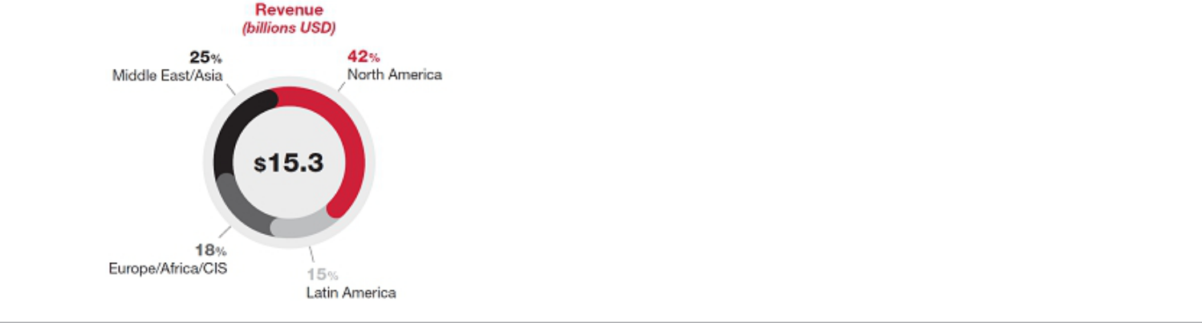

Cash Flow Execution

During 2021, we generated $1.9 billion of operating cash flow and had $799 million of capital expenditures and $257 million of proceeds from sales of property, plant, and equipment, resulting in over $1.3 billion of free cash flow. This demonstrates our ability to generate strong free cash flow in different business environments. We additionally returned $161 million to shareholders through dividends and repaid $700 million of debt.
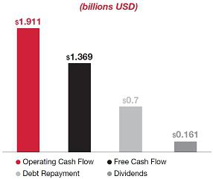

* Management believes that free cash flow, defined as “operating cash flow” less “capital expenditures” plus “proceeds from sale of property, plant, and equipment” is an important liquidity measure that is useful to investors and management for assessing the business’s ability to generate cash.

www.halliburton.com HALLIBURTON | 2022 Proxy Statement 38

Back to Contents

Debt Reduction Progress

Halliburton has strengthened our balance sheet, reducing gross debt by $1.2 billion during the pandemic, with another $600 million reduction in the first quarter of 2022.
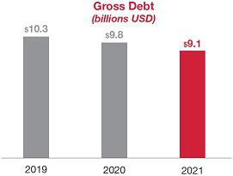

We delivered superior ROCE performance over the one-, three-, and five-year periods ending December 31, 2021, relative to the Oilfield Services Index (OSX), our two largest competitors, and our Performance Peer Group. The details are depicted in the chart below:
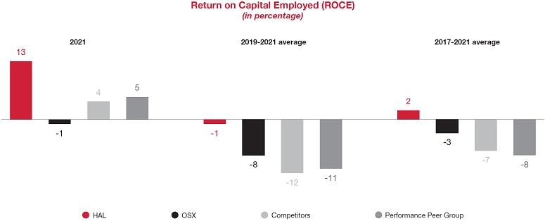

HALLIBURTON | 2022 Proxy Statement 39

Back to Contents

The Foundation of Our Executive Compensation Program

2021 Named Executive Officers

Name | Age | Occupation
Jeffrey A. Miller | 58 | Chairman, President and Chief Executive Officer
Lance Loeffler | 45 | Executive Vice President and Chief Financial Officer
Eric J. Carre | 56 | Executive Vice President – Global Business Lines
Joe D. Rainey | 65 | President – Eastern Hemisphere
Mark J. Richard | 60 | President – Western Hemisphere

Our Executive Compensation Program Objectives

Our executive compensation program is designed to achieve the following objectives:

- Provide a clear and direct relationship between executive pay and our performance on both a short-term and long-term basis;

- Target market competitive pay levels with a comparator peer group;

- Emphasize operating performance drivers;

- Link executive pay to measures that drive shareholder returns;

- Support our business strategies; and

- Maximize the return on our human resource investment.

Good Compensation Governance Practices At-A-Glance

What We Do |  | What We Don’t Do
Use mix of relative and absolute financial metrics |  | No repricing of underwater stock options
The majority of total direct compensation opportunity is performance- |  | No excessive perquisites
based, at-risk, and long-term
Deliver rewards that are based on the achievement of long-term |  | No guaranteed bonuses or uncapped incentives
objectives and the creation of shareholder value


Maintain a clawback policy in the event of a material financial restatement or fraud

Maintain robust executive and Director stock ownership requirements Use an independent, external compensation consultant
Benchmark against a relevant group of peer companies

Rigorous oversight of incentive metrics, goals, and pay-for-performance relationship


No single trigger vesting upon a change of control (applicable to awards to NEOs for 2019 forward)

No excise tax gross-ups

No hedging or pledging of company securities by executives and Directors
No buyout or exchange of underwater options

No special or one-time stock grants for internal promotions

Hold an annual say-on-pay vote |  |  | No liberal share counting or recycling
www.halliburton.com |  |  |  | HALLIBURTON | 2022 Proxy Statement 40

Back to Contents

Elements of our Executive Compensation Program for 2021

Halliburton’s executive compensation program for the 2021 plan year was composed of base salary, a short-term incentive, and long-term incentives as described below:

FIXED


AT

RISK

Reward |  |  |  | How Award Value
Element | Objective | Key Features |  | is Determined | 2021 Decisions
Base Salary | Compensates executives | Fixed element of |  | Benchmarked against a | Effective January 1, 2021, base
 | based on their | compensation paid in cash. |  | group of comparably sized | salaries were reinstated to pre-
 | responsibilities, experience, |  |  | corporations and industry | reduction January 1, 2020,
 | and skillset. |  |  | peers. | levels.
Short-Term | To motivate and incentivize | Award value and measures |  | Performance measured | Award values were targeted at
(Annual) | performance over a one-year | are reviewed annually. |  | against: | the market median for 2021.
Incentive | period. | Targets are set at the
 |  | beginning of the period. |  | • 75% NOPAT | Additionally, split year
 |  |  |  | • 25% Asset Turns | performance goals consisting
 |  |  |  | • 25% Asset Turns | of two six-month performance
 |  |  |  |  | periods were established to
 |  |  |  |  | address the challenge with
 |  |  |  |  | setting full year performance
 |  |  |  |  | goals in an uncertain market
 |  |  |  |  | environment.
Long-Term | To motivate and incentivize | Value is delivered: |  | The 2021 performance units | Award values were targeted at
Incentives | sustained performance over |  |  | measured against ROCE | the market median for 2021.
 | the long-term. Aligns | • | 70% performance units | performance relative to
 | interests of our NEOs with |  | measured over three | performance peers and
 | long-term shareholders. |  | years (1/2 in stock; 1/2 in | includes a relative TSR
 |  |  | cash) with relative TSR | modifier.
 |  |  | modifier | Restricted stock grants have
 |  | • | 30% restricted stock | Restricted stock grants have

time-based vesting and value
is driven by our share price.

HALLIBURTON | 2022 Proxy Statement 41

Back to Contents

Compensation Mix

As illustrated below, the majority of our CEO’s and NEOs’ total direct compensation opportunity is performance-based, at-risk, and long-term. The graphs depict the mix of total target direct compensation set for our CEO and NEOs for the 2021 plan year. As part of its process, the Compensation Committee makes decisions about target long-term incentive award opportunities for the following year during its regular December meeting. For the 2021 plan year, the Compensation Committee approved restricted stock grants in December 2020.
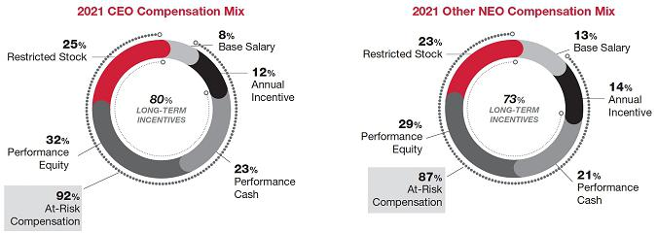

Setting Executive Compensation

Role of the Compensation Committee

The Compensation Committee oversees the executive compensation program and has overall responsibility for making final decisions about total compensation for all of the NEOs, except for the CEO, which is set by the entire Board of Directors. As part of its annual process, the Compensation Committee works closely with senior management (as appropriate) and the Compensation Committee’s independent compensation consultant. This process ensures consistency from year to year and adherence to the responsibilities listed in the Committee’s Charter, which is available on our website.

The CEO does not provide recommendations concerning his own compensation, nor is he present when his compensation is discussed by the Compensation Committee. The Compensation Committee, with input from its independent compensation consultant, discusses the elements of his compensation in executive session and makes a recommendation to all the non-management Directors for discussion and final approval. At the Compensation Committee’s request, a member of management attends the executive session to answer questions.

The CEO, with input from the Compensation Committee’s independent compensation consultant, assists the Compensation Committee in setting compensation for the other NEOs.

Use of Independent Consultants and Advisors

The Compensation Committee engaged Pearl Meyer as its independent compensation consultant during 2021. Pearl Meyer does not provide any other services to us. The primary responsibilities of the independent compensation consultant are to:

- Provide independent and objective market data;

- Conduct compensation analysis;

- Recommend potential changes to the Comparator Peer Group and performance peer group;

- Recommend plan design changes;

- Advise on risks associated with compensation plans; and

- Review and advise on pay programs and pay levels.

These services are provided as requested by the Compensation Committee throughout the year. Based on their review of our executive compensation program, Pearl Meyer concluded that our compensation plans do not appear to present any material risks to the Company or its shareholders in the design, metrics, interaction between, or administration of the incentive plans.

www.halliburton.com HALLIBURTON | 2022 Proxy Statement 42

Back to Contents

Comparator and Performance Peer Companies

The Compensation Committee uses various market data to examine and set target compensation opportunities for the NEOs, as well as determine actual award payouts, to ensure that it provides competitive compensation opportunities and approves actual compensation outcomes that are aligned with shareholder expectations. The following provides context for the different peer groups used to support the Compensation Committee’s process:

- Comparator Peer Group — used to determine market levels of total compensation for the 2021 plan year.

- Performance Peer Group — used to assess relative ROCE performance over a three-year performance period for determining Performance Unit Program (PUP) payouts.

- Oilfield Services Index (OSX) — used to assess relative TSR performance and adds a long-term performance component to the PUP directly linked to stock price (modifier imposes an award penalty for bottom quartile performance and provides an incentive for top quartile performance).

2021 Comparator Peer Group

The Compensation Committee regularly assesses the market competitiveness of the Company’s executive compensation program based on data from a comparator peer group. The companies comprising the Comparator Peer Group are selected based on the following considerations:

- Market capitalization;

- Revenue and number of employees;

- Global impact and reach; and

- Industry affiliation.

Industry affiliation includes companies that are involved in the oil and natural gas and energy services industries. With data provided by the independent compensation consultant, the Compensation Committee reviews the Comparator Peer Group annually to ensure relevance.

Given the market uncertainty and business disruptions during 2020, the Compensation Committee determined, with input from its independent compensation consultant, that annual benchmarking data would be insufficient for annual compensation decisions. The Compensation Committee used data from the 2020 Comparator Peer Group of the following peer companies within the energy industry and selected companies representing general industry to determine market levels of total compensation for the 2021 plan year:

3M Company | Hess Corporation
Anadarko Petroleum Corporation | Honeywell International Inc.
Apache Corporation | Johnson Controls International plc
Baker Hughes | National Oilwell Varco, Inc.
Caterpillar Inc. | Occidental Petroleum Corporation
ConocoPhillips | Raytheon Company
Deere and Company | Schlumberger Limited
Emerson Electric Co. | Transocean Ltd.
Fluor Corporation | Weatherford International plc

Because of variances in market capitalization and revenue size among the companies comprising our Comparator Peer Group, the market data is size adjusted by revenue as necessary so that it is comparable with our trailing 12 months revenue. These adjusted values are used to compare our executives’ compensation to those of the Comparator Peer Group.

Total compensation for each NEO is structured to target market competitive pay levels in base salary and short- and long-term incentive opportunities. We

also place an emphasis on variable pay at risk, which enables this compensation structure to position actual pay above or below the 50th percentile of our Comparator Peer Group depending on performance.

A consistent pre-tax, present value methodology is used in assessing stock-based and other long-term incentive awards.

The independent compensation consultant gathers and performs an analysis of market data for each NEO, comparing each of their individual components of compensation and total compensation to that of the Comparator Peer Group. This competitive analysis consists of comparing the market data of each of the
pay elements and total compensation at the 25th, 50th, and 75th percentiles of the Comparator Peer Group to current compensation for each NEO.

When determining target total compensation for the CEO, the Compensation Committee takes into consideration competitive market pay levels for the CEOs in the Comparator Peer Group. The Compensation Committee also considers the CEO’s performance and accomplishments in the areas of business development and expansion, management succession, development and retention of management, ethical leadership, and the achievement of financial and operational objectives. Each year, our CEO and the members of the Board agree upon a set of objectives addressing the following areas:

- Leadership and vision;

- Integrity;

- Keeping the Board informed on matters affecting Halliburton;

- Performance of the business;

HALLIBURTON | 2022 Proxy Statement 43

Back to Contents

- Development and implementation of initiatives that provide long-term economic benefits;

- Accomplishment of strategic objectives; and

- Development of management.

See Individual Performance Highlights for the objectives set for Mr. Miller and his performance against those objectives.

Other NEO compensation is determined similarly by evaluating each NEO’s performance and considering the market competitive pay levels of the Comparator Peer Group for the NEO’s position. The Compensation Committee also considers the importance of keeping our management team focused and stable, especially given that other oilfield services companies have aggressively recruited our NEOs and other executives in the past. In fact, over thirty of our former executives have departed to become CEOs and/or senior executives of other oilfield services companies.

2021 Performance Peer Group

For determining PUP award payouts, the Compensation Committee measures ROCE on a relative basis over three years to the results of a performance peer group it selects. The Performance Peer Group used for the PUP is comprised of oilfield equipment and services companies and domestic and international exploration and production companies. This peer group is used for the PUP because these companies represent the timing, cyclicality, and volatility of the oil and natural gas industry and provide an appropriate industry group for measuring our relative performance.

For the 2021 cycle, the Compensation Committee set the performance measures on a 100% relative ROCE basis with relative performance to be measured as of the three-year period ending December 31, 2023.

The Performance Peer Group used for the 2021 PUP consists of the following companies:

Apache Corporation | Nabors Industries Ltd.
Baker Hughes | National Oilwell Varco, Inc.
Chesapeake Energy Corporation | Schlumberger Limited
Devon Energy Corporation | TechnipFMC
Hess Corporation | Transocean Ltd.
Marathon Oil Corporation | Weatherford International plc
Murphy Oil Corporation | The Williams Companies, Inc.

OSX

In addition to relative ROCE, the PUP also uses a relative TSR modifier that compares three-year performance against the OSX and can increase or decrease the incentive opportunity payout by 25%. The OSX is comprised of companies that are engaged in the same industry as we are. These are also the same companies with whom we compete for investors’ dollars.

2021 Executive Compensation Outcomes in Detail

Base Salary

The Compensation Committee generally targets base salaries at the median of the Comparator Peer Group. The Compensation Committee also considers the following factors when setting base salary:

- Level of responsibility;

- Experience in current role and equitable compensation relationships among internal peers;

- Performance and leadership; and

- External factors involving competitive positioning, general economic conditions, and marketplace compensation trends.

No specific formula is applied to determine the weight of each factor.

Salary reviews are conducted annually to evaluate each executive. Individual salaries are not necessarily adjusted each year.

In response to the substantial decline in global demand for oil caused by the COVID-19 pandemic, as well as the impact of the pandemic on the broader economic environment and our business, Mr. Miller and the other NEOs voluntarily reduced their base salaries by 20% and 10%, respectively, effective May 1, 2020.

At its regular December 2020 meeting, the Compensation Committee determined that base salaries for our NEOs would be reinstated to their pre-reduction January 1, 2020, levels on January 1, 2021.

www.halliburton.com HALLIBURTON | 2022 Proxy Statement 44

Back to Contents

Short-Term (Annual) Incentive

The Annual Performance Pay Plan is designed to provide executives and other key members of management the opportunity to earn an annual cash bonus based on the annual performance of the Company. The Annual Performance Pay Plan places a significant percentage of each NEO’s annual cash compensation at risk and aligns the interests of executives and shareholders. It is administered in accordance with the terms of the Stock and Incentive Plan.

Impact of the Macroeconomic Environment and COVID-19 on Our Approach to Annual Incentives

Given the market uncertainty and continuing business challenges driven by the COVID-19 pandemic, the Compensation Committee decided at the onset of 2021 that it would replace its traditional 12-month performance period with two, six-month performance periods that would run from January 1, 2021, through
June 30, 2021 (1st performance period), and July 1, 2021, through December 31, 2021 (2nd performance period). Given the economic uncertainty, this split plan-year approach provided the Committee the agility mid-year to ensure that the performance goals for the 2nd performance period were appropriately rigorous. This resulted in more challenging performance goals for the 2nd half of the year than for the 1st half of the year. Specifically, the threshold

performance goals for the 2nd performance period the Committee set were higher than both the maximum performance goals and actual results for the 1st performance period. The aggregate performance goals would have been lower if established for a 12-month performance period.

2021 Target Award Opportunities

Individual incentive award opportunities are established as a percentage of base salary at the beginning of the plan year based on market competitive targets. The maximum award a NEO can receive is limited to two times the target opportunity level. The level of achievement of annual performance determines the dollar amount of incentive compensation payable to participants following completion of the plan year. The Compensation Committee set incentive award opportunities under the plan for 2021 as follows:

NEO | Threshold | Target | Maximum
Mr. Miller | 60% | 150% | 300%
Mr. Loeffler | 40% | 100% | 200%
Mr. Carre | 40% | 100% | 200%
Mr. Rainey | 44% | 110% | 220%
Mr. Richard | 44% | 110% | 220%

Threshold, Target, and Maximum opportunity dollar amounts can be found in the Grants of Plan-Based Awards in Fiscal 2021 table.

HALLIBURTON | 2022 Proxy Statement 45

Back to Contents

2021 Financial Performance Metrics and Results

For 2021, as discussed above, performance under the Annual Performance Pay Plan was based on the achievement of pre-established performance metrics: Net Operating Profit After-Taxes (NOPAT) and Asset Turns. The Compensation Committee selected these metrics because they are key financial measures upon which we set our performance expectations for the year and place an increased emphasis on free cash flow and capital discipline.
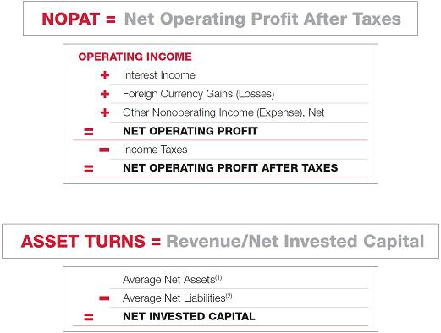

- Average Net Assets excludes cash and marketable investments, and current and non-current deferred income tax assets.

- Average Net Liabilities excludes current and long-term debt, which includes finance lease liabilities, and non-current deferred income tax liability.

Adjustments in the calculation of NOPAT and Asset Turns may, at times, be approved by the Compensation Committee and can include the treatment of unusual items that may have impacted our actual results.

At the beginning of each plan year, the Compensation Committee approves an incentive award schedule that equates levels of performance with cash reward opportunities. The performance goals range from “Threshold” to “Target” to “Maximum”. Threshold reflects the minimum performance level which must be achieved for an award to be earned and Maximum reflects the maximum awards that can be earned.

Traditionally, the performance goals are based on our annual operating plan, as reviewed and approved by our Board, and are set at levels to meet or exceed shareholder expectations of our performance, as well as expectations of the relative performance to our competitors. Given the cyclical nature of our business, our performance goals vary from year to year, which can similarly impact the difficulty in achieving the goals. The Compensation Committee may also consider other business performance factors that are important to our investors, including health, safety, environment, and service quality, in determining the final payout amounts under the Annual Performance Pay Plan.

For both performance periods, the Compensation Committee set performance goals for our NEOs based on Company-wide consolidated NOPAT results. Threshold NOPAT was based on 90% of planned Operating Income, Target NOPAT on 100% of planned Operating Income, and Maximum NOPAT on 110% of planned Operating Income. Threshold Asset Turns was based on 98% of planned Revenues, Target Asset Turns on 100% of planned Revenues, and Maximum Asset Turns on 102% of planned Revenues. Net Invested Capital was based on 100% of our operating plan in all performance range scenarios.

The Compensation Committee set the 2021 award levels, targeted to the market median, for our NEOs based on the Company-wide consolidated NOPAT and Asset Turns results.

www.halliburton.com HALLIBURTON | 2022 Proxy Statement 46

Back to Contents

The performance goals for both performance periods are noted in the table below:

 |  |  | Performance Range
Performance Period | Metrics | Weighting | Threshold | Target | Maximum | Actual
January 1, 2021, through June 30, 2021 | NOPAT | 75% | $448 M | $501 M | $554 M | $609 M
(1st performance period) | Asset Turns | 25% | 0.647 | 0.660 | 0.673 | 0.686
July 1, 2021, through December 31, 2021 | NOPAT | 75% | $662 M | $739 M | $817 M | $1,444 M
(2nd performance period) | Asset Turns | 25% | 0.731 | 0.746 | 0.761 | 0.789

Because actual 2021 Asset Turns and NOPAT results for both of the 1st and 2nd performance periods exceeded the maximum performance goals, our NEOs received an overall payout of 200% of target for the Annual Performance Pay Plan. As evidence of the Compensation Committee’s commitment to setting robust targets, over the past ten years, the Annual Performance Pay Plan achieved Maximum performance levels four times, Target performance levels two times, and fell short of the Threshold performance level four times, resulting in no payout.

Long-Term Incentives

The Stock and Incentive Plan is designed to reward consistent achievement of value creation and operating performance goals, align management with shareholder interests, and encourage long-term perspective and commitment. Long-term incentives represent the largest component of total executive compensation opportunity.

Using a mix of incentive vehicles allows us to provide a diversified yet balanced long-term incentive program that effectively addresses volatility in our industry and in the stock market, in addition to maintaining an incentive to meet performance goals. For the 2021 plan year, the Compensation Committee used the following combination of equity vehicles for long-term incentive grants:

Vehicle | Weighting | Purpose
Performance Units | 70% of Award | Rewards achievement of specific financial goals measured over a three-year performance
 |  | period
Restricted Stock⁽¹⁾ | 30% of Award | Supports leadership retention/stability objectives; five-year vesting period

- Restricted stock grants are generally subject to a graded vesting schedule of 20% per year over five years. However, different vesting schedules may be utilized at the discretion of the Compensation Committee. Shares of restricted stock receive dividend or dividend equivalent payments.

Individual Incentive Opportunities

In determining the size of long-term incentive awards, the Compensation Committee first considers market data for comparable positions and then may adjust the awards upwards or downwards based on the Compensation Committee’s review of internal equity. This can result in positions of similar magnitude and pay receiving awards of varying size. Awards are targeted to the market median.

As part of its process, the Compensation Committee makes decisions about target long-term incentive award opportunities for the following year during its regular December meeting. For the 2021 plan year, the Compensation Committee approved restricted stock grants in December 2020.

Individual incentive opportunities are established based on market references and the NEO’s role within the organization. In the Grants of Plan-Based Awards in Fiscal 2021 table, the Threshold, Target, and Maximum columns under the heading Estimated Future Payouts Under Non-Equity Incentive Plan Awards indicate the potential cash payout for each NEO under the Performance Unit Program (PUP) for the 2021 cycle and the Threshold, Target, and Maximum columns under the heading Estimated Future Payouts Under Equity Incentive Plan Awards indicate the Target potential shares that can be earned by each NEO under the PUP for the 2021 cycle. The potential payouts are performance driven and completely at risk. Actual payouts and shares vesting, if any, will not be determined until the three-year cycle closes on December 31, 2023.

A Closer Look at the Performance Unit Program

The PUP provides NEOs and other selected executives with incentive opportunities based on our consolidated ROCE during a three-year performance period. This program reinforces our objectives for sustained long-term performance and value creation. It also reinforces strategic planning processes and balances short- and long-term decision making.

The program measures ROCE on a relative basis to the results of a performance peer group over three years. The Performance Peer Group used for the PUP is comprised of oilfield equipment and services companies and domestic and international exploration and production companies. This peer group is used for the PUP because these companies represent the timing, cyclicality, and volatility of the oil and natural gas industry and provide an appropriate industry group for measuring our relative performance. The 2021 Performance Peer Group is listed on page 44 of this CD&A.

HALLIBURTON | 2022 Proxy Statement 47

Back to Contents

The three-year performance period aligns this measurement with our and our Performance Peer Group’s business cycles. ROCE indicates the efficiency and profitability of our capital investments and is determined based on the ratio of earnings divided by average capital employed. The calculation is as follows:
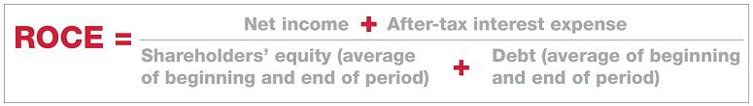

Why ROCE?

Highly correlated to stock price performance over the long-term, applying drivers that management can directly influence.
Aligned with our strategy of delivering industry-leading returns across the business cycle.
Reinforces the Company’s objective for sustained long-term performance and value creation.

Overwhelmingly supported by our shareholders.

Eliminates the subjectivity inherent in setting long-term absolute targets in a cyclical industry.
Provides our management team with clear line of sight to long-term financial results.

Consistent with our executive compensation objectives and strategy to deliver leading returns in our industry, over the past 10 years we delivered superior ROCE performance relative to the Oilfield Services Index (OSX), our two largest competitors, and our Performance Peer Group. We believe that this long-term focus on generating superior returns within our industry also correlates with our industry TSR outperformance over the same period of time.

2021 Cycle PUP

2021 Cycle – Performance Matrix

At the end of the three-year award cycle, the average ROCE of Halliburton and the Performance Peer Group will be calculated, and performance percentiles will be determined. If Halliburton’s relative performance ranking is between the 25th and 75th percentiles, the payout will be interpolated accordingly. If Halliburton’s relative performance ranking is below the 25th percentile, there will not be a payout.

The PUP also uses a relative TSR modifier that compares three-year performance against the OSX and can increase or decrease the incentive opportunity payout by 25%. The modifier imposes an award penalty for bottom quartile performance and an incentive for top quartile performance as follows:

 |  |  |  |  | Relative TSR Modifier
 |  |  |  |  | 2nd/3rd Quartile | Upper Quartile⁽²⁾
 |  |  |  | Lower Quartile | Performance | Upper Quartile⁽²⁾
 |  |  |  | Performance | >25th percentile & <75th | Performance
 |  |  | Unadjusted | ≤25th percentile | percentile | ≥75th percentile
 |  |  | Incentive |  | MULTIPLIER
 |  |  | Opportunity⁽¹⁾ | 75% | 100% | 125%
HAL ROCE | Below |  | 0% | 0% | 0% | 0%
Ranking vs. | Threshold |  |  | (0% x 75%) | (0% x 100%) | (0% x 125%)
Performance | <25th percentile
Peer Group |  | Threshold | 25% | 18.75% | 25% | 31.25%
 |  | 25th percentile |  | (25% x 75%) | (25% x 100%) | (25% x 125%)
 |  | Plan | 100% | 75% | 100% | 125%
 | 50th percentile |  |  | (100% x 75%) | (100% x 100%) | (100% x 125%)
 |  | Challenge | 200% | 150% | 200% | 250%
 |  | ≥75th percentile |  | (200% x 75%) | (200% x 100%) | (200% x 125%)
- If Halliburton’s relative ROCE performance ranking is between the 25th and 75th percentiles, the payout will be interpolated accordingly.

- If TSR is in the upper quartile but negative, the TSR Modifier will not apply.

www.halliburton.com HALLIBURTON | 2022 Proxy Statement 48

Back to Contents

Any awards earned at the end of the 2021 cycle will be issued 50% in stock and 50% in cash.

2019 Cycle PUP

The table below shows the incentive opportunity based on Halliburton’s ROCE performance relative to that of our Performance Peer Group for the 2019

cycle of the PUP that ended on December 31, 2021. We achieved ROCE of -1.0% which was above the 75th percentile of our Performance Peer Group’s ROCE of -2.9% and yielded an award paid at 200% of the target opportunity level. The 2019 PUP Cycle is the last cycle that will be paid 100% in cash. Future cycles will be awarded 50% in cash and 50% in stock.

2019 Cycle – Performance Matrix

 | Threshold | Target | Maximum
Halliburton Ranking vs. Performance Peer Group | 25th Percentile | 50th Percentile | 75th Percentile
Incentive Opportunity as a % of Target | 25% | 100% | 200%

The NEOs received payments as set forth in the Non-Equity Incentive Plan Compensation column in the Summary Compensation Table. The program allows for rewards to be paid in cash, stock, or a combination of cash and stock.

Other Executive Benefits and Policies

Retirement and Savings Plan

All NEOs may participate in the Halliburton Retirement and Savings Plan, which is the defined contribution benefit plan available to all eligible U.S.

employees. The matching contribution amounts we contributed on behalf of each NEO are included in the Supplemental Table: All Other Compensation.

Supplemental Executive Retirement Plan

The objective of the Supplemental Executive Retirement Plan, or SERP, is to provide a competitive level of pay replacement upon retirement. The current pay replacement target is 75% of base salary at age 65 with 25 years of service, using the highest annual salary during the last three years of employment.

The material factors and guidelines considered in making an allocation include: (i) retirement benefits provided, both qualified and nonqualified; (ii) current compensation; (iii) length of service; and (iv) years of service to normal retirement.

The calculation takes into account the following variables: (i) base salary; (ii) years of service; (iii) age; (iv) employer portion of qualified plan savings; (v) age 65 value of any defined benefit plan; and (vi) existing nonqualified plan balances and any other retirement plans.

Several assumptions are made annually and include a base salary increase percentage, qualified and nonqualified plan contributions and investment earnings, and an annuity rate. These factors are reviewed and approved annually by the Compensation Committee in advance of calculating any awards.

To determine the annual benefit, external actuaries calculate the total lump sum retirement benefit needed at age 65 from all company retirement sources to produce an annual retirement benefit of 75% of the highest annual salary during the last three years of employment. Company retirement sources include any Company contributions to qualified benefit plans and contributions to nonqualified benefit plans. If the combination of these two sources does not yield a total retirement balance that will meet the 75% objective, then contributions may be made annually through the SERP to bring the total benefit up to the targeted level.

To illustrate, assume $10 million is needed at age 65 to produce an annual retirement benefit equal to 75% of base salary. The participant is projected to have $3 million in the qualified benefit plans resulting from Company contributions at retirement and $4 million in the nonqualified retirement plans resulting from Company contributions at retirement. Since the total of these two sources is $7 million, a shortfall of $3 million results. This is the amount needed to achieve the 75% pay replacement objective. This shortfall may be offset through annual contributions to the SERP.

Participation in the SERP is limited to the direct reports of the CEO and other selected executives as recommended by the CEO and approved at the discretion of the Compensation Committee. However, participation one year does not guarantee future participation. In 2021, the Compensation Committee authorized retirement allocations under the SERP to all NEOs as listed in the Supplemental Table: All Other Compensation and the 2021 Nonqualified Deferred Compensation table.

All of the NEOs, except Mr. Loeffler, are fully vested in their respective account balances. Balances for active and terminated participants earn interest at an annual rate of 5% and 10%, respectively.

HALLIBURTON | 2022 Proxy Statement 49

Back to Contents

Elective Deferral Plan

All NEOs may participate in the Halliburton Elective Deferral Plan, which was established to provide highly compensated employees with an opportunity to defer earned base salary and incentive compensation to help meet retirement and other future income needs.

Participants may elect to defer up to 75% of their annual base salary and up to 75% of their incentive compensation into the plan. Deferral elections must be made on an annual basis, including the type and timing of distribution. Plan earnings are based on the NEO’s choice of up to 12 investment options with varying degrees of risk, including the risk of loss. Investment options may be changed by the NEO daily.

In 2021, none of our NEOs participated in this plan. Messrs. Rainey and Richard have account balances from participation in the plan in prior years. Messrs.

Miller, Loeffler, and Carre are not participants in the plan. Further details can be found in the 2021 Nonqualified Deferred Compensation table.

Benefit Restoration Plan

The Halliburton Company Benefit Restoration Plan provides a vehicle to restore qualified plan benefits which are reduced as a result of limitations on contributions imposed under the Internal Revenue Code (IRC) or due to participation in other plans we sponsor and to defer compensation that would otherwise be treated as excessive remuneration within the meaning of IRC Section 162(m). Awards are made annually to those who meet these criteria and earn interest at an annual rate as defined by the plan document. Awards and corresponding interest balances are 100% vested and distributed upon separation.

In accordance with the plan document, participants earn monthly interest at the 120% AFR rate, provided the interest rate shall be no less than 6% per annum or greater than 10% per annum. Because the 120% AFR rate was below the 6% minimum interest threshold, plan participants earned interest at an annual rate of 6% in 2021.

In 2021, all NEOs received awards under this plan in the amounts included in the Supplemental Table: All Other Compensation and the 2021 Nonqualified Deferred Compensation table.

Perquisites

Effective January 1, 2019, we eliminated several perquisites including tax gross ups for personal use of corporate aircraft, executive physical examinations, and financial planning reimbursements. We also eliminated reimbursements for country club dues for all our NEOs.

We do not provide cars to our NEOs. However, a car and part-time driver is available for Mr. Miller’s limited use as needed for security purposes and so that he can work while in transit to meet customers or attend business-related functions.

We provided security at the personal residences of Mr. Miller during 2021.

As a result of the recommendations provided by an independent, third-party security consultant, the Board has determined that Mr. Miller must use company aircraft for all travel. The security study also recommends that his spouse and children use company-provided aircraft.

Mr. Rainey is an expatriate under our long-term expatriate business practice. A differential is commonly paid to expatriates in assignment locations where the cost of goods and services is greater than the cost for the same goods and services in the expatriate’s home country. Differentials are determined by AIRINC, a third-party consultant. Mr. Rainey receives certain assignment allowances, including a goods and services differential and host country housing and utilities. He also participates in our tax equalization program, which neutralizes the tax effect of the international assignment and approximates the tax obligation the expatriate would pay in his home country. Mr. Rainey’s expatriate benefits package is commensurate with benefits offered to all other Halliburton expatriates.

Specific amounts for the above-mentioned perquisites are detailed for each NEO in the Supplemental Table: All Other Compensation.

Clawback Policy

We have a clawback policy under which we will seek to recoup incentive compensation in all appropriate cases paid to, awarded, or credited for the benefit of any of our executive officers, which includes all NEOs, if and to the extent that:

- The amount of incentive compensation was calculated based on the achievement of financial results that were subsequently reduced due to a restatement of our financial results;

- The officer engaged in fraudulent conduct that caused the need for the restatement; and

- The amount of incentive compensation that would have been paid to, awarded to, or credited for the benefit of the officer, had our financial results been properly reported, would have been lower than the amount actually paid, awarded, or credited.

The policy also provides that we will seek to recoup incentive compensation in all appropriate cases paid to, awarded to, or

www.halliburton.com HALLIBURTON | 2022 Proxy Statement 50

Back to Contents

credited for the benefit of any of our executive officers, which includes all NEOs, and certain other senior officers, if and to the extent that:

- It is determined that, in connection with the performance of that officer’s duties, he or she breached his or her fiduciary duty by knowingly or recklessly engaging in a material violation of a U.S. federal or state law, or failed to supervise an employee who substantially participated in such a violation; or

- The officer is named as a defendant in a law enforcement proceeding for having breached his or her fiduciary duty by knowingly or recklessly engaging in a material violation of a U.S. federal or state law, the officer disagrees with the allegations relating to the proceeding, and either (i) we initiate a review and determine that the alleged action is not indemnifiable or (ii) the officer does not prevail at trial, enters into a plea arrangement, agrees to the entry of a final administrative or judicial order imposing sanctions, or otherwise admits to the violation in a legal proceeding.

The disinterested members of the Board and the disinterested members of the Compensation Committee and the Nominating and Corporate Governance Committee may be involved in reviewing, considering, and making determinations regarding the officer’s alleged conduct, whether recoupment is appropriate or required, and the type and amount of incentive compensation to be recouped from the officer.

The policy also provides that, to the extent permitted by applicable law and not previously disclosed in a filing with the SEC, we will disclose in our proxy statement the circumstances of any recoupment arising under the policy or that there has not been any recoupment pursuant to the policy for the prior calendar year. There was no recoupment under the policy in 2021.

Stock Ownership Requirements

We have stock ownership requirements for our executive officers, which include all NEOs, to further align their interests with our shareholders.

Our CEO is required to own Halliburton common stock in an amount equal to or in excess of six times his annual base salary. Executive officers that report directly to the CEO are required to own an amount of Halliburton common stock equal to or in excess of three times their annual base salary, and all other executive officers are required to own an amount of Halliburton common stock equal to or in excess of two times their annual base salary. The Compensation Committee reviews their holdings, which include restricted shares and all other Halliburton common stock owned by the officer, at each December meeting. Each executive officer has five years to meet the requirements, measured from the date the officer becomes subject to the ownership level for the applicable office.

After the five-year stock ownership period described above, executive officers who have not met their minimum ownership requirement must retain 100% of the net shares acquired upon restricted stock vesting until they achieve their required ownership level. Also, any stock option exercise must be an exercise and hold.

As of December 31, 2021, all NEOs met the requirements.

Hedging and Pledging Policy

We have a policy under which our Directors and executive officers, which includes all NEOs, and certain senior officers are prohibited from:

- hedging activities related to Halliburton securities; and

- the pledging of Halliburton securities.

The policy defines hedging activities as the use of any financial instrument designed to hedge or offset a change in the market value of any Halliburton security and defines pledging as the use of a Halliburton security or any related derivative security as collateral for any form of indebtedness.

Additionally, the policy:

- discourages all employees and Directors from speculative activities in Halliburton securities and related derivative securities, such as puts or call options;

- applies to all Halliburton securities, including restricted stock, restricted stock units, options, and debt securities, which are issued by any Halliburton entity, and any other security directly or indirectly exercisable for or convertible or exchangeable into any Halliburton security; and

- applies regardless of whether or not the securities were acquired from our equity compensation plans.

Elements of Post-Termination Compensation and Benefits

Termination events that trigger payments and benefits include normal or early retirement, cause, death, disability, and voluntary termination. Post-termination or change-in-control payments may include severance, accelerated vesting of restricted stock and stock options, payments under cash-based short- and long-term incentive plans, share vesting under the long-term incentive plan, payout of nonqualified account balances, and health benefits, among others. The impact of various events on each element of compensation for the NEOs is detailed in the Post-Termination or Change-In-Control Payment table.

HALLIBURTON | 2022 Proxy Statement 51

Back to Contents

Impact of Regulatory Requirements on Compensation

IRC Section 162(m) generally disallows a tax deduction to public companies for compensation paid to the CEO, CFO, or any of the three other most highly compensated officers to the extent the compensation exceeds $1 million in any year. Effective for tax years beginning after December 31, 2017, Section 162(m) has been revised to eliminate the performance-based compensation exception.

Although the tax deductibility of compensation is a consideration evaluated by our Compensation Committee, the Committee believes that the elimination of the deduction on compensation payable in excess of the $1 million limitation for our NEOs is not material relative to the benefit of being able to attract and retain talented management. Accordingly, our Compensation Committee will continue to pay compensation that is not deductible.

www.halliburton.com HALLIBURTON | 2022 Proxy Statement 52

Back to Contents

Executive Compensation Tables

Summary Compensation Table

The following tables set forth information regarding our CEO, CFO, and our three other most highly compensated executive officers for the fiscal year ended December 31, 2021.

 |  |  |  |  |  |  | Change In
 |  |  |  |  |  | Non-Equity | Pension Value
 |  |  |  | Stock | Option | Incentive Plan | and NQDC | All Other
Name and |  | Salary | Bonus | Awards | Awards | Compensation | Earnings | Compensation | Total
Principal Position | Year | ($) | ($) | ($) | ($) | ($) | ($) | ($) | ($)
Jeffrey A. Miller | 2021 | 1,500,000 | 0 | 6,300,070 | 0 | 14,131,664 | 242,327 | 1,417,921 | 23,591,982
Chairman, President and | 2020 | 1,300,000 | 0 | 9,687,697 | 0 | 9,456,914 | 252,566 | 1,622,208 | 22,319,385
Chief Executive Officer
Chief Executive Officer | 2019 | 1,500,000 | 0 | 3,584,073 | 0 | 5,730,380 | 139,300 | 1,799,861 | 12,753,614
Lance Loeffler | 2021 | 760,000 | 0 | 1,765,560 | 0 | 4,398,952 | 28,146 | 480,841 | 7,433,499
Executive Vice President | 2020 | 709,333 | 0 | 2,554,478 | 0 | 0 | 19,725 | 504,508 | 3,788,044
and Chief Financial Officer
and Chief Financial Officer | 2019 | 650,000 | 0 | 888,858 | 0 | 0 | 4,656 | 465,091 | 2,008,605
Eric J. Carre | 2021 | 800,000 | 0 | 1,710,830 | 0 | 4,417,392 | 90,828 | 608,429 | 7,627,479
Executive Vice President – | 2020 | 746,667 | 0 | 2,455,778 | 0 | 2,534,094 | 89,513 | 697,483 | 6,523,535
Global Business Lines
Global Business Lines | 2019 | 800,000 | 0 | 848,065 | 0 | 2,485,124 | 45,466 | 737,503 | 4,916,158
Joe D. Rainey | 2021 | 910,000 | 0 | 2,258,133 | 0 | 5,760,776 | 541,642 | 2,200,075 | 11,670,626
President – Eastern | 2020 | 849,333 | 0 | 3,256,812 | 0 | 3,378,792 | 490,397 | 4,868,394 | 12,843,728
Hemisphere
Hemisphere | 2019 | 910,000 | 0 | 1,129,322 | 0 | 3,307,924 | 409,467 | 2,368,494 | 8,125,207
Mark J. Richard | 2021 | 810,000 | 0 | 2,217,592 | 0 | 5,540,776 | 205,693 | 1,321,497 | 10,095,558
President – Western | 2020 | 756,000 | 0 | 3,226,875 | 0 | 2,000,000 | 123,041 | 1,337,580 | 7,443,496
Hemisphere
Hemisphere | 2019 | 716,678 | 0 | 1,129,322 | 0 | 1,656,000 | 88,574 | 1,321,431 | 4,912,005

Note: Some shareholders asked that we show the impact of the change in our performance award structure on the 2021 total compensation reflected above for Mr. Miller. The total compensation amount includes, in the Non-Equity Incentive Plan Compensation column above, $9,631,664, which is a cash award from the 2019 PUP cycle earned in 2021. It also includes in the Stock Awards column $6,300,070 for a performance shares award granted in 2021 (even though the performance shares award has not yet been earned and if earned, will not be determined until the cycle concludes at the end of 2023). If the performance shares award had been made as a cash award under our old performance award structure, the $6,300,070 would not appear in the 2021 compensation table.

Salary. The amounts in the Salary column reflect the salary earned by each NEO.

Stock Awards. The amounts in the Stock Awards column reflect the grant date fair value of the performance shares awarded in 2021. The amount reflects an accounting expense and does not correspond to actual value that may be realized by a NEO in the future. We use a Monte Carlo simulation that uses a probabilistic approach and was performed by an actuary to determine grant date fair value. The NEOs may never realize any value from these performance shares and, to the extent that they do, the amounts realized may have no correlation to the amounts reported above.

Non-Equity Incentive Plan Compensation. The Non-Equity Incentive Plan Compensation column reflects amounts earned in 2021 for the 2021 Halliburton Annual Performance Pay Plan and the 2019 cycle Performance Unit Program.

The 2021 Halliburton Annual Performance Pay Plan amounts paid to each NEO are: $4,500,000 for Mr. Miller; $1,520,000 for Mr. Loeffler; $1,600,000 for Mr.

Carre; $2,002,000 for Mr. Rainey; and $1,782,000 for Mr. Richard.

The 2019 cycle Performance Unit Program amounts paid to each NEO are: $9,631,664 for Mr. Miller; $2,878,952 for Mr. Loeffler; $2,817,392 for Mr. Carre; $3,758,776 for Mr. Rainey; and $3,758,776 for Mr. Richard. The amounts paid to the NEOs for the 2019 cycle Performance Unit Program differ from what is shown in the Grants of Plan-Based Awards in Fiscal Year 2021 table under Estimated Future Payments Under Non-Equity Incentive Plan Awards. That table indicates the potential award amounts payable in cash under the 2021 cycle Performance Unit Program, which will close on December 31, 2023.

HALLIBURTON | 2022 Proxy Statement 53

Back to Contents

Change in Pension Value and NQDC Earnings. The amounts in the Change in Pension Value and NQDC Earnings column are attributable to the above-market earnings for various nonqualified plans. The methodology for determining what constitutes above-market earnings is the difference between the interest rate as stated in the applicable nonqualified plan document and the Internal Revenue Service Long-Term 120% AFR rate as of December 31, 2021. The 120% AFR rate used for determining above-market earnings in 2021 was 2.28%.

Supplemental Executive Retirement Plan Above-Market Earnings. The current interest rate for active participant accounts in the Supplemental Executive Retirement Plan is 5% as defined by the plan document. The above-market earnings for active participants equaled 2.72% (5% (plan interest) minus 2.28%) for 2021.

NEOs earned above-market earnings for their balances associated with the plan as follows: $217,130 for Mr. Miller; $25,455 for Mr. Loeffler; $79,267 for Mr.

Carre; $215,486 for Mr. Rainey; and $64,860 for Mr. Richard.

Benefit Restoration Plan Above-Market Earnings. In accordance with the plan document, participants earn monthly interest at the 120% AFR rate, provided the interest rate shall be no less than 6% per annum or greater than 10% per annum. Because the 120% AFR rate was below the 6% minimum interest threshold, the above-market earnings associated with this plan were 3.72% (6% (plan interest) minus 2.28%) for 2021.

NEOs earned above-market earnings for their balances associated with the plan as follows: $25,197 for Mr. Miller; $2,691 for Mr. Loeffler; $11,561 for Mr.

Carre; $22,360 for Mr. Rainey; and $7,610 for Mr. Richard.

Elective Deferral Plan Above-Market Earnings. The average NEO earnings for the balances associated with the Elective Deferral Plan were 9.60% for 2021.

The above-market earnings associated with this plan equaled 7.32% (9.60% minus 2.28%) for 2021.

NEOs earned above-market earnings for balances associated with the plan as follows: $303,796 for Mr. Rainey; and $133,223 for Mr. Richard. Messrs.

Miller, Loeffler, and Carre are not participants in and do not have any prior balances in the Elective Deferral Plan.

The amounts shown in this column differ from the amounts shown for the Supplemental Executive Retirement Plan, the Benefit Restoration Plan, and the Elective Deferral Plan in the 2021 Nonqualified Deferred Compensation table under the Aggregate Earnings in Last Fiscal Year column because that table includes all earnings and losses, and the Summary Compensation Table shows above-market earnings only.

All Other Compensation. Detailed information for amounts included in the All Other Compensation column can be found in the Supplemental Table: All Other Compensation.

Supplemental Table: All Other Compensation

The following table details the components of the All Other Compensation column of the Summary Compensation Table for 2021.

 |  | Halliburton |  | Restricted | HRSP |  | Benefit
 | Halliburton | Giving |  | Stock | Employer | HRSP | Restoration |  | Expatriate | All
 | Foundation | Choices | HALPAC | Dividends | Match | Basic | Plan | SERP | Assignment | Other | Total
Name | ($) | ($) | ($) | ($) | ($) | ($) | ($) | ($) | ($) | ($) | ($)
Jeffrey A. Miller | 112,500 | 0 | 5,000 | 110,957 | 13,000 | 5,800 | 84,700 | 1,034,000 | 0 | 51,964 | 1,417,921
Lance Loeffler | 24,255 | 600 | 5,000 | 22,098 | 12,188 | 5,800 | 32,900 | 378,000 | 0 | 0 | 480,841
Eric J. Carre | 0 | 0 | 0 | 24,179 | 13,750 | 5,800 | 35,700 | 529,000 | 0 | 0 | 608,429
Joe D. Rainey | 0 | 0 | 0 | 0 | 13,000 | 5,800 | 43,400 | 0 | 2,137,875 | 0 | 2,200,075
Mark J. Richard | 45,000 | 480 | 5,000 | 27,317 | 14,500 | 5,800 | 36,400 | 1,187,000 | 0 | 0 | 1,321,497

Halliburton Foundation. The Halliburton Foundation allows NEOs and other employees to donate to approved universities, medical hospitals, and primary schools of their choice. In 2021, the Halliburton Foundation matched donations up to $20,000 on a 2.25 for 1 basis. Mr. Miller participated in the Halliburton Foundation’s matching program for Directors, which allowed his 2021 contributions up to $50,000 to qualified organizations to be matched on a 2.25 for 1 basis.

Halliburton Giving Choices. The Halliburton Giving Choices Program allows NEOs and other employees to donate to approved not-for-profit charities of their choice. We match donations by contributing ten cents for every dollar contributed by employees. The amounts shown represent the match amounts the program donated to charities on behalf of the NEOs in 2021.

Halliburton Political Action Committee. The Halliburton Political Action Committee, or HALPAC, allows NEOs and other eligible employees to donate to political candidates and participate in the political process. We match the NEOs’ and other employees’ donations to HALPAC dollar-for-dollar to a 501(c)(3) status nonprofit organization of the contributor’s choice. The amounts shown represent the match amounts donated to charities on behalf of the NEOs in 2021.

Restricted Stock Dividends. This is the amount of dividends paid on restricted stock held by NEOs in 2021. Restricted stock units granted to employees do not receive dividend payments. Except where there is a distinction to make between the two types of awards, this proxy statement refers to both restricted stock and restricted stock units as “restricted stock”.

www.halliburton.com HALLIBURTON | 2022 Proxy Statement 54

Back to Contents

Retirement and Savings Plan Employer Match. This is the contribution we made on behalf of each NEO to the Halliburton Retirement and Savings Plan, our defined contribution plan. We match employee contributions up to 5% of each employee’s eligible base salary up to the 401(a)(17) compensation limit of $290,000 in 2021.

Retirement and Savings Plan Basic Contribution. This is the contribution we made on behalf of each NEO to the Retirement and Savings Plan. If actively employed on December 31, 2021, or if they meet retirement eligibility requirements of the plan as of their separation date, each employee receives a contribution equal to 2% of their eligible base pay up to the 401(a)(17) compensation limit of $290,000 in 2021.

Benefit Restoration Plan. This is the award earned under the Benefit Restoration Plan in 2021 as discussed in the Benefit Restoration Plan section of Compensation Discussion and Analysis. Associated interest, awards, and beginning and ending balances for the Benefit Restoration Plan are included in the 2021 Nonqualified Deferred Compensation table.

Supplemental Executive Retirement Plan. This is the award approved under the Supplemental Executive Retirement Plan in 2021 as discussed in the Supplemental Executive Retirement Plan section of Compensation Discussion and Analysis. Associated interest, awards, and beginning and ending balances for the Supplemental Executive Retirement Plan are included in the 2021 Nonqualified Deferred Compensation table.

Expatriate Assignment. In 2021, Mr. Rainey received compensation associated with his expatriate assignment similar in type to that received by other expatriates on comparable assignments. He received $78,968 for cost of living adjustment; $91,000 for mobility premium; $1,832,837 for tax equalization; $102,330 for imputed housing allowance; $19,670 for tax preparation; and $13,070 for auto imputed allowance.

All Other.

- Aircraft Usage. As a result of the recommendations provided by an independent, third-party security consultant, the Board has determined that Mr. Miller must use company aircraft for all travel. The security study also recommends that his spouse and children use company-provided aircraft. For 2021, the incremental cost to us for this personal use of our aircraft was $41,487 for Mr. Miller. For total compensation purposes in 2021, we valued the incremental cost of the personal use of aircraft using a method that takes into account: landing, parking, hanger, flight planning services, and dead-head costs; crew travel expenses; supplies and catering; aircraft fuel and oil expenses per hour of flight; any customs, foreign permit, and similar fees; and passenger ground transportation. NEOs are not reimbursed for the tax impact of any imputed income resulting from aircraft usage.

- Home Security. We provide security for residences based on risk assessments. In 2021, home security costs were $4,224 for Mr. Miller.

- Car/Driver. A car and part-time driver is available for Mr. Miller’s limited use as needed for security purposes and so that he can work while in transit to meet customers or attend business-related functions. In 2021, the cost to us for personal use was $6,253.

HALLIBURTON | 2022 Proxy Statement 55

Back to Contents

Grants of Plan-Based Awards in Fiscal 2021

The following table represents amounts associated with the 2021 cycle Performance Unit Program and the 2021 Annual Performance Pay Plan.

 |  |  |  |  |  |  |  |  |  | All Other | Grant Date
 |  |  |  |  |  |  |  |  |  | Stock Awards: | Fair Value
 |  | Estimated Future Payouts Under |  |  |  | Estimated Future Payouts Under |  |  |  | Number of | of Stock and
 |  | Non-Equity Incentive Plan Awards |  |  |  | Equity Incentive Plan Awards |  |  |  | Shares of | Options
 |  | Threshold | Target | Maximum |  | Threshold | Target | Maximum |  | Stock or Units | Awards
Name | Grant Date | ($) | ($) | ($) |  | (#) | (#) | (#) |  | (#) | ($)⁽⁴⁾
Jeffrey A. Miller |  | 1,076,195 | 4,304,780 | 10,761,950⁽¹⁾
 |  | 900,000 | 2,250,000 | 4,500,000⁽²⁾
 | 1/4/2021 |  |  |  |  | 77,700 | 310,800 | 777,000⁽³⁾ |  |  | 6,300,070
Lance Loeffler |  | 301,768 | 1,207,070 | 3,017,675⁽¹⁾
 |  | 304,000 | 760,000 | 1,520,000⁽²⁾
 | 1/4/2021 |  |  |  |  | 21,775 | 87,100 | 217,750⁽³⁾ |  |  | 1,765,560
Eric J. Carre |  | 292,426 | 1,169,705 | 2,924,263⁽¹⁾
 |  | 320,000 | 800,000 | 1,600,000⁽²⁾
 | 1/4/2021 |  |  |  |  | 21,100 | 84,400 | 211,000⁽³⁾ |  |  | 1,710,830
Joe D. Rainey |  | 385,284 | 1,541,135 | 3,852,838⁽¹⁾
 |  | 400,400 | 1,001,000 | 2,002,000⁽²⁾
 | 1/4/2021 |  |  |  |  | 27,850 | 111,400 | 278,500⁽³⁾ |  |  | 2,258,133
Mark J. Richard |  | 378,845 | 1,515,380 | 3,788,450⁽¹⁾
 |  | 356,400 | 891,000 | 1,782,000⁽²⁾
 | 1/4/2021 |  |  |  |  | 27,350 | 109,400 | 273,500⁽³⁾ |  |  | 2,217,592

- Cash opportunity levels under the 2021 cycle of the Performance Unit Program.

- Cash opportunity levels under the 2021 Halliburton Annual Performance Pay Plan.

- Share opportunity levels under the 2021 cycle of the Performance Unit Program.

- This column reflects the grant date fair value at target of the equity based incentive awards under the PUP.

As indicated by footnotes (1) and (3), the cash opportunities for each NEO under the 2021 cycle Performance Unit Program if the Threshold, Target, or Maximum levels are achieved are reflected under Estimated Future Payouts Under Non-Equity Incentive Plan Awards and the share opportunities are reflected under Estimated Future Payouts Under Equity Incentive Plan Awards. The potential payouts are performance driven and completely at risk. For more information on the 2021 cycle Performance Unit Program, refer to Long-term Incentives in Compensation Discussion and Analysis.

As indicated by footnote (2), the opportunities for each NEO under the 2021 Halliburton Annual Performance Pay Plan are also reflected under Estimated Future Payouts Under Non-Equity Incentive Plan Awards. The potential payouts are performance driven and completely at risk. For more information on the 2021 Halliburton Annual Performance Pay Program, refer to Short-term (Annual) Incentive in Compensation Discussion and Analysis.

The performance share grants awarded to the NEOs during 2021 are subject to a three-year performance period. All performance shares are priced at fair market value on the date of grant. Quarterly dividends will not be paid during the performance period but shall be accrued and paid in cash at the time, and to the extent, the underlying shares of Company common stock are delivered.

www.halliburton.com HALLIBURTON | 2022 Proxy Statement 56

Back to Contents

Outstanding Equity Awards at Fiscal Year End 2021

The following table represents outstanding stock option and restricted stock awards for our NEOs as of December 31, 2021. The market value of shares or units of stock not vested was determined by multiplying the number of unvested restricted shares at year end by the closing price of our common stock on the NYSE of $22.87 on December 31, 2021.

 |  |  | Option Awards |  |  |  |  | Stock Awards
 |  |  |  |  |  |  |  |  | Equity | Equity
 |  |  |  |  |  |  |  |  | Incentive | Incentive
 |  |  |  |  |  |  |  |  | Plan | Plan Awards:
 |  |  |  |  |  |  |  |  | Awards: | Market or
 |  | Number of | Number of |  |  |  |  |  | # Unearned | Payout Value
 |  | Securities | Securities |  |  |  | Number of | Market Value | Shares | of Unearned
 |  | Underlying | Underlying |  |  |  | Shares | of Shares | Units or | Shares
 |  | Unexercised | Unexercised | Option |  |  | or Units | or Units of | Other | Units or
 |  | Options | Options | Exercise | Option |  | of Stock | Stock | Rights | Other Rights
 |  | (#) | (#) | Price | Expiration |  | Not Vested | Not Vested | Not Vested | Not Vested
Name | Grant Date | Exercisable | Unexercisable | ($) | Date |  | (#) | ($) | (#) | ($)
Jeffrey A. Miller⁽¹⁾ | 12/4/2013 | 55,700 | – | 50.62 | 12/4/2023 |  | – | – | – | –
 | 12/3/2014 | 115,100 | – | 40.75 | 12/3/2024 |  | – | – | – | –
 | 12/2/2015 | 99,200 | – | 38.95 | 12/2/2025 |  | – | – | – | –
 | 12/7/2016 | 69,500 | – | 53.54 | 12/7/2026 |  | – | – | – | –
 | 6/1/2017 | – | – |  |  |  | 150,000 | 3,430,500 | – | –
 | 12/6/2017 | 128,500 | – | 43.38 | 12/6/2027 |  | 15,420 | 352,655 | – | –
 | 12/5/2018 | 171,200 | – | 31.44 | 12/5/2028 |  | 39,920 | 912,970 | – | –
 | 12/4/2019 | – | – |  |  |  | 100,160 | 2,290,659 | – | –
 | 1/2/2020 | – | – |  |  |  | – | – | 194,773 | 4,454,459
 | 12/2/2020 | – | – |  |  |  | 213,120 | 4,874,054 | – | –
TOTAL | 1/4/2021 | – | – |  |  |  | – | – | 310,800 | 7,107,996
TOTAL |  | 639,200 | – |  |  |  | 518,620 | 11,860,838 | 505,573 | 11,562,455
Lance Loeffler⁽²⁾ | 1/2/2015 | 15,594 | – | 39.49 | 1/2/2025 |  | – | – | – | –
 | 1/4/2016 | 27,912 | – | 34.48 | 1/4/2026 |  | – | – | – | –
 | 1/3/2017 | 16,678 | – | 55.68 | 1/3/2027 |  | 1,296 | 29,640 | – | –
 | 1/2/2018 | 20,416 | – | 49.61 | 1/2/2028 |  | 3,064 | 70,074 | – | –
 | 12/5/2018 | 51,100 | – | 31.44 | 12/5/2028 |  | 11,920 | 272,610 | – | –
 | 12/4/2019 | – | – |  |  |  | 24,840 | 568,091 | – | –
 | 1/2/2020 | – | – |  |  |  | – | – | 48,300 | 1,104,621
 | 12/2/2020 | – | – |  |  |  | 59,760 | 1,366,711 | – | –
TOTAL | 1/4/2021 | – | – |  |  |  | – | – | 87,100 | 1,991,977
TOTAL |  | 131,700 | – |  |  |  | 100,880 | 2,307,126 | 135,400 | 3,096,598

HALLIBURTON | 2022 Proxy Statement 57

Back to Contents
 |  |  |  |  | Option Awards |  |  |  |  |  | Stock Awards
 |  |  |  |  |  |  |  |  |  |  |  | Equity | Equity
 |  |  |  |  |  |  |  |  |  |  |  | Incentive | Incentive
 |  |  |  |  |  |  |  |  |  |  |  | Plan | Plan Awards:
 |  |  |  |  |  |  |  |  |  |  |  | Awards: | Market or
 |  |  |  | Number of | Number of |  |  |  |  |  |  | # Unearned | Payout Value
 |  |  |  | Securities | Securities |  |  |  | Number of |  | Market Value | Shares | of Unearned
 |  |  |  | Underlying | Underlying |  |  |  | Shares |  | of Shares | Units or | Shares
 |  |  |  | Unexercised | Unexercised | Option |  |  | or Units |  | or Units of | Other | Units or
 |  |  |  | Options | Options | Exercise | Option |  | of Stock |  | Stock | Rights | Other Rights
 |  |  |  | (#) | (#) | Price | Expiration |  | Not Vested |  | Not Vested | Not Vested | Not Vested
Name |  | Grant Date |  | Exercisable | Unexercisable | ($) | Date |  | (#) |  | ($) | (#) | ($)
Eric J. Carre⁽³⁾ |  | 1/2/2014 |  | 8,300 | – | 50.01 | 1/2/2024 |  |  | – | – | – | –
 |  | 1/2/2015 |  | 24,750 | – | 39.49 | 1/2/2025 |  |  | – | – | – | –
 |  | 1/4/2016 |  | 9,534 | – | 34.48 | 1/4/2026 |  |  | – | – | – | –
 |  | 12/7/2016 |  | 30,100 | – | 53.54 | 12/7/2026 |  |  | – | – | – | –
 |  | 12/6/2017 |  | 34,425 | – | 43.38 | 12/6/2027 |  | 4,140 |  | 94,682 | – | –
 |  | 12/5/2018 |  | 50,100 | – | 31.44 | 12/5/2028 |  | 11,680 |  | 267,122 | – | –
 |  | 12/4/2019 |  | – | – |  |  |  | 23,700 |  | 542,019 | – | –
 |  | 1/2/2020 |  | – | – |  |  |  |  | – | – | 46,100 | 1,054,307
 |  | 12/2/2020 |  | – | – |  |  |  | 57,840 |  | 1,322,801 | – | –
TOTAL |  | 1/4/2021 |  | – | – |  |  |  |  | – | – | 84,400 | 1,930,228
 |  |  |  | 157,209 | – |  |  |  | 97,360 |  | 2,226,624 | 130,500 | 2,984,535
Joe D. Rainey⁽⁴⁾ |  | 12/5/2012 |  | 37,933 | – | 33.50 | 12/5/2022 |  |  | – | – | – | –
 |  | 12/4/2013 |  | 45,500 | – | 50.62 | 12/4/2023 |  |  | – | – | – | –
 |  | 12/3/2014 |  | 59,500 | – | 40.75 | 12/3/2024 |  |  | – | – | – | –
 |  | 12/2/2015 |  | 58,700 | – | 38.95 | 12/2/2025 |  |  | – | – | – | –
 |  | 12/7/2016 |  | 40,100 | – | 53.54 | 12/7/2026 |  |  | – | – | – | –
 |  | 5/17/2017 |  | – | – |  |  |  | 54,089 |  | 1,237,015 | – | –
 |  | 12/6/2017 |  | 45,900 | – | 43.38 | 12/6/2027 |  | 5,520 |  | 126,242 | – | –
 |  | 12/5/2018 |  | 66,800 | – | 31.44 | 12/5/2028 |  | 15,560 |  | 355,857 | – | –
 |  | 12/4/2019 |  | – | – |  |  |  | 31,560 |  | 721,777 | – | –
 |  | 1/2/2020 |  | – | – |  |  |  |  | – | – | 61,400 | 1,404,218
 |  | 12/2/2020 |  | – | – |  |  |  | 76,400 |  | 1,747,268 | – | –
TOTAL |  | 1/4/2021 |  | – | – |  |  |  |  | – | – | 111,400 | 2,547,718
 |  |  |  | 354,433 | – |  |  |  | 183,129 |  | 4,188,159 | 172,800 | 3,951,936
Mark J. Richard⁽⁵⁾ |  | 1/3/2012 |  | 6,400 | – | 34.15 | 1/3/2022 |  |  | – | – | – | –
 |  | 1/3/2013 |  | 13,900 | – | 36.31 | 1/3/2023 |  |  | – | – | – | –
 |  | 1/2/2014 |  | 7,900 | – | 50.01 | 1/2/2024 |  |  | – | – | – | –
 |  | 1/2/2015 |  | 14,807 | – | 39.49 | 1/2/2025 |  |  | – | – | – | –
 |  | 1/4/2016 |  | 28,604 | – | 34.48 | 1/4/2026 |  |  | – | – | – | –
 |  | 1/3/2017 |  | 17,119 | – | 55.68 | 1/3/2027 |  | 2,081 |  | 47,592 | – | –
 |  | 1/2/2018 |  | 24,019 | – | 49.61 | 1/2/2028 |  | 5,644 |  | 129,078 | – | –
 |  | 12/20/2018 |  | 43,924 | – | 27.14 | 12/20/2028 |  | 10,316 |  | 235,927 | – | –
 |  | 12/4/2019 |  | – | – |  |  |  | 31,560 |  | 721,777 | – | –
 |  | 1/2/2020 |  | – | – |  |  |  |  | – | – | 61,400 | 1,404,218
 |  | 12/2/2020 |  | – | – |  |  |  | 75,040 |  | 1,716,165 | – | –
TOTAL |  | 1/4/2021 |  | – | – |  |  |  |  | – | – | 109,400 | 2,501,978
 |  |  |  | 156,673 | – |  |  |  | 124,641 |  | 2,850,539 | 170,800 | 3,906,196
www.halliburton.com |  |  |  |  |  |  |  |  |  | HALLIBURTON | 2022 Proxy Statement 58

Back to Contents

- Mr. Miller’s stock option awards vest annually in equal amounts over three-year vesting schedules. His restricted stock awards vest in equal amounts over each grant’s five-year vesting schedule, except for the June 1, 2017, award, which will vest 100% five years from the date of grant.

- Mr. Loeffler’s stock option awards vest annually in equal amounts over three-year vesting schedules. His restricted stock awards vest in equal amounts over each grant’s five-year vesting schedule.

- Mr. Carre’s stock option awards vest annually in equal amounts over three-year vesting schedules. His restricted stock awards vest in equal amounts over each grant’s five-year vesting schedule.

- Mr. Rainey’s stock option awards vest annually in equal amounts over three-year vesting schedules. His restricted stock awards vest in equal amounts over each grant’s five-year vesting schedule, except for the May 17, 2017, award, which will vest 100% five years from the date of grant.

- Mr. Richard’s stock option awards vest annually in equal amounts over three-year vesting schedules. His restricted stock awards vest in equal amounts over each grant’s five-year vesting schedule.

2021 Option Exercises and Stock Vested

The following table represents stock options exercised and restricted shares that vested during fiscal year 2021 for our NEOs.

 | Option Awards |  |  | Stock Awards
 | Number of Shares | Value Realized |  | Number of Shares | Value Realized
 | Acquired on Exercise | on Exercise |  | Acquired on Vesting | on Vesting
Name | (#) | ($) |  | (#) | ($)
Jeffrey A. Miller | – | – |  | 130,407 | 2,890,667
Lance Loeffler | – | – |  | 34,096 | 735,025
Eric J. Carre | – | – |  | 79,301 | 1,644,189
Joe D. Rainey | – | – |  | 47,760 | 1,061,080
Mark J. Richard | – | – |  | 42,683 | 912,576

The value realized for vested restricted stock awards was determined by multiplying the fair market value of the shares (closing price of our common stock on the NYSE on the vesting date) by the number of shares that vested. Shares vested on various dates throughout the year. The value listed represents the aggregate value of all shares that vested for each NEO in 2021.

2021 Nonqualified Deferred Compensation

The 2021 Nonqualified Deferred Compensation table reflects balances in our nonqualified plans as of January 1, 2021, contributions made by the NEO and us during 2021, earnings (the net of the gains and losses on funds, as applicable), distributions, and the ending balance as of December 31, 2021. The plans are described in Compensation Discussion and Analysis.

 |  |  | Executive | Registrant | Aggregate |  | Aggregate
 |  |  | Contributions | Contributions | Earnings |  | Balance At
 |  | 01/01/21 | In Last | In Last | In Last | Aggregate | Last Fiscal
 |  | Balance | Fiscal Year | Fiscal Year | Fiscal Year | Distributions | Year End
Name | Plan | ($) | ($) | ($) | ($) | ($) | ($)
Jeffrey A. Miller | SERP | 8,003,214 | 0 | 1,034,000 | 399,603 | 0 | 9,436,817
 | Benefit Restoration | 678,128 | 0 | 84,700 | 40,658 | 0 | 803,486
Lance Loeffler | TOTAL | 8,681,342 | 0 | 1,118,700 | 440,261 | 0 | 10,240,303
Lance Loeffler | SERP | 942,404 | 0 | 378,000 | 46,942 | 0 | 1,367,346
 | Benefit Restoration | 72,656 | 0 | 32,900 | 4,348 | 0 | 109,904
Eric J. Carre | TOTAL | 1,015,060 | 0 | 410,900 | 51,290 | 0 | 1,477,250
Eric J. Carre | SERP | 2,924,086 | 0 | 529,000 | 145,936 | 0 | 3,599,022
 | Benefit Restoration | 311,150 | 0 | 35,700 | 18,655 | 0 | 365,505
 | TOTAL | 3,235,236 | 0 | 564,700 | 164,591 | 0 | 3,964,527

HALLIBURTON | 2022 Proxy Statement 59

Back to Contents
 |  |  |  | Executive | Registrant | Aggregate |  | Aggregate
 |  |  |  | Contributions | Contributions | Earnings |  | Balance At
 |  |  | 01/01/21 | In Last | In Last | In Last | Aggregate | Last Fiscal
 |  |  | Balance | Fiscal Year | Fiscal Year | Fiscal Year | Distributions | Year End
Name |  | Plan | ($) | ($) | ($) | ($) | ($) | ($)
Joe D. Rainey |  | SERP | 7,938,877 | 0 | 0 | 396,492 | 0 | 8,335,369
 |  | Benefit Restoration | 601,548 | 0 | 43,400 | 36,075 | 0 | 681,023
 |  | Elective Deferral | 4,512,346 | 0 | 0 | 406,678 | 0 | 4,919,024
Mark J. Richard |  | TOTAL | 13,052,771 | 0 | 43,400 | 839,245 | 0 | 13,935,416
 |  | SERP | 2,403,596 | 0 | 1,187,000 | 119,663 | 0 | 3,710,259
 |  | Benefit Restoration | 204,927 | 0 | 36,400 | 12,282 | 0 | 253,609
 |  | Elective Deferral | 1,461,694 | 0 | 0 | 166,550 | 240,338 | 1,387,906
 |  | TOTAL | 4,070,217 | 0 | 1,223,400 | 298,495 | 240,338 | 5,351,774

Employment Contracts and Change-in-Control Arrangements

Employment Contracts

All of our NEOs have employment agreements with us that contain substantial non-compete and non-solicitation provisions post separation.

The employment agreements provide that if the agreement is terminated by the employee for good reason or by death, disability, or retirement or his employment is terminated by the Company for any reason other than cause or a fiduciary violation, all restrictions on restricted stock and units will lapse. In addition, in the case of a termination by the employee for good reason or termination by the Company for any reason other than cause or a fiduciary violation, the employee will receive a lump sum cash payment equal to two years of his base salary then in effect.

Change-in-Control Arrangements

We do not maintain individual change-in-control agreements or provide for excise tax gross-ups on any payments associated with a change-in-control. Some of our compensation plans, however, contain change-in-control provisions, which could result in payment of specific benefits.

Under the Stock and Incentive Plan, in the event of a change-in-control, awards granted after February 13, 2019, are subject to double-trigger vesting, such that, if a participant is terminated due to involuntary termination without cause, death, disability, good reason (as defined in an employment agreement, or a similar constructive termination event, in each case, only if a severance benefit is payable upon termination of employment due to such event pursuant to an employment agreement), or other event as specified in the participant’s award document within the period beginning on the date of the public announcement of a transaction that, if consummated, would constitute a corporate change and ending on the date that is the earlier of the announcement of the termination of the proposed transaction or two years after the consummation of the transaction (a Qualifying Termination), the following will occur automatically:

- any outstanding options and stock appreciation rights shall become immediately vested and fully exercisable for the full term thereof;

- any restrictions on restricted stock awards shall immediately lapse;

- all performance measures upon which an outstanding performance award is contingent are deemed achieved and the holder shall receive a payment equal to the target amount of the award he or she would have been entitled to receive; and

- any outstanding cash awards, including stock value equivalent awards, immediately vest and are paid based on the vested value of the award.

Under the Annual Performance Pay Plan:

- in the event of a change-in-control during a plan year, a participant experiencing a Qualifying Termination will be entitled to payment equal to the target amount of the award he or she would have been entitled to receive, without proration; and

- in the event of a change-in-control after the end of a plan year but before the payment date, a participant will be entitled to an immediate cash payment equal to the incentive earned for the plan year.

Under the Performance Unit Program:

- in the event of a change-in-control during a performance cycle, a participant experiencing a Qualifying Termination will be entitled to both a payment equal to the target amount of the cash award he or she would have been entitled to receive and the vesting of the target amount of performance shares awarded, without proration; and

www.halliburton.com HALLIBURTON | 2022 Proxy Statement 60

Back to Contents

- in the event of a change-in-control after the end of a performance cycle but before the payment and vesting date, a participant will be entitled to an immediate payment equal to the cash award earned and the vesting of performance shares earned for that performance cycle.

Under the Employee Stock Purchase Plan, in the event of a change-in-control, unless the successor corporation assumes or substitutes new stock purchase rights:

- the purchase date for the outstanding stock purchase rights will be accelerated to a date fixed by the Compensation Committee prior to the effective date of the change-in-control; and

- upon such effective date, any unexercised stock purchase rights will expire and we will refund to each participant the amount of his or her payroll deductions made for purposes of the Employee Stock Purchase Plan that have not yet been used to purchase stock.

Post-Termination or Change-in-Control Payments

The following tables and narratives represent the impact of certain termination events or a change-in-control on each element of compensation for NEOs as of December 31, 2021.

 |  |  |  | Termination Event
 |  |  | Early
 |  |  | Retirement | Early |  |  | Term
 |  |  | w/o | Retirement | Normal | Term | w/o |  | Change-in-
Name |  | Resignation | Approval | w/Approval | Retirement | for Cause | Cause |  | Control
Name | Payments | ($) | ($) | ($) | ($) | ($) | ($) |  | ($)
Jeffrey A. Miller | Severance | 0 | 0 | 0 | 0 | 0 | 3,000,000 |  | 0
 | Annual Perf. Pay Plan | 0 | 0 | 0 | 0 | 0 | 0 |  | 0
 | Restricted Stock | 0 | 0 | 11,860,839 | 11,860,839 | 0 | 11,860,839 |  | 4,696,126
 | Stock Options | 0 | 0 | 0 | 0 | 0 | 0 |  | 0
 | Performance Cash | 0 | 0 | 10,242,317 | 10,242,317 | 0 | 0 |  | 0
 | Performance Shares | 0 | 0 | 13,347,435 | 13,347,435 | 0 | 0 |  | 0
 | Nonqualified Plans | 10,240,303 | 10,240,303 | 10,240,303 | 10,240,303 | 10,240,303 | 10,240,303 |  | 0
 | Health Benefits | 0 | 12,000 | 12,000 | 0 | 0 | 0 |  | 0
 | TOTAL | 10,240,303 | 10,252,303 | 45,702,894 | 45,690,894 | 10,240,303 | 25,101,142 |  | 4,696,126
Lance Loeffler | Severance | 0 | 0 | 0 | 0 | 0 | 1,520,000 |  | 0
 | Annual Perf. Pay Plan | 0 | 0 | 0 | 0 | 0 | 0 |  | 0
 | Restricted Stock | 0 | 0 | 2,307,126 | 2,307,126 | 0 | 2,307,126 |  | 372,324
 | Stock Options | 0 | 0 | 0 | 0 | 0 | 0 |  | 0
 | Performance Cash | 0 | 0 | 2,657,809 | 2,657,809 | 0 | 0 |  | 0
 | Performance Shares | 0 | 0 | 3,501,008 | 3,501,008 | 0 | 0 |  | 0
 | Nonqualified Plans | 109,904 | 109,904 | 109,904 | 109,904 | 109,904 | 109,904 |  | 0
 | Health Benefits | 0 | 0 | 0 | 0 | 0 | 0 |  | 0
 | TOTAL | 109,904 | 109,904 | 8,575,847 | 8,575,847 | 109,904 | 3,937,030 |  | 372,324
Eric J. Carre | Severance | 0 | 0 | 0 | 0 | 0 | 1,600,000 |  | 0
 | Annual Perf. Pay Plan | 0 | 0 | 0 | 0 | 0 | 0 |  | 0
 | Restricted Stock | 0 | 0 | 2,226,623 | 2,226,623 | 0 | 2,226,623 |  | 361,803
 | Stock Options | 0 | 0 | 0 | 0 | 0 | 0 |  | 0
 | Performance Cash | 0 | 0 | 2,546,754 | 2,546,754 | 0 | 0 |  | 0
 | Performance Shares | 0 | 0 | 3,365,686 | 3,365,686 | 0 | 0 |  | 0
 | Nonqualified Plans | 3,964,527 | 3,964,527 | 3,964,527 | 3,964,527 | 3,964,527 | 3,964,527 |  | 0
 | Health Benefits | 0 | 0 | 0 | 0 | 0 | 0 |  | 0
 | TOTAL | 3,964,527 | 3,964,527 | 12,103,590 | 12,103,590 | 3,964,527 | 7,791,150 |  | 361,803

HALLIBURTON | 2022 Proxy Statement 61

Back to Contents
 |  |  |  |  | Termination Event
 |  |  |  | Early
 |  |  |  | Retirement | Early |  |  | Term
 |  |  |  | w/o | Retirement | Normal | Term | w/o |  | Change-in-
Name |  |  | Resignation | Approval | w/Approval | Retirement | for Cause | Cause |  | Control
 |  | Payments | ($) | ($) | ($) | ($) | ($) | ($) |  | ($)
Joe D. Rainey |  | Severance | 0 | 0 | 0 | 0 | 0 | 1,820,000 |  | 0
 |  | Annual Perf. Pay Plan | 0 | 0 | 0 | 0 | 0 | 0 |  | 0
 |  | Restricted Stock | 0 | 0 | 4,188,160 | 4,188,160 | 0 | 4,188,160 |  | 1,719,115
 |  | Stock Options | 0 | 0 | 0 | 0 | 0 | 0 |  | 0
 |  | Performance Cash | 0 | 0 | 3,384,279 | 3,384,279 | 0 | 0 |  | 0
 |  | Performance Shares | 0 | 0 | 4,463,446 | 4,463,446 | 0 | 0 |  | 0
 |  | Nonqualified Plans | 13,935,416 | 13,935,416 | 13,935,416 | 13,935,416 | 13,935,416 | 13,935,416 |  | 0
 |  | Health Benefits | 0 | 12,000 | 12,000 | 0 | 0 | 0 |  | 0
 |  | TOTAL | 13,935,416 | 13,947,416 | 25,983,301 | 25,971,301 | 13,935,416 | 19,943,576 |  | 1,719,115
Mark J. Richard |  | Severance | 0 | 0 | 0 | 0 | 0 | 1,620,000 |  | 0
 |  | Annual Perf. Pay Plan | 0 | 0 | 0 | 0 | 0 | 0 |  | 0
 |  | Restricted Stock | 0 | 0 | 2,850,540 | 2,850,540 | 0 | 2,850,540 |  | 412,598
 |  | Stock Options | 0 | 0 | 0 | 0 | 0 | 0 |  | 0
 |  | Performance Cash | 0 | 0 | 3,362,817 | 3,362,817 | 0 | 0 |  | 0
 |  | Performance Shares | 0 | 0 | 4,425,345 | 4,425,345 | 0 | 0 |  | 0
 |  | Nonqualified Plans | 5,351,774 | 5,351,774 | 5,351,774 | 5,351,774 | 5,351,774 | 5,351,774 |  | 0
 |  | Health Benefits | 0 | 12,000 | 12,000 | 0 | 0 | 0 |  | 0
 |  | TOTAL | 5,351,774 | 5,363,774 | 16,002,476 | 15,990,476 | 5,351,774 | 9,822,314 |  | 412,598

Resignation. Resignation is defined as leaving employment with us voluntarily, without having attained early or normal retirement status (see the applicable sections below for information on what constitutes these statuses). Upon resignation, the following actions will occur for the NEO’s various elements of compensation:

- Severance Pay. No severance would be paid to the NEO.

- Annual Performance Pay Plan. No payment would be made to the NEO under the Performance Pay Plan.

- Restricted Stock. Any restricted stock holdings would be forfeited upon the date of resignation. Restricted stock holdings information can be found in the Outstanding Equity Awards at Fiscal Year End 2021 table.

- Stock Options. The NEO must exercise outstanding, vested options within 30 to 90 days after the NEO’s resignation or the options will be forfeited as per the terms of the stock option agreements. Any unvested stock options would be forfeited. Stock option information can be found in the Outstanding Equity Awards at Fiscal Year End 2021 table.

- Performance Cash. The NEO would not be eligible to receive payments under the Performance Unit Program.

- Performance Shares. The NEO would not be eligible to receive performance shares under the Performance Unit Program.

- Nonqualified Plans. The NEO is entitled to any vested benefits under the applicable nonqualified plans as shown in the 2021 Nonqualified Deferred Compensation table. Payments from the Supplemental Executive Retirement Plan and Benefit Restoration Plan are paid out of an irrevocable grantor trust. The principal and income of the trust are treated as our assets and income for federal income tax purposes and are subject to the claims of our general creditors to the extent provided in the plan. The Elective Deferral Plan is unfunded and we make payments from our general assets. Payments from these plans may be paid in a lump sum or in annual installments for a maximum ten-year period.

- Health Benefits. The NEO is not eligible for the $12,000 credit to assist in paying for retiree medical costs.

Early Retirement. A NEO becomes eligible for early retirement when the NEO has attained age 55 with ten years of service or when the NEO’s age and years of service equals 70 points. Eligibility for early retirement does not guarantee retention of stock awards (lapse of forfeiture restrictions on restricted stock and ability to exercise outstanding options for the remainder of the stated term) or the pro rata distribution of performance awards, if earned. Early retirement eligibility is a condition that must be met before the Compensation Committee will consider retention of stock awards and pro rata participation in performance awards upon separation from employment. For example, if a NEO is eligible for early retirement but is leaving us to go to work for a competitor, then the NEO’s stock awards would not be considered for retention.

Early Retirement (Without Approval). The impact on the NEO’s various elements of compensation is the same as described under Resignation except as follows:

- Health Benefits. A NEO that was age 40 or older as of December 31, 2004, and qualifies for early retirement under our health and welfare plans, which require that the NEO has attained age 55 with ten years of service or that the NEO’s age

www.halliburton.com HALLIBURTON | 2022 Proxy Statement 62

Back to Contents

and years of service equals 70 points with a minimum of ten years of service, is eligible for a $12,000 credit toward retiree medical costs incurred prior to age 65. The credit is only applicable if the NEO chooses Halliburton retiree medical coverage. This benefit is amortized as a monthly credit applied to the cost of retiree medical coverage based on the number of months from the time of early retirement to age 65. For example, if a NEO is 10 years or 120 months away from age 65 at the time of the NEO’s early retirement, the NEO will receive a monthly credit in the amount of $100 ($12,000/120 months). Should the NEO choose not to elect coverage with Halliburton after the NEO’s separation, the NEO would not receive any cash in lieu of the credit.

Early Retirement (With Approval).The following actions will occur for the NEO’s various elements of compensation:

- Severance Pay. No severance would be paid to the NEO.

- Annual Performance Pay Plan. If the NEO retires prior to the end of the plan year for any reason other than death or disability, he would forfeit any payment due under the plan, unless the Compensation Committee determines that the payment should be prorated for the partial plan year.

- Restricted Stock. Any stock holdings restrictions would lapse upon the date of retirement. Restricted stock holdings information can be found in the Outstanding Equity Awards at Fiscal Year End 2021 table.

- Stock Options. The NEO will be granted retention of the NEO’s option awards. The unvested awards will continue to vest per the vesting schedule outlined in the NEO stock option agreements and any vested options will not expire until 10 years from the grant award date. Stock option information can be found in the Outstanding Equity Awards at Fiscal Year End 2021 table.

- Performance Cash. The NEO will participate on a prorated basis for any Performance Unit Program cycles that have not been completed at the time of the NEO’s retirement. These payments, if earned, are paid out and the NEO would receive payments at the same time as other participants, which is usually no later than March of the year following the close of the cycle.

- Performance Shares. The NEO will participate on a prorated basis for any Performance Unit Program cycles that have not been completed at the time of the NEO’s retirement. The shares, if earned, are vested and the NEO would receive the performance shares at the same time as other participants, which is usually no later than March of the year following the close of the cycle.

- Nonqualified Plans. The NEO is entitled to any vested benefits under the applicable nonqualified plans as shown in the 2021 Nonqualified Deferred Compensation table. Refer above to Resignation for more information on Nonqualified Plans.

- Health Benefits. Same as described under Early Retirement (Without Approval).

Normal Retirement. A NEO would be eligible for normal retirement should the NEO cease employment at age 65 or later. The impact on the NEO’s various elements of compensation is the same as described under Early Retirement (With Approval) except as follows:

- Health Benefits. The NEO is not eligible for the $12,000 credit to assist in paying for retiree medical costs.

Termination (For Cause). Should we terminate a NEO for cause, such as violating our Code of Business Conduct, the impact on the NEO’s various elements of compensation is the same as described under Resignation.

Termination (Without Cause). Should we terminate a NEO without cause, such as termination at our convenience, then the provisions of the NEO’s employment agreement related to severance payments and lapsing of stock restrictions would apply. Payments for these items are conditioned on a release agreement being executed by the NEO. The impact on the NEO’s various elements of compensation is the same as described under Normal Retirement except as follows:

- Severance Pay. Severance is paid according to terms of the applicable employment agreement. Each NEO would receive severance in the amount of two times base salary at the time of termination.

- Performance Cash. No payment would be paid to the NEO under the Performance Unit Program.

- Performance Shares. No performance shares would be vested under the Performance Unit Program.

Change-in-Control. Should a change-in-control take place, the following actions will occur for the NEO’s various elements of compensation:

- Annual Performance Pay Plan. A NEO experiencing a Qualifying Termination will be entitled to payment equal to the target amount of the award he or she would have been entitled to receive, without proration.

- Restricted Stock. Restricted shares granted under the Stock and Incentive Plan prior to February 13, 2019, are automatically vested. Restricted shares granted on or after February 13, 2019, only vest in the event of a Qualifying Termination. Restricted stock holdings information can be found in the Outstanding Equity Awards at Fiscal Year End 2021 table.

- Stock Options. Any outstanding options granted under the Stock and Incentive Plan prior to February 13, 2019, shall become immediately vested and fully exercisable by the NEO.No stock options were granted to NEOs in 2021. Stock option information can be found in the Outstanding Equity Awards at Fiscal Year End 2021 table.

- Performance Cash. For performance cycles beginning prior to 2019, in the event of a change-in-control during a performance cycle, the NEO will be entitled to an immediate cash payment equal to the maximum amount he or she would have been entitled to receive for the performance cycle, prorated through the date of the change-in-control. Beginning with the 2019 performance cycle, a NEO experiencing a Qualifying Termination will be entitled to payment equal to the target amount of the award he or she would have been entitled to receive, without proration.

- Performance Shares. As described in Compensation Discussion and Analysis, beginning with the 2020 performance cycle, 50% of a NEO’s opportunity was granted in shares. For the 2020 performance cycle and subsequent performance cycles, a NEO experiencing a Qualifying Termination will be entitled to share vesting equal to the target amount of the award he or she would have been entitled to receive, without proration.

HALLIBURTON | 2022 Proxy Statement 63

Back to Contents

Equity Compensation Plan Information

The following table provides certain information, as of December 31, 2021, with respect to our equity compensation plans.

 |  |  |  | Number of Securities
 |  |  |  | Remaining Available for
 | Number of Securities to be | Weighted-Average |  | Future Issuance Under Equity
 | Issued Upon Exercise of | Exercise Price of |  | Compensation Plans (Excluding
 | Outstanding Options, | Outstanding Options, |  | Securities Reflected in
 | Warrants and Rights | Warrants and Rights |  | Column (a))
Plan Category | (a) |  | (b) | (c)
Equity compensation plans approved
by security holders | 24,173,808 | $ | 40.42 | 63,657,436
Equity compensation plans not
approved by security holders | — |  | — | —
TOTAL | 24,173,808 | $ | 40.42 | 63,657,436

CEO Pay Ratio

For 2021, the annual total compensation of our CEO was 291 times the median of the annual total compensation of all employees, based on annual total compensation of $23,607,166 for the CEO and $81,076 for the median employee. There was no material change in our employee demographics and compensation structure; therefore, the median employee identified in 2020 was utilized in our 2021 analysis. What follows is a description of the methodology used from 2020.

This disclosure is based on an October 1, 2020, employee population of 40,853, of which 11,226 were U.S. employees and 29,627 were non-U.S.

employees. We excluded from this employee population 2,020 non-U.S. employees from 47 countries as the total number of employees from these non-U.S.

jurisdictions was less than 5% of our total employee population. After applying the exclusion, the total employee population was 38,833.

Non-U.S. Employee Country Exclusions

Country | Headcount | Country | Headcount | Country | Headcount | Country | Headcount
Ecuador | 335 | Vietnam | 58 | Spain | 14 | Equatorial Guinea | 2
Kazakhstan | 217 | New Zealand | 57 | Mozambique | 10 | Kenya | 2
Congo | 134 | Germany | 56 | Côte d'Ivoire | 9 | South Korea | 2
Italy | 131 | Denmark | 50 | Philippines | 9 | Peru | 2
Bolivia | 129 | Guyana | 40 | Austria | 8 | Suriname | 2
Trinidad and Tobago | 106 | Ukraine | 38 | Turkmenistan | 7 | Switzerland | 2
Romania | 94 | Papua New Guinea | 26 | Myanmar | 5 | Turkey | 2
Netherlands | 81 | Bangladesh | 24 | Cyprus | 3 | Belgium | 1
Pakistan | 76 | Chile | 24 | Hungary | 3 | Israel | 1
Panama | 69 | Poland | 24 | Yemen | 3 | South Africa | 1
Ghana | 63 | France | 22 | Albania | 2 | Uganda | 1
Cameroon | 58 | Japan | 15 | Bulgaria | 2

The median employee was identified using base pay, overtime pay, bonuses, allowances, and premiums. We used the total gross wages of all employees as of our determination date of October 1, 2020, as a reasonable estimate of the median total gross wages for the employee population and identified all employees within 1% of the median total gross wages. From this group we selected an employee as a reasonable representative of our median employee. Annual total compensation for both the CEO and the median employee was calculated in accordance with Item 402(c)(2)(x) of Regulation S-K.

The annual total compensation for our CEO includes both the amount reported in the “Total” column of our 2021 Summary Compensation Table, $23,591,982, and the estimated value of our CEO’s health and welfare benefits, $15,184. Due to the flexibility afforded in calculating the CEO pay ratio, the ratio may not be comparable to CEO pay ratios presented by other companies.

www.halliburton.com HALLIBURTON | 2022 Proxy Statement 64

Back to Contents

General Information

We are providing these proxy materials to you in connection with the solicitation by the Board of Directors of Halliburton Company of proxies to be voted at our 2022 Annual Meeting of Shareholders and at any adjournment or postponement of the meeting. By executing and returning the enclosed proxy, by following the enclosed voting instructions, or by voting via the Internet or by telephone, you authorize the persons named in the proxy to represent you and vote your shares on the matters described in the Notice of Annual Meeting.

The Notice of Internet Availability of Proxy Materials is being sent to shareholders on or about April 5, 2022. Our Annual Report on Form 10-K, including financial statements, for the fiscal year ended December 31, 2021, accompanies this proxy statement. The Annual Report on Form 10-K shall not be considered as a part of the proxy solicitation materials or as having been incorporated by reference.

Subject to space availability, all shareholders as of the record date, or their duly appointed proxies, may attend the Annual Meeting and each may be accompanied by one guest. Admission to the Annual Meeting will be on a first-come, first-served basis. Registration will begin at 8:00 a.m. and the Annual Meeting will begin at 9:00 a.m. Please note that we will ask you to present valid picture identification, such as a driver’s license or passport, when you check in at the registration desk.

If you hold your shares in “street name” (that is, through a broker or other nominee), you must bring a proxy issued in your name from the record holder to the meeting.

You may not bring cameras, recording equipment, electronic devices, large bags, briefcases, or packages into the Annual Meeting.

If you attend the Annual Meeting, you may vote in person. If you are not present, you can only vote your shares if you have voted via the Internet, by telephone, or returned a properly executed proxy; in these cases, your shares will be voted as you specified. If you return a properly executed proxy and do not specify a vote, your shares will be voted in accordance with the recommendations of the Board. You may revoke the authorization given in your proxy at any time before the shares are voted at the Annual Meeting.

The record date for determination of the shareholders entitled to vote at the Annual Meeting is the close of business on March 21, 2022. Our common stock, par value $2.50 per share, is our only class of capital stock that is outstanding. As of March 21, 2022, there were 900,558,794 shares of our stock outstanding. Each outstanding share of common stock is entitled to one vote on each matter submitted to the shareholders for a vote at the Annual Meeting. We will keep a complete list of shareholders entitled to vote at our principal executive offices for ten days before the meeting and will have the list available at the Annual Meeting. Our principal executive offices are located at 3000 N. Sam Houston Parkway East, Administration Building, Houston, Texas 77032.

Votes cast by proxy or in person at the Annual Meeting will be counted by the persons we appoint to act as election inspectors for the Annual Meeting. Except as set forth below, the affirmative vote of the majority of shares present in person or represented by proxy at the Annual Meeting and entitled to vote on the subject matter will be the act of the shareholders. Shares for which a shareholder has elected to abstain on a matter will count for purposes of determining the presence of a quorum and, except as set forth below, will have the effect of a vote against the matter.

Each Director shall be elected by the vote of the majority of the votes cast by holders of shares represented in person or by proxy and entitled to vote in the election of Directors, provided that if the number of nominees exceeds the number of Directors to be elected and all shareholder-proposed nominees have
not been withdrawn before the tenth (10th) day preceding the day we mail the Notice of Internet Availability of Proxy Materials to shareholders for the Annual Meeting, the Directors shall be elected by the vote of a plurality of the shares represented in person or by proxy at the Annual Meeting and entitled to vote on the election of Directors. A majority of the votes cast means that the number of shares voted “for” a Director must exceed the number of votes cast “against” that Director; we will not count abstentions. As a condition of being nominated by the Board for continued service as a Director, each Director nominee has signed and delivered to the Board an irrevocable letter of resignation limited to and conditioned on that Director failing to achieve a majority of the votes cast at an election where Directors are elected by majority vote. For any Director nominee who fails to be elected by a majority of votes cast, where Directors are elected by majority vote, his or her irrevocable letter of resignation will be deemed tendered on the date the election results are certified. Such resignation shall only be effective upon acceptance by the Board.

The election inspectors will treat broker non-vote shares, which are shares held in street name that cannot be voted by a broker on specific matters in the absence of instructions from the beneficial owner of the shares, as shares that are present and entitled to vote for purposes of determining the presence of a quorum. In determining the outcome of any matter for which the broker does not have discretionary authority to vote, however, those shares will not have any effect on that matter. A broker may be entitled to vote those shares on other matters.

In accordance with our confidential voting policy, no particular shareholder’s vote will be disclosed to our Directors, officers, or employees, except:

- as necessary to meet legal requirements and to assert claims for and defend claims against us;

- when disclosure is voluntarily made or requested by the shareholder;

- when the shareholder writes comments on the proxy card; or

- in the event of a proxy solicitation not approved and recommended by the Board.

The proxy solicitor, the election inspectors, and the tabulators of all proxies, ballots, and voting tabulations are independent and are not our employees.

HALLIBURTON | 2022 Proxy Statement 65

Back to Contents

Additional Information

Involvement in Certain Legal Proceedings

There are no legal proceedings to which any of our Directors, executive officers, or any associate of any of our Directors or executive officers is a party adverse to us or has a material interest adverse to us.

Advance Notice Procedures and Shareholder Proposals

Under our By-laws, no business, including nominations of a person for election as a Director, may be brought before an Annual Meeting unless it is specified in the notice of the Annual Meeting or is otherwise brought before the Annual Meeting by or at the direction of the Board or by a shareholder who meets the requirements specified in our By-laws and has delivered notice to us (containing the information specified in the By-laws). To be timely, a shareholder’s notice for matters to be brought before the Annual Meeting of Shareholders in 2023 must be delivered to or mailed and received by our Corporate Secretary at 3000 N. Sam Houston Parkway East, Administration Building, Houston, Texas 77032, not less than 90 days nor more than 120 days prior to the anniversary date of the 2022 Annual Meeting of Shareholders, or no later than February 17, 2023, and no earlier than January 18, 2023. These requirements are separate from and in addition to the SEC’s requirements that a shareholder must meet in order to have a shareholder proposal included in our proxy statement.

This advance notice requirement does not preclude discussion by any shareholder of any business properly brought before the Annual Meeting in accordance with these procedures.

Shareholders interested in submitting a proposal for inclusion in the proxy materials for the Annual Meeting of Shareholders in 2023 may do so by following the procedures prescribed in SEC Rule 14a-8. To be eligible for inclusion, shareholder proposals must be received by our Corporate Secretary at 3000 N. Sam Houston Parkway East, Administration Building, Houston, Texas 77032, no later than December 6, 2022. The 2023 Annual Meeting will be held on May 17, 2023.

In addition, to comply with the universal proxy rules (once effective), shareholders who intend to solicit proxies in support of director nominees other than Company nominees must provide notice that sets forth the information required by Rule 14a-19 under the Securities Exchange Act of 1934 no later than March 19, 2023.

Proxy Solicitation Costs

We are soliciting the proxies accompanying this proxy statement and we will bear the cost of soliciting those proxies. We have retained Innisfree M&A Incorporated to aid in the solicitation of proxies. For these services, we will pay Innisfree a fee of $17,500 and reimburse it for out-of-pocket disbursements and expenses. Our officers and employees may solicit proxies personally and by telephone or other electronic communications with some shareholders if proxies are not received promptly. We will, upon request, reimburse banks, brokers, and others for their reasonable expenses in forwarding proxies and proxy materials to beneficial owners of our stock.

www.halliburton.com HALLIBURTON | 2022 Proxy Statement 66

Back to Contents

Other Matters

As of the date of this proxy statement, we know of no business that will be presented for consideration at the Annual Meeting other than the matters described in this proxy statement. If any other matters should properly come before the Annual Meeting for action by shareholders, it is intended that proxies will be voted on those matters in accordance with the judgment of the person or persons voting the proxies.

By Authority of the Board of Directors
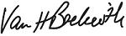

Van H. Beckwith

Executive Vice President, Secretary and Chief Legal Officer

April 5, 2022

HALLIBURTON | 2022 Proxy Statement 67

Back to Contents

Directions to the Halliburton Annual Meeting of Shareholders

The Halliburton North Belt Facility is located on the North Sam Houston Parkway (Beltway 8 Tollway) south feeder between Aldine Westfield and JFK Boulevard.

3000 N. Sam Houston Parkway East

Houston, Texas 77032

281-871-4000

From I-45 |  | From I-69 / US 59 and IAH
• Take the Sam Houston Parkway East |  | • Take the Sam Houston Parkway West
• Exit JFK Blvd |  | • | Exit Aldine Westfield
 |  | • | “U-Turn” at Aldine Westfield and proceed east on the Sam Houston Parkway feeder
The main entrance to the North Belt facility will be on your right, about halfway between Aldine Westfield and JFK Blvd.
www.halliburton.com |  |  |  | HALLIBURTON | 2022 Proxy Statement 68

Back to Contents


Back to Contents
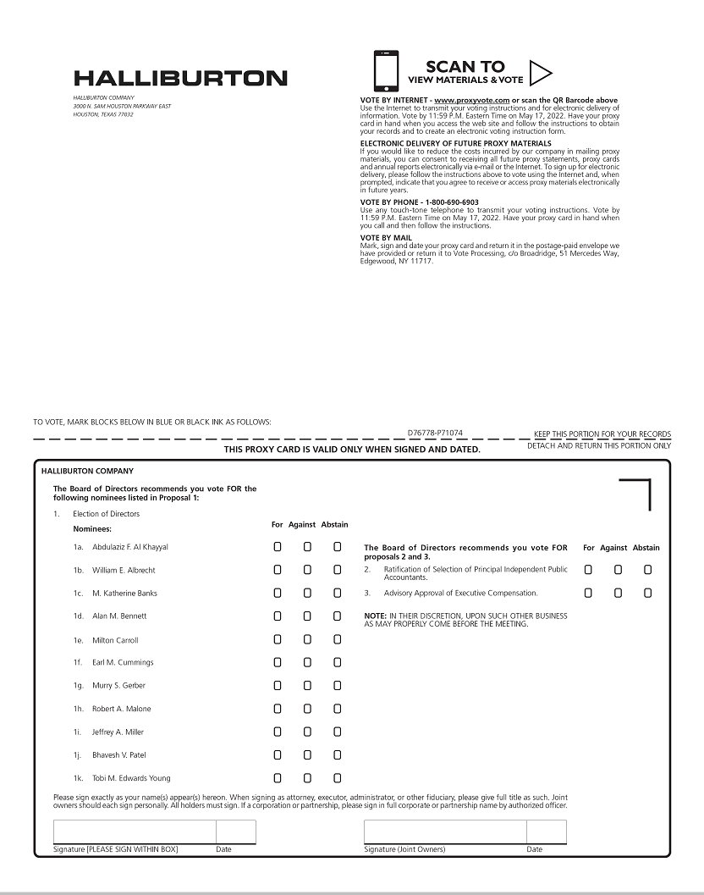

Back to Contents


