UNITED STATES
SECURITIES AND EXCHANGE COMMISSION
Washington, D.C. 20549

FORM 8-K

CURRENT REPORT
Pursuant to Section 13 OR 15(d) of The Securities Exchange Act of 1934

Date of Report (Date of earliest event reported): October 15, 2026

HALLIBURTON COMPANY
(Exact name of registrant as specified in its charter)
Delaware |  |  | 001-03492 |  |  | 75-2677995
(State or other jurisdiction of incorporation) |  |  | (Commission File Number) |  |  | (IRS Employer Identification No.)
3000 North Sam Houston Parkway East, |  |  | Houston, |  |  | Texas |  |  | 77032
(Address of principal executive offices) |  |  |  |  |  |  |  |  | (Zip Code)
Registrant’s telephone number, including area code: (281) 871-2699
Not Applicable
(Former name or former address, if changed since last report)

Check the appropriate box below if the Form 8-K filing is intended to simultaneously satisfy the filing obligation of the registrant under any of the following provisions:
☐ |  |  | Written communications pursuant to Rule 425 under the Securities Act (17 CFR 230.425)
☐ |  |  | Soliciting material pursuant to Rule 14a-12 under the Exchange Act (17 CFR 240.14a-12)
☐ |  |  | Pre-commencement communications pursuant to Rule 14d-2(b) under the Exchange Act (17 CFR 240.14d-2(b))
☐ |  |  | Pre-commencement communications pursuant to Rule 13e-4(c) under the Exchange Act (17 CFR 240.13e-4(c))
Securities registered pursuant to Section 12(b) of the Act:
Title of each class |  |  | Trading Symbol |  |  | Name of each exchange on which registered
Common Stock, par value $2.50 per share |  |  | HAL |  |  | New York Stock Exchange
 |  |  |  |  |  | NYSE Texas, Inc.

Indicate by check mark whether the registrant is an emerging growth company as defined in Rule 405 of the Securities Act of 1933 (§230.405 of this chapter) or Rule 12b-2 of the Securities Exchange Act of 1934 (§240.12b-2 of this chapter).
Emerging growth company |  |  | ☐
If an emerging growth company, indicate by check mark if the registrant has elected not to use the extended transition period for complying with any new or revised financial accounting standards provided pursuant to Section 13(a) of the Exchange Act. ☐

Item 5.02. Departure of Directors or Certain Officers; Election of Directors; Appointment of Certain Officers; Compensatory Arrangements of Certain Officers.

On October 15, 2026, the Board of Directors (the “Board”) of Halliburton Company (“Halliburton”) appointed David C. Hernandez as a member of the Board to fill a vacancy. The size of the Board remains at 12 directors. Mr. Hernandez currently serves as President and Director of Hunt Consolidated, Inc. (“Hunt Consolidated”). Mr. Hernandez brings extensive C-suite leadership experience across energy and industrial businesses, including expertise in corporate strategy, capital allocation, financial oversight, enterprise risk management, regulatory compliance, and governance. Mr. Hernandez has served as President of Hunt Consolidated since 2025, and during 2019-2022. In addition, during 2023-2024 he served as Chairman and Managing Director of Hunt Consolidated. Prior to joining Hunt Consolidated, Mr. Hernandez served as Vice President of Tax for Electronic Data Systems. Mr. Hernandez earned a J.D. from The University of Chicago and a Bachelor of Science in Finance from the University of Virginia McIntire School of Commerce.

There are no arrangements or understandings between Mr. Hernandez and any other persons pursuant to which Mr. Hernandez was selected as a director. The Board appointed Mr. Hernandez to the Audit Committee and the Health, Safety and Environment Committee. There are no transactions in which Mr. Hernandez has an interest that are required to be disclosed pursuant to Item 404(a) of Regulation S-K. The Board has determined that Mr. Hernandez is independent under the listing standards of the New York Stock Exchange and Halliburton’s Corporate Governance Guidelines, and designated him an “audit committee financial expert” as defined under the applicable rules and regulations of the Securities and Exchange Commission (“SEC”). In connection with Mr. Hernandez's committee appointments, the Board moved Mr. Timothy A. Leach from the Audit Committee and appointed him to the Compensation Committee.

Mr. Hernandez will participate in the compensation arrangements for non-management directors as described in Halliburton’s Definitive Proxy Statement on Schedule 14A for Halliburton’s 2026 Annual Meeting of Shareholders filed with the SEC on March 31, 2026. Mr. Hernandez will receive an initial equity award of restricted stock units (“RSUs”) equal to the prorated value of the annual equity award of $200,000 granted to Halliburton’s non-management Directors. Each RSU represents the right to receive a share of Halliburton’s common stock on a future date as provided in the award agreement. The factor used to determine the prorated award is the number of whole months of service from the beginning of the month in which the Board service begins to the following first of December divided by twelve. The number of RSUs awarded is determined by dividing the prorated award amount by the average of the closing prices of Halliburton’s common stock on the New York Stock Exchange on each business day during the full calendar month immediately preceding the date Mr. Hernandez joined the Board. Based on this formula, Mr. Hernandez will receive an initial award of 961 RSUs.

In connection with Mr. Hernandez’s appointment, Halliburton entered into an indemnification agreement with Mr. Hernandez on October 15, 2026. The indemnification agreement provides that, subject to certain exceptions and limitations set forth therein, Halliburton will indemnify and advance certain expenses to Mr. Hernandez to the fullest extent, and only to the extent, permitted by applicable law in effect as of the date of the indemnification agreement and to such greater extent as applicable law may thereafter from time to time permit. The foregoing description of the indemnification agreement does not purport to be complete and is qualified in its entirety by reference to the full text of the Form of Indemnification Agreement for Directors, a copy of which is incorporated by reference as Exhibit 10.1 to this Current Report on Form 8-K.

Item 7.01. Regulation FD Disclosure.

On October 15, 2026, Halliburton issued a press release announcing the appointment of David C. Hernandez to its Board, a copy of which is furnished as Exhibit 99.1 to this Current Report on Form 8-K and is incorporated by reference herein.

The information furnished pursuant to this Item 7.01, including Exhibit 99.1, shall not be deemed to be “filed” for the purposes of Section 18 of the Securities Exchange Act of 1934, as amended (the “Exchange Act”), or otherwise subject to the liabilities of that section, nor shall such information be deemed incorporated by reference into any registration statement or other filing under the Securities Act of 1933, as amended, or the Exchange Act, unless specifically identified in such filing as being incorporated by reference in such filing.

Item 9.01. Financial Statements and Exhibits.

(d) Exhibits.

10.1 Form of Indemnification Agreement for Directors (incorporated by reference to Exhibit 10.2 of Halliburton’s Form 10-Q for the quarter ended June 30, 2023, File No. 001-03492).

99.1 Press Release of Halliburton Company, dated October 15, 2026.

104 Cover Page Interactive Data File - the cover page XBRL tags are embedded within the Inline XBRL document.

SIGNATURES

Pursuant to the requirements of the Securities Exchange Act of 1934, the registrant has duly caused this report to be signed on its behalf by the undersigned hereunto duly authorized.

 |  |  | HALLIBURTON COMPANY
Date: October 15, 2026 |  |  | By: |  |  | /s/ Pamela L. Taylor
 |  |  |  |  |  | Pamela L. Taylor
 |  |  |  |  |  | Vice President, Public Law and Assistant Secretary

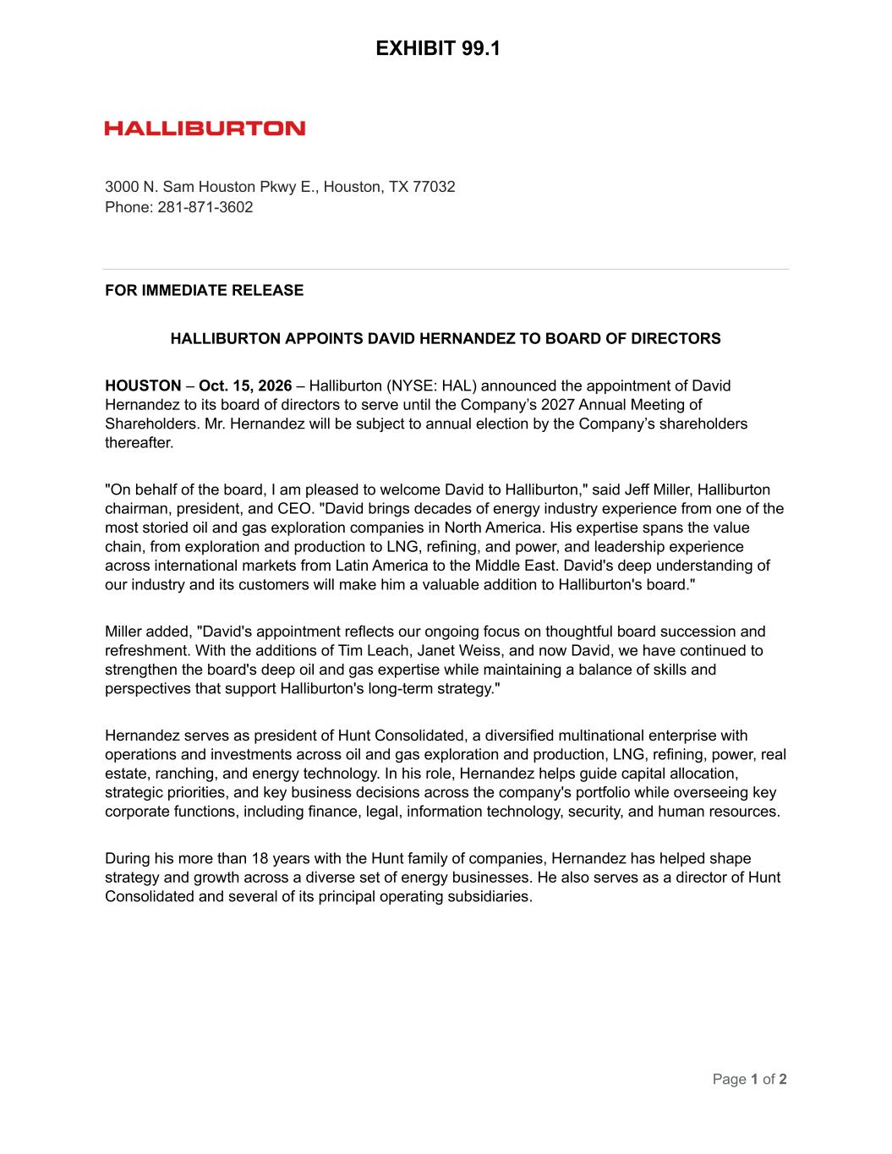

Page 1 of 2 3000 N. Sam Houston Pkwy E., Houston, TX 77032 Phone: 281-871-3602 FOR IMMEDIATE RELEASE HALLIBURTON APPOINTS DAVID HERNANDEZ TO BOARD OF DIRECTORS HOUSTON – Oct. 15, 2026 – Halliburton (NYSE: HAL) announced the appointment of David Hernandez to its board of directors to serve until the Company’s 2027 Annual Meeting of Shareholders. Mr. Hernandez will be subject to annual election by the Company’s shareholders thereafter. "On behalf of the board, I am pleased to welcome David to Halliburton," said Jeff Miller, Halliburton chairman, president, and CEO. "David brings decades of energy industry experience from one of the most storied oil and gas exploration companies in North America. His expertise spans the value chain, from exploration and production to LNG, refining, and power, and leadership experience across international markets from Latin America to the Middle East. David's deep understanding of our industry and its customers will make him a valuable addition to Halliburton's board." Miller added, "David's appointment reflects our ongoing focus on thoughtful board succession and refreshment. With the additions of Tim Leach, Janet Weiss, and now David, we have continued to strengthen the board's deep oil and gas expertise while maintaining a balance of skills and perspectives that support Halliburton's long-term strategy." Hernandez serves as president of Hunt Consolidated, a diversified multinational enterprise with operations and investments across oil and gas exploration and production, LNG, refining, power, real estate, ranching, and energy technology. In his role, Hernandez helps guide capital allocation, strategic priorities, and key business decisions across the company's portfolio while overseeing key corporate functions, including finance, legal, information technology, security, and human resources. During his more than 18 years with the Hunt family of companies, Hernandez has helped shape strategy and growth across a diverse set of energy businesses. He also serves as a director of Hunt Consolidated and several of its principal operating subsidiaries. EXHIBIT 99.1

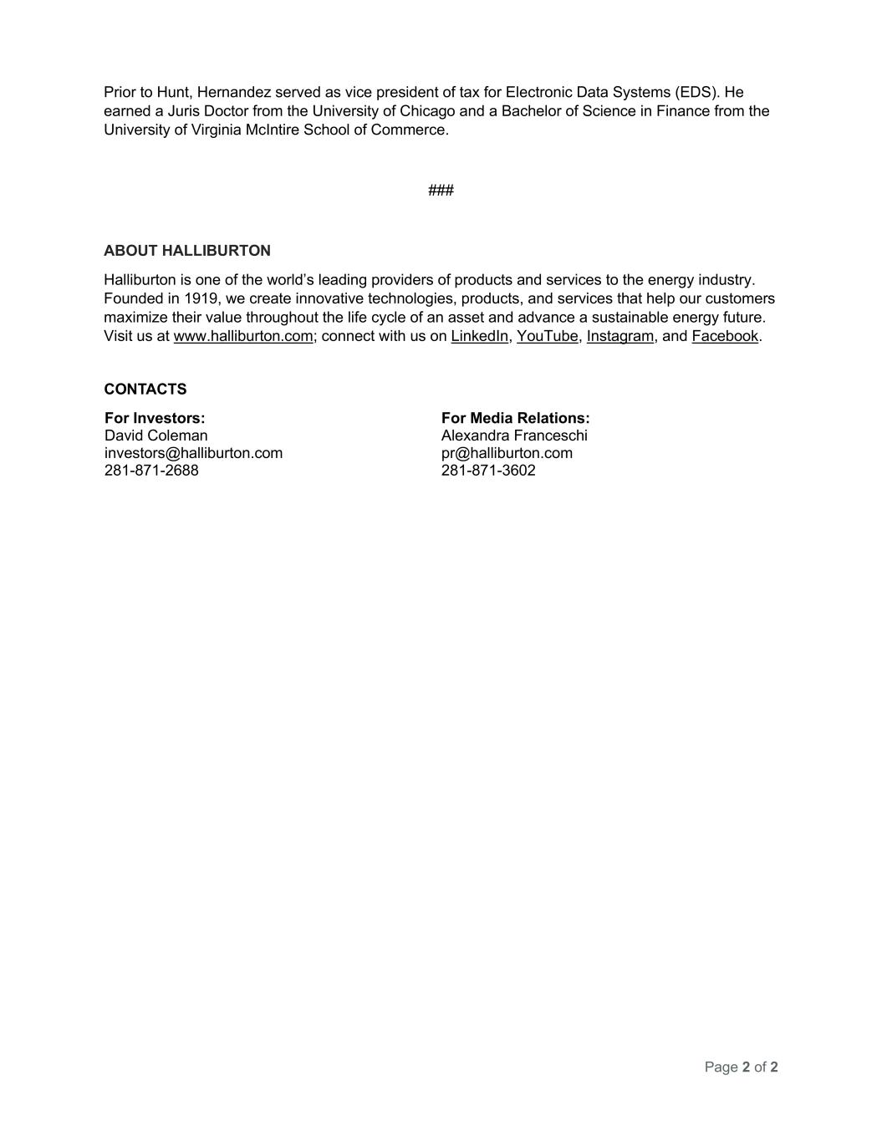
Page 2 of 2 Prior to Hunt, Hernandez served as vice president of tax for Electronic Data Systems (EDS). He earned a Juris Doctor from the University of Chicago and a Bachelor of Science in Finance from the University of Virginia McIntire School of Commerce. ### ABOUT HALLIBURTON Halliburton is one of the world’s leading providers of products and services to the energy industry. Founded in 1919, we create innovative technologies, products, and services that help our customers maximize their value throughout the life cycle of an asset and advance a sustainable energy future. Visit us at www.halliburton.com; connect with us on LinkedIn, YouTube, Instagram, and Facebook. CONTACTS For Investors: David Coleman investors@halliburton.com 281-871-2688 For Media Relations: Alexandra Franceschi pr@halliburton.com 281-871-3602

