SEC Form 4

FORM 4

Check this box if no longer subject to Section 16. Form 4 or Form 5 obligations may continue. See Instruction 1(b).

Check this box to indicate that a transaction was made pursuant to a contract, instruction or written plan for the purchase or sale of equity securities of the issuer that is intended to satisfy the affirmative defense conditions of Rule 10b5-1(c). See Instruction 10.

UNITED STATES SECURITIES AND EXCHANGE COMMISSION
Washington, D.C. 20549
Washington, D.C. 20549 |  | OMB APPROVAL
STATEMENT OF CHANGES IN BENEFICIAL OWNERSHIP
STATEMENT OF CHANGES IN BENEFICIAL OWNERSHIP |  | OMB Number: | 3235-0287
 |  | Estimated average burden
Filed pursuant to Section 16(a) of the Securities Exchange Act of 1934 |  | hours per response: | 0.5
or Section 30(h) of the Investment Company Act of 1940
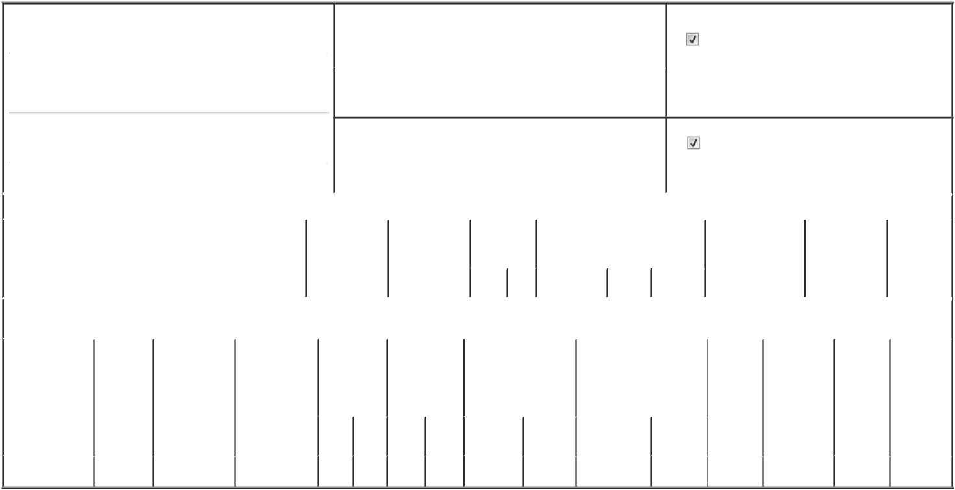

1. Name and Address of Reporting Person* |  |  |  |  |  |  | 2. Issuer Name and Ticker or Trading Symbol
 |  | Hernandez David Christopher |  |  |  |  | HALLIBURTON CO [ HAL ]
 |  |  |  |  |  |  | Foreign Trading Symbol
 |  | (Last) | (First) |  | (Middle)
 |  |  |  |  |  |  | 3. Date of Earliest Transaction (Month/Day/Year)
 |  | 3000 N SAM HOUSTON PKWY E
 |  |  |  |  |  | 10/23/2026

- Relationship of Reporting Person(s) to Issuer (Check all applicable)

Director 10% Owner

Officer (give title Other (specify

below) below)

(Street) |  |  |  |  |  |  | 4. If Amendment, Date of Original Filed (Month/Day/Year) |  |  |  |  |  |  | 6. Individual or Joint/Group Filing (Check Applicable Line)
 | HOUSTON | TX | 77032 |  |  |  |  |  |  |  |  |  |  |  |  | Form filed by One Reporting Person
 |  |  |  |  |  |  |  |  |  |  |  |  |  |  |  | Form filed by More than One Reporting Person
 | (City) | (State) | (Zip)
 |  |  |  | Table I - Non-Derivative Securities Acquired, Disposed of, or Beneficially Owned
1. Title of Security (Instr. 3) |  |  |  |  | 2. Transaction |  |  | 2A. Deemed |  | 3. |  | 4. Securities Acquired (A) or |  |  |  | 5. Amount of |  | 6. Ownership |  | 7. Nature of
 |  |  |  |  | Date |  |  | Execution Date, |  |  | Transaction | Disposed Of (D) (Instr. 3, 4 and 5) |  |  |  | Securities |  | Form: Direct (D) |  | Indirect
 |  |  |  |  | (Month/Day/Year) |  |  | if any |  |  | Code (Instr. |  |  |  |  | Beneficially Owned |  | or Indirect (I) |  | Beneficial
 |  |  |  |  |  |  |  | (Month/Day/Year) |  | 8) |  |  |  |  |  | Following Reported |  | (Instr. 4) |  | Ownership
 |  |  |  |  |  |  |  |  |  |  |  |  |  |  |  | Transaction(s) (Instr. |  |  |  | (Instr. 4)
 |  |  |  |  |  |  |  |  |  |  | Code V | Amount | (A) or | Price |  | 3 and 4)
 |  |  |  |  |  |  |  |  |  |  | Code V | Amount | (D)
 |  |  |  | Table II - Derivative Securities Acquired, Disposed of, or Beneficially Owned
 |  |  |  | (e.g., puts, calls, warrants, options, convertible securities)
1. Title of |  | 2. | 3. Transaction | 3A. Deemed |  | 4. Transaction |  | 5. Number of |  | 6. Date Exercisable and |  |  | 7. Title and Amount of |  |  | 8. Price of | 9. Number of |  | 10. | 11. Nature
Derivative Security |  | Conversion | Date | Execution Date, |  | Code (Instr. 8) |  | Derivative |  | Expiration Date |  |  | Securities Underlying |  |  | Derivative | derivative |  | Ownership | of Indirect
(Instr. 3) |  | or Exercise | (Month/Day/Year) | if any |  |  |  | Securities |  | (Month/Day/Year) |  |  | Derivative Security (Instr. 3 |  |  | Security | Securities |  | Form: | Beneficial
 |  | Price of |  | (Month/Day/Year) |  |  |  | Acquired (A) or |  |  |  |  | and 4) |  |  | (Instr. 5) | Beneficially |  | Direct (D) | Ownership
 |  | Derivative |  |  |  |  |  | Disposed of (D) |  |  |  |  |  |  |  |  | Owned |  | or Indirect | (Instr. 4)
 |  | Security |  |  |  |  |  | (Instr. 3, 4 and |  |  |  |  |  |  |  |  | Following |  | (I) (Instr. 4)
 |  |  |  |  |  |  |  | 5) |  |  |  |  |  |  |  |  | Reported
 |  |  |  |  |  |  |  |  |  |  |  |  |  |  |  |  | Transaction(s)
 |  |  |  |  |  |  |  |  |  |  |  |  |  | Amount or |  |  | (Instr. 4)
 |  |  |  |  |  |  |  |  |  | Date |  | Expiration |  | Number of
 |  |  |  |  |  | Code V |  | (A) | (D) | Exercisable |  | Date | Title | Shares
10/2026 Restricted |  | (1) | 10/23/2026 |  |  |  | A | 961 |  | (2) |  | (2) | Common Stock | 961 |  | $0 | 961 |  | D
Stock Units |  | (1) | 10/23/2026 |  |  |  | A | 961 |  |  |  |  |  |  |  | $0 | 961 |  | D

Explanation of Responses:

- Each restricted stock unit represents a right to receive one share of the Company common stock.

- The restricted stock units vest in one year on the first anniversary of the award. Shares will be delivered to the reporting person either upon vesting, or if reporting person elected to defer receipt, following cessation as a director.

Remarks:

/s/ Sarah I. Rubenfeld, by Power of

Attorney

** Signature of Reporting Person

10/26/2026

Date

Reminder: Report on a separate line for each class of securities beneficially owned directly or indirectly.

* If the form is filed by more than one reporting person, see Instruction 4 (b)(v).

- Intentional misstatements or omissions of facts constitute Federal Criminal Violations See 18 U.S.C. 1001 and 15 U.S.C. 78ff(a). Note: File three copies of this Form, one of which must be manually signed. If space is insufficient, see Instruction 6 for procedure.
Persons who respond to the collection of information contained in this form are not required to respond unless the form displays a currently valid OMB Number.



